# Lab: Creating a Blog with ASP.NET MVC

In this lab, we shall create a fully-functional **Blog system** in ASP.NET MVC with SQL Server database using Entity Framework and MVC. This tutorial is part of the [“Software Technologies” course @ SoftUni](https://softuni.bg/courses/software-technologies).

# Overview

[**ASP.MVC**](https://en.wikipedia.org/wiki/ASP.NET_MVC) - This is a [**web application framework**](https://en.wikipedia.org/wiki/Web_framework) developed by Microsoft, which implements the **model–view–controller** ([**MVC**](https://en.wikipedia.org/wiki/Model%E2%80%93view%E2%80%93controller)) pattern, with which you should already be familiar with. In other words, this gives you a **bare bone working web app** (you will see that you can start it immediately after creating the project) out of the box, on top of which you can **build your own app**. Consider it our **foundation**.

[**Entity Framework**](https://en.wikipedia.org/wiki/Entity_Framework) - Basically, this gives you a way to **interact with a database** by making you see database objects ([**tables**](https://en.wikipedia.org/wiki/Table_(database))) as classes (It is analogous to Doctrine, which you have already used but is very different). Once familiar with **object-oriented programming** you should appreciate how handy this is.

[**SQL**](https://en.wikipedia.org/wiki/SQL) - Query language used for **managing a database**. In our case, Entity Framework will take care of this.

# Initial Setup

## Create a New ASP.NET MVC Application

First, let's start by creating an **ASP.NET MVC Application**. Don't forget to name the project appropriately, as if you leave this for later, you can encounter major problems:

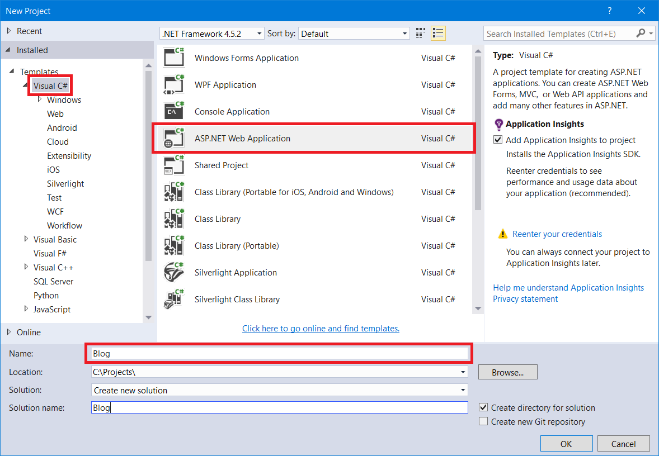

In the next window, choose "**MVC**" and untick the "**Host in the cloud**" checkbox:

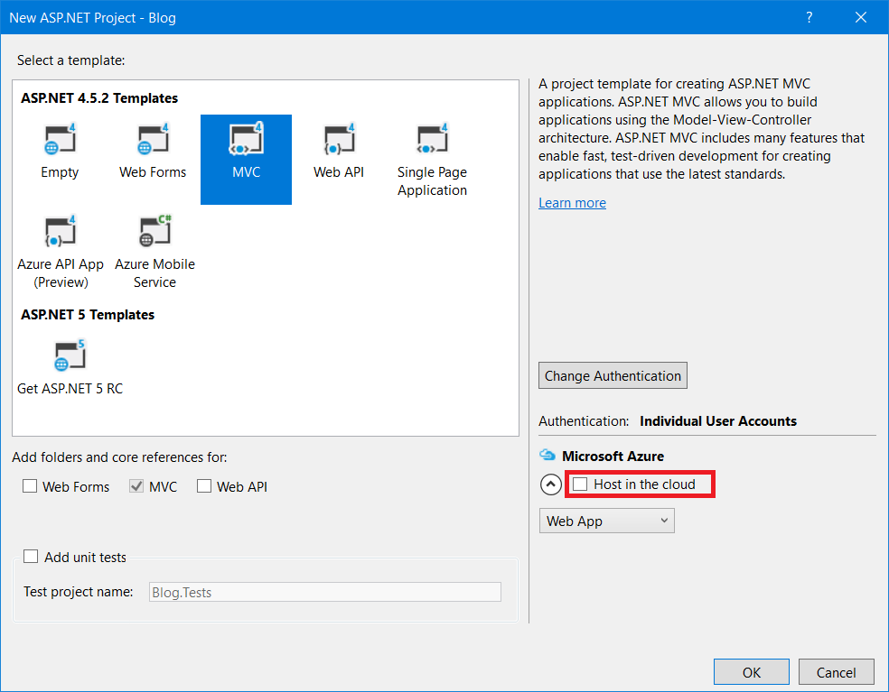

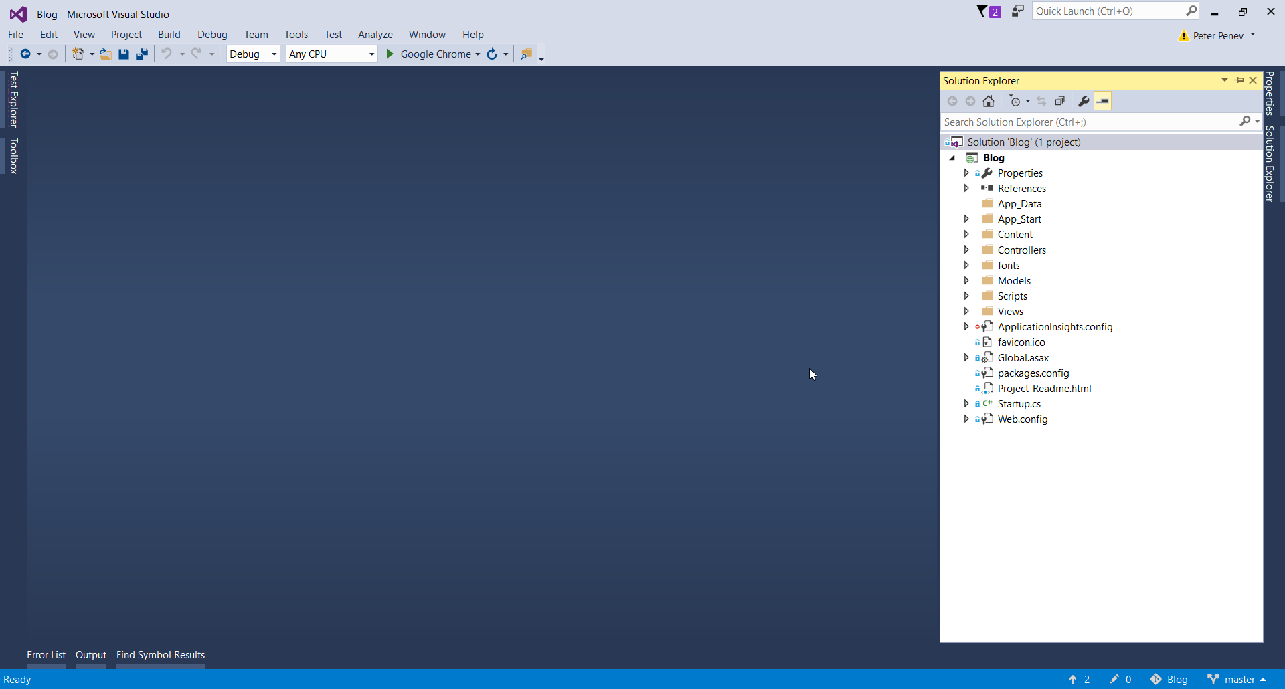

## Run the Application

Run the application to see what was generated by the Visual Studio MVC application template. Press **[Ctrl+F5]**.

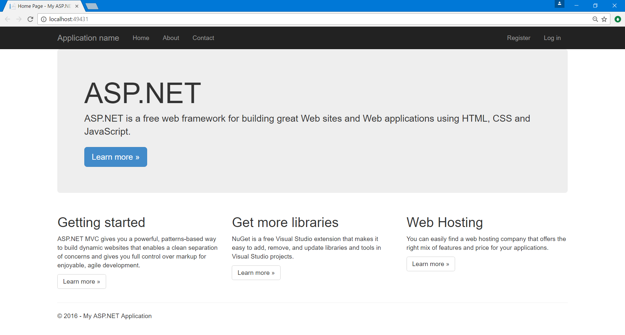

## Register a User

Click on the button in the upper right corner and **register a user**. **If you register** a user successfully **proceed with the next steps**.

**If you get an exception**, you need to **install MSSQL Server LocalDB**. You can get the instructions from the course instance.

After you are done installing, **proceed with blog creation**.

## Plug in Custom Bootstrap File

We need to **insert our bootstrap file** in the project so we can start using it. This can be done by replacing the old one (because **ASP.NET MVC** already uses bootstrap) by heading to the "**Content**" folder. Just delete all files there and place the provided **bootstrap.css**:

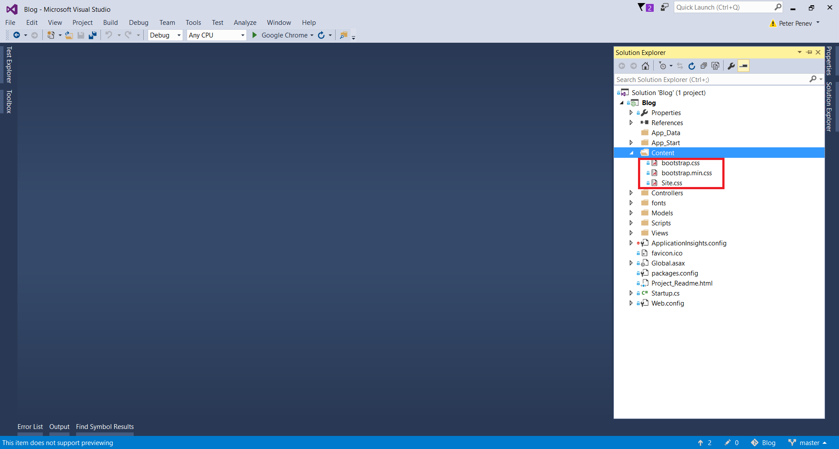

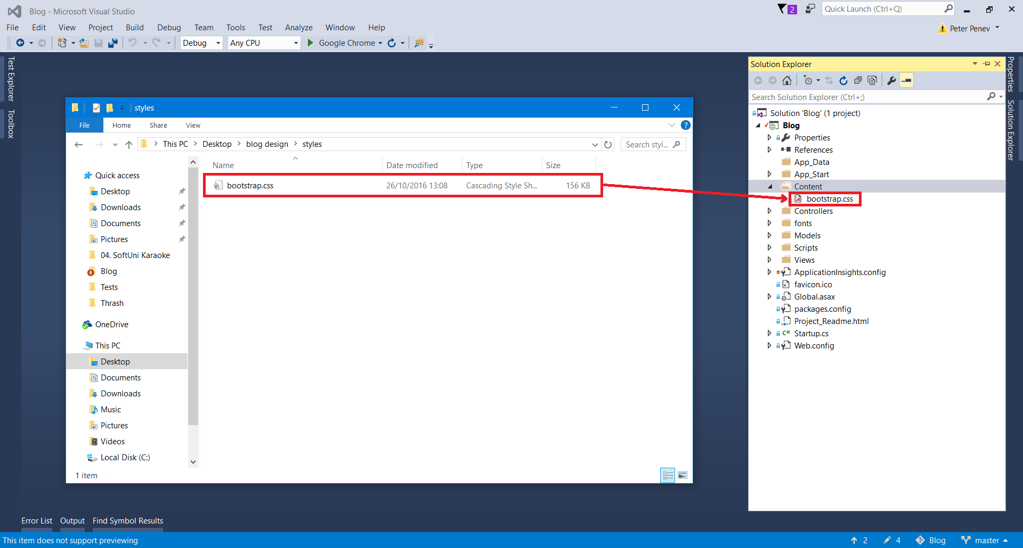

After you do this, **start the application** again to make sure everything works and that you have the new style. Make sure that you **build the project** again with **[Ctrl + Shift +B]**, because you need to recompile in order to see the changes. You can also just save it **[Ctrl + Shift + S]** and start it again **[Ctrl + F5]**:

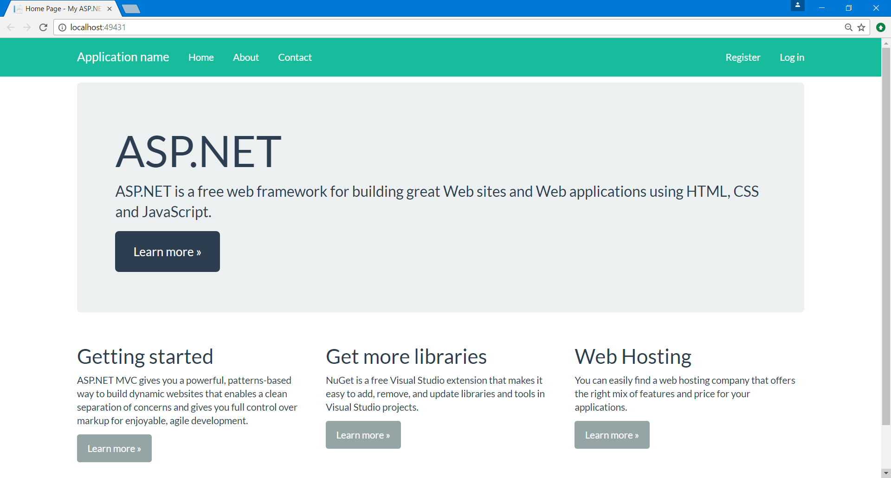

Now, obviously the navbar looks different, but that is just because the default layout uses the "**navbar-inverse**" bootstrap class. When we **edit the general layout of the blog**, everything will start to look as it should.

## Setup the General Layout of the Blog

Now we need to set the **general layout**. Just head to the "**Views"** folder. This is the folder that **holds all the views** for the project. Inside you can see that there are some other folders:

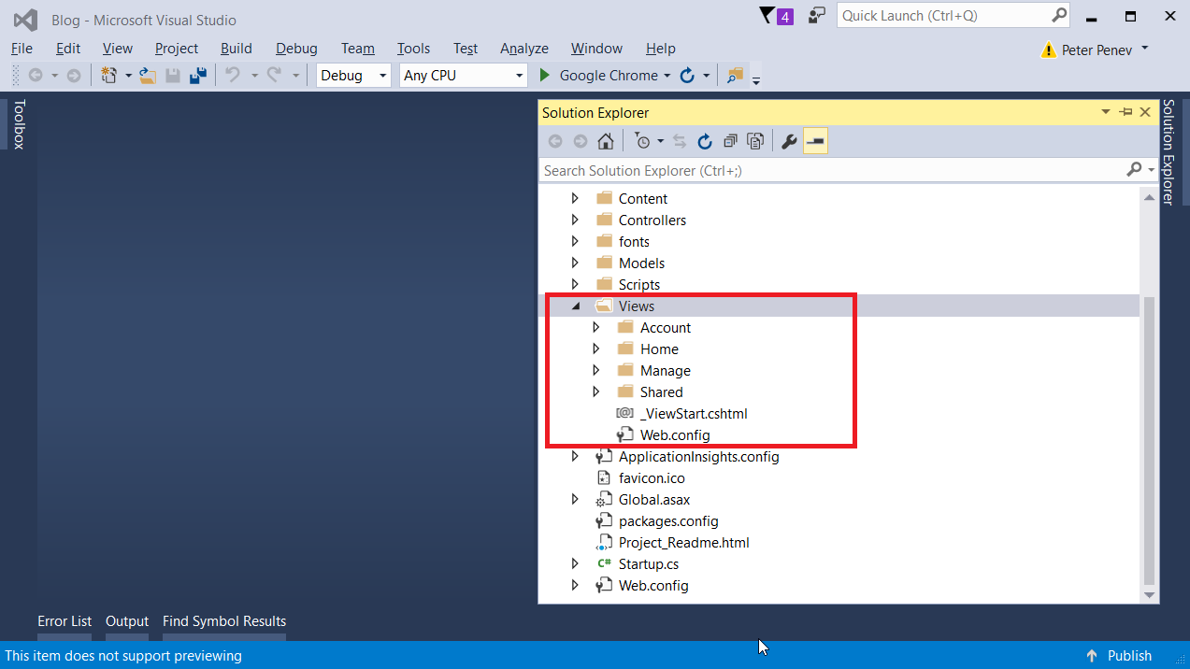

* **Account** - This folder holds all views that are related to **user registration** and **login**
* **Home** - Contains the **home page views**
* **Manage** - Views related to **managing user accounts** (changing password, adding a phone number, etc.)
* **Shared** - folder containing views that are **common for all of the project** (general layout, contact page, etc.)

As you probably guessed we need the "**Shared**" folder. In it you will find a file named "_Layout.cshtml". It begins with an underscore because it is a **partial view** (more on that later).

In it just **delete all code** and **paste the provided** one:

|  |
| --- |
| <!DOCTYPE html>  <html>  <head>  <meta charset="utf-8" />  <meta name="viewport" content="width=device-width, initial-scale=1.0">  <title>@ViewBag.Title - My ASP.NET Application</title>  @Styles.Render("~/Content/css")  @Scripts.Render("~/bundles/modernizr")  </head>  <body>  <div class="navbar navbar-default navbar-fixed-top">  <div class="container">  <div class="navbar-header">  <button type="button" class="navbar-toggle" data-toggle="collapse" data-target=".navbar-collapse">  <span class="icon-bar"></span>  <span class="icon-bar"></span>  <span class="icon-bar"></span>  </button>  @Html.ActionLink("SOFTUNI BLOG", "Index", "Home", new { area = "" }, new { @class = "navbar-brand" })  </div>  <div class="navbar-collapse collapse">  @Html.Partial("_LoginPartial")  </div>  </div>  </div>  <div class="container body-content">  @RenderBody()  <footer class="pull-right">  <p>&copy; @DateTime.Now.Year - SoftUni Blog</p>  </footer>  </div>  @Scripts.Render("~/bundles/jquery")  @Scripts.Render("~/bundles/bootstrap")  @RenderSection("scripts", required: false)  </body>  </html> |

**Test again** and now you should see that the navbar is the good old navbar that you see for the fourth time in this course:

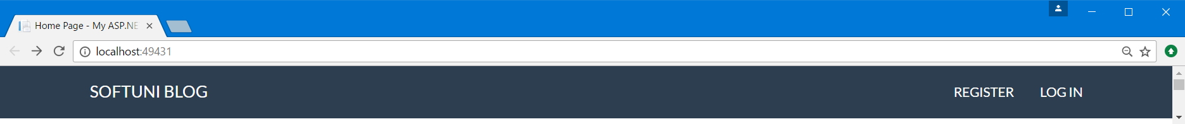

Now, there are many **new** and **interesting** things in the code that you have just copied and pasted.

For example, you can see **some of the code has** the **"@"** sign in front of it. This is part of the [**Razor**](http://www.w3schools.com/asp/razor_intro.asp) engine and is analogous to **Twig** (you saw that in PHP and Symphony). Basically, it gives you the ability to **mix HTML code with C# code**. Everywhere that there is a **"@"** means that there is a **language switch** (it is a little bit more complex, if you are interested in the syntax, [google it](https://www.google.bg/webhp?sourceid=chrome-instant&ion=1&espv=2&ie=UTF-8#q=razor+engine+syntax)).

For example:

* **@Styles.Render("~/Content/css")** - links the page to the css file.
* **@Html.ActionLink("SoftUni Blog", "Index", "Home", new { area = "" }, new { @class = "navbar-brand" })** - creates a link with name "SoftUni Blog", that will be accessible through the "Index" method of the "Home" controller.
* **@Html.Partial("_LoginPartial")** - this renders the partial view (a view inside another view) _LoginPartial. You can find it at "**Shared/_LoginPartial.cshtml**" folder.
* **@RenderBody()** - renders the view that is currently passed to the browser. For example, if you are accessing the index action in the home controller, the view of the body will be "**Views/Home/Index.cshtml**".

## Edit the Home Page

We are just going to put a placeholder on the home page. Go to "**Views/Index.cshtml**" and paste this:

|  |
| --- |
| @{  ViewBag.Title = "Home Page";  }  <h1>Index</h1> |

It will just make the home page look like this:

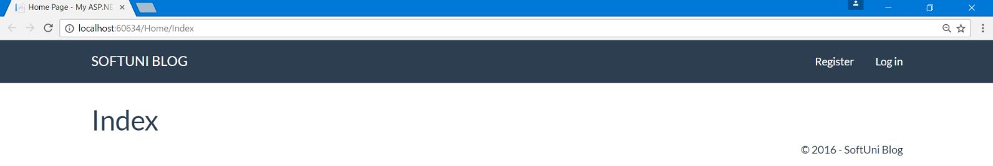

## Delete Unnecessary Actions and Views

Now if you head to the Home Controller (**"Controllers/HomeController.cs"**) you should see that there are three methods (actions - **Index()**, **About()** and **Contact()**). You don’t need **About()** and **Contact()**.

Also, if you look at the home page **we don't have links** to them anymore. You can **safely delete them**:

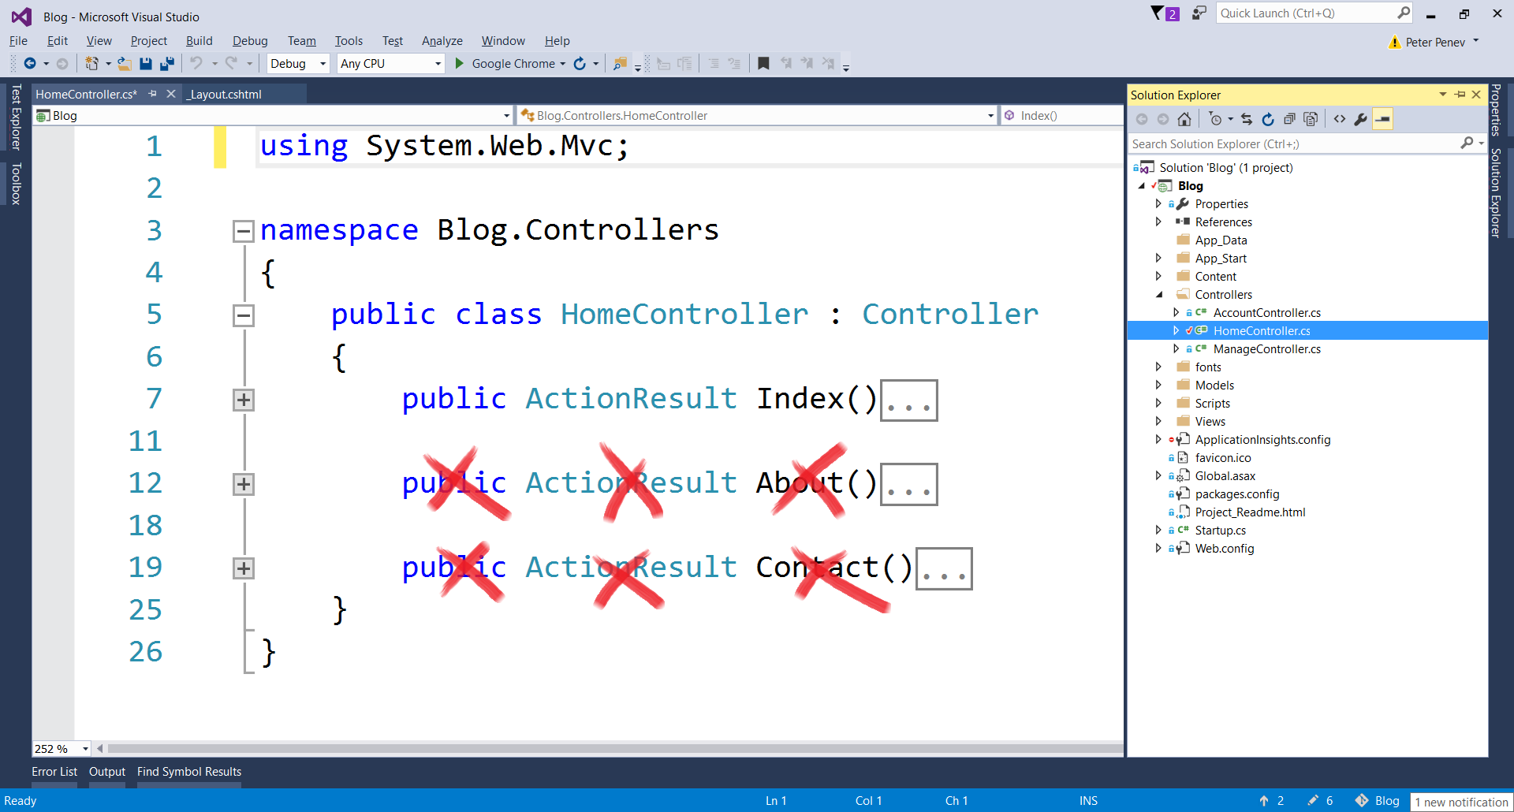

This also means that **you can safely delete the views** that are linked to them. You can find them at "**Views/Home**":

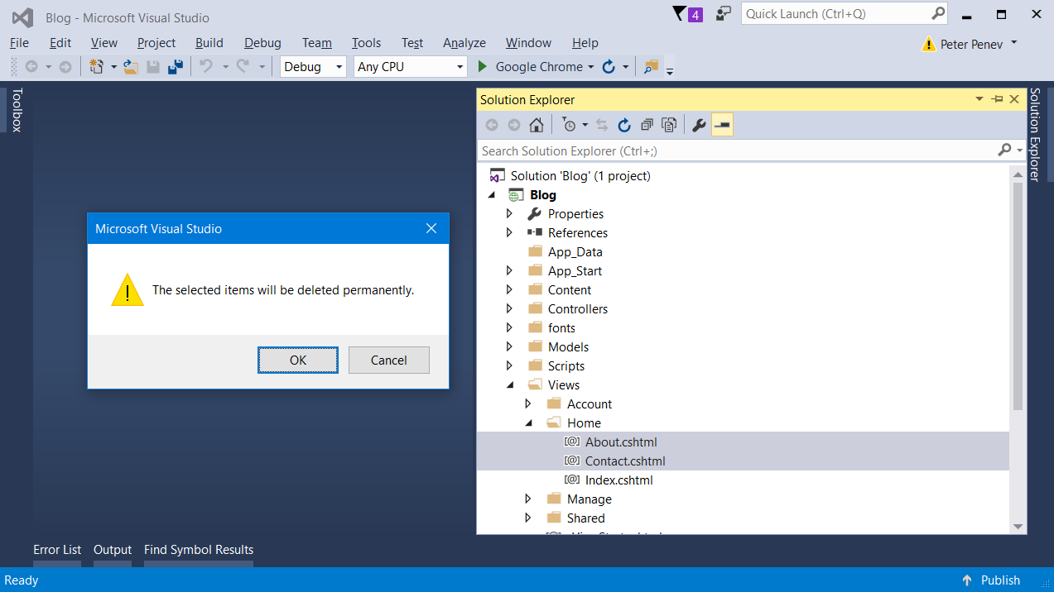

# Edit Class Structure

## Separate Application User and Database Context

In **ASP.NET MVC** you get the user **authentication** as part of the package, but let's take a brief examination.

You can see the user class at "**Models/IdentityModels.cs**". There are **two classes inside the file** and one of them is the **ApplicationUser** class. It **holds information about the user** such as his user name, email, password etc. However, it is a **good practice to have only one class inside a file**, so let's do exactly this:

**Create a new class** inside the same folder "**IdentityModels**":

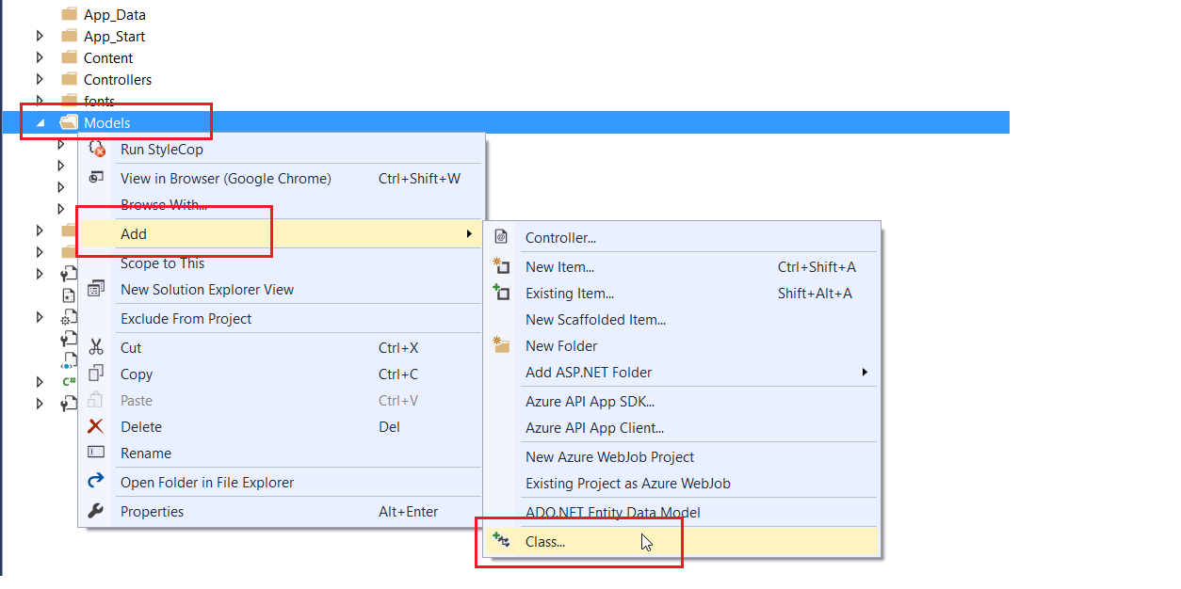

Call it "**ApplicationUser**":

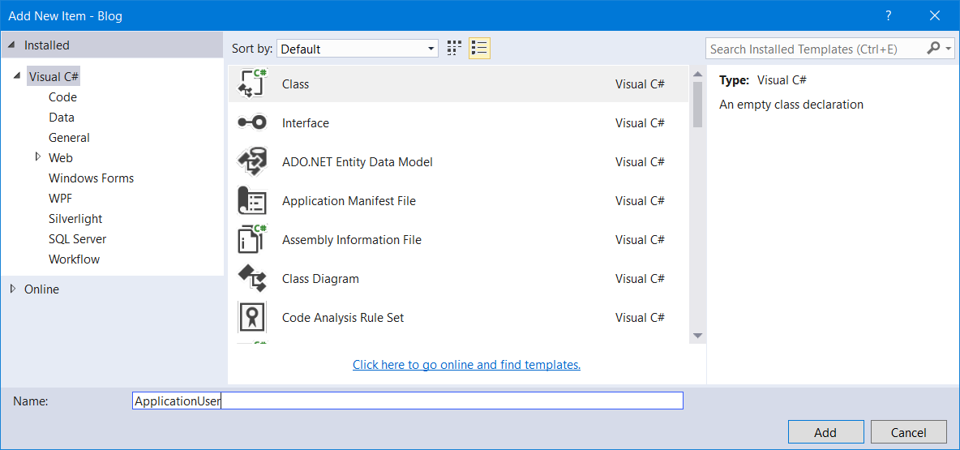

Now, **take all the code** that is the **definition of this class** from "**IdentityModels**" file and paste it inside the new file:

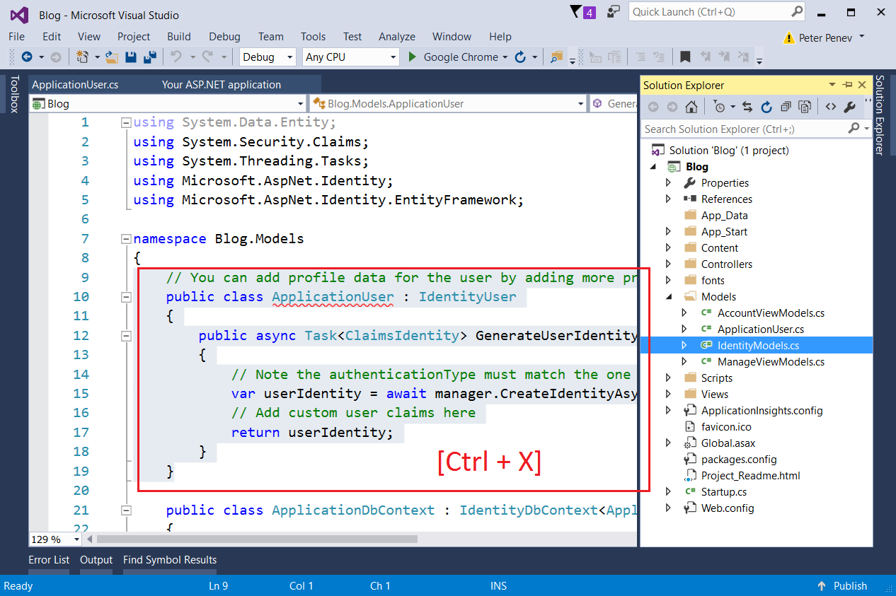

Place it inside the new file (**ApplicationUser**) you have just created:

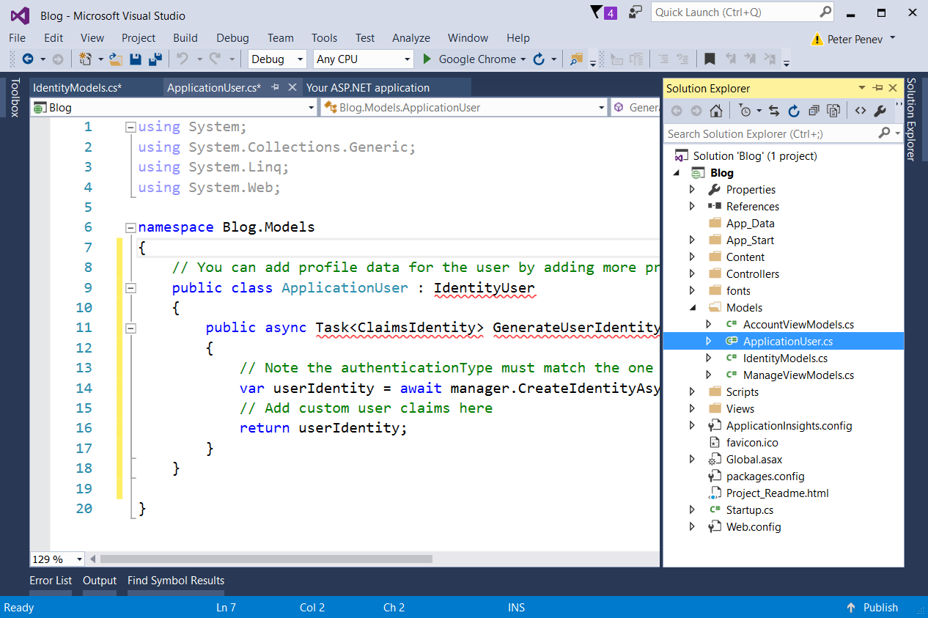

You can see that there are a lot of red underlining. This is because, inside the new file, **there are no references** to the **libraries that are used**. Just **click on top of an underlined class** (for example **IdentityUser**) and hit **[Ctrl + .]**, this should show a menu:

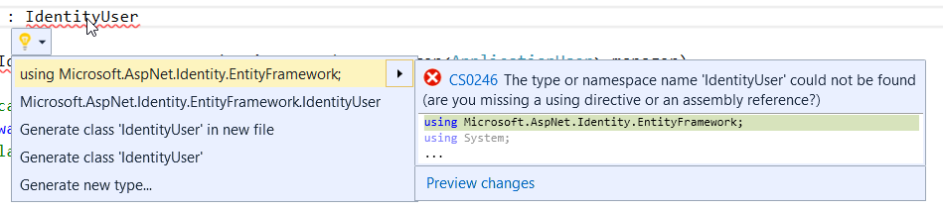

**Choose "using…"**, hit enter and this should add the specified assembly as a using statement **in the beginning of the file**.

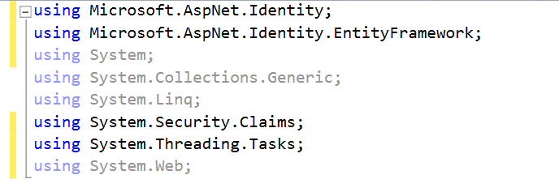

Do this for the rest of the underlined classes or methods **until you can rebuild your solution**.

Rebuild with **[Ctrl + Shift + B].**

## Rename ApplicationDbContext

First, rename the file "**IdentityModes.cs**" to "**BlogDbContext.cs**", because now it holds exactly that, the **blog database context**:

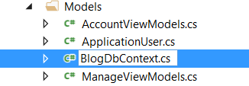

And then **rename the class** (Rename with **[Ctrl + R, R]** after selecting the name of the class):

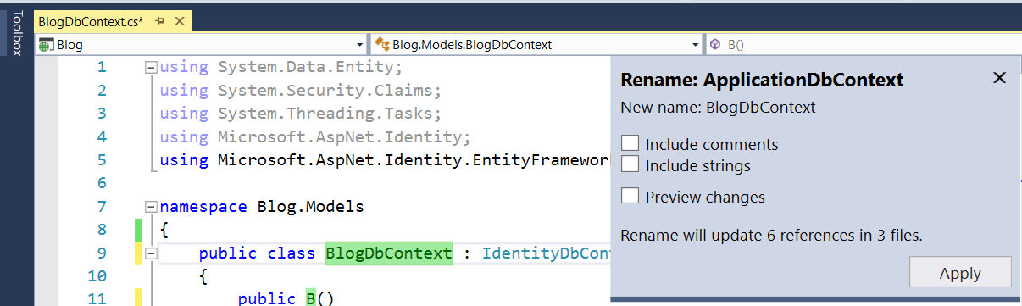

**Rebuild the solution** and if there are any errors, fix them by adding the missing libraries.

## Modify Default Password Requirements

**ASP.NET MVC** has really complex password requirements. We can change this by editing three separate files:

First go to **"App_Start/IdentityConfig.cs"** and look for this code:

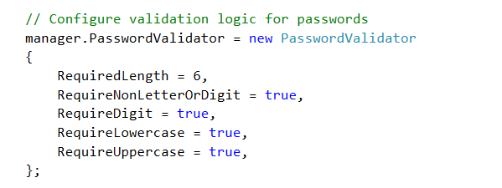

Make the **required length equal to 1** and **the rest equal to false**. This will be much more comfortable for testing.

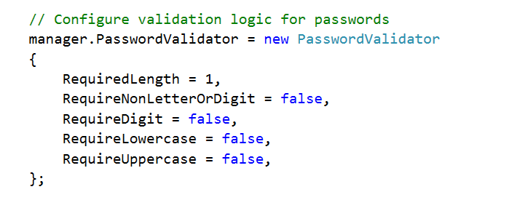

Then go to "**Models/AccountViewModels.cs**" and "**Models/ManageViewModels.cs**" and find these and **edit them to be equal to 1**:

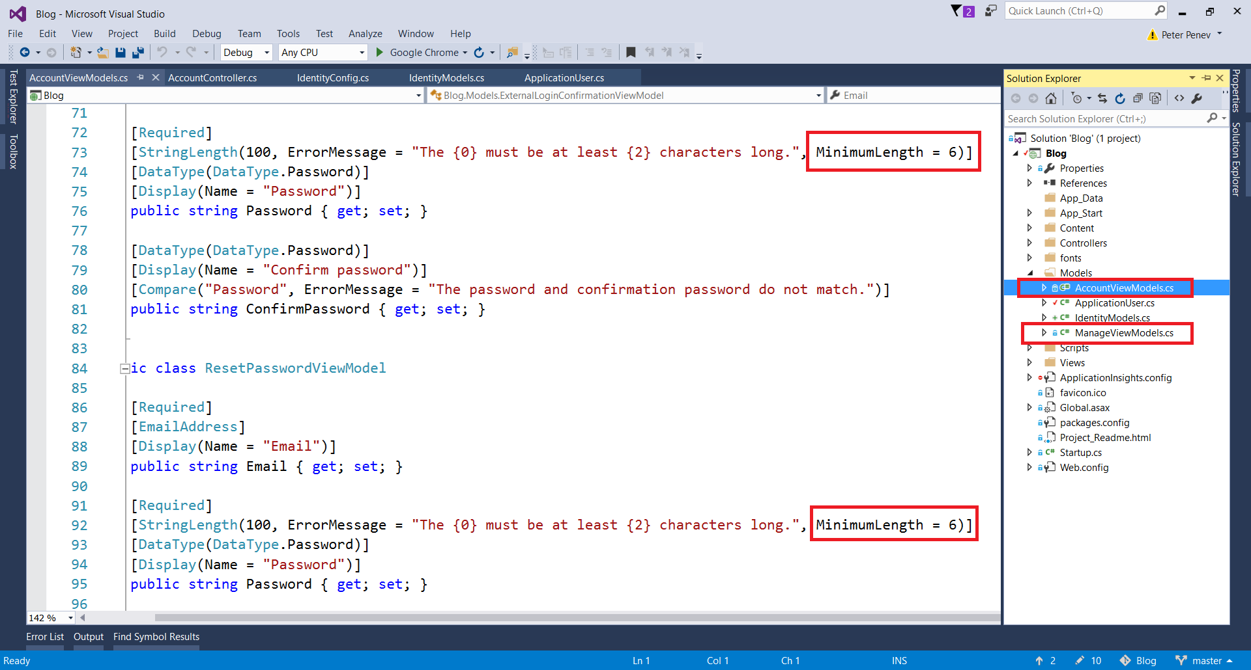

## Test Identity

You can test if the authentication module actually works. Just **start the application** and **click on register**. Register a new user and try to log off and to log in again:

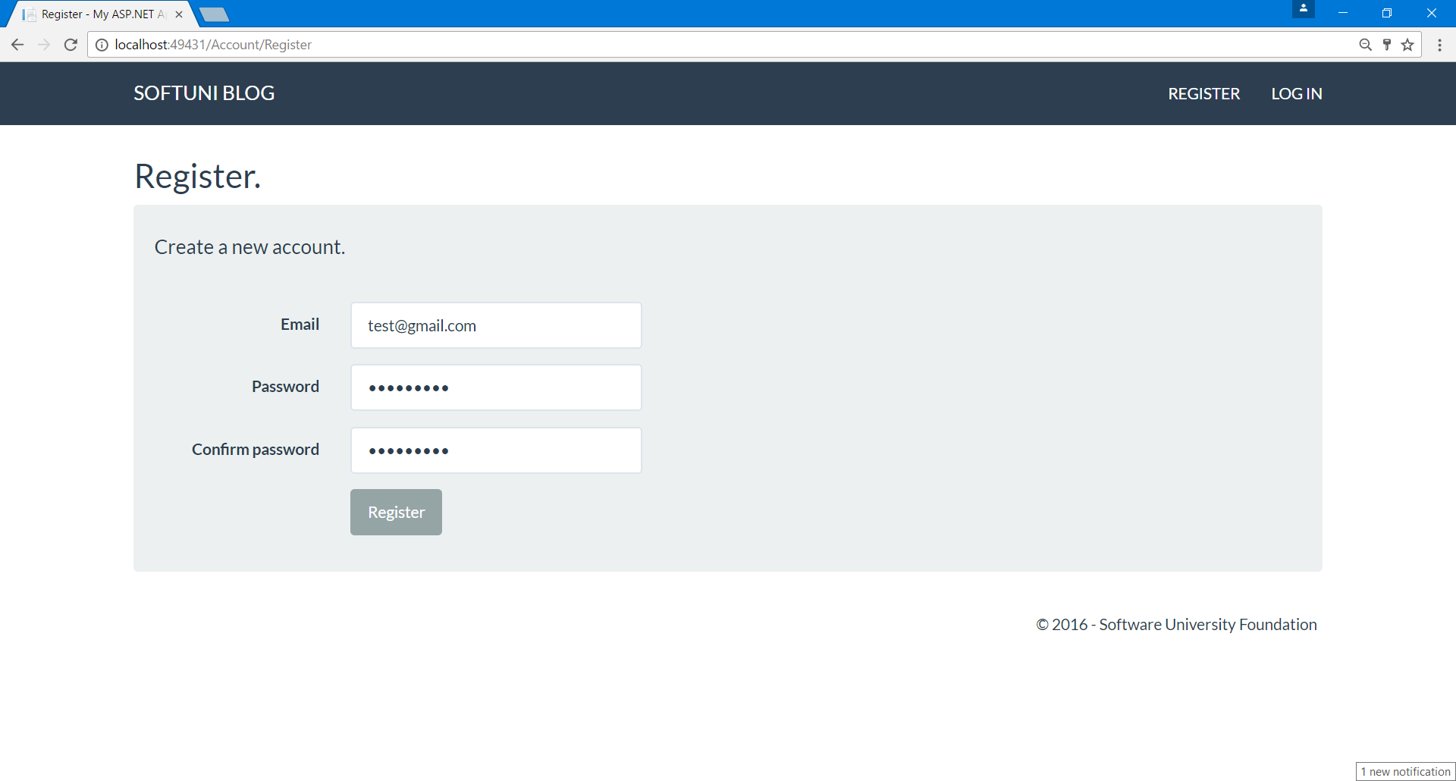

## Inspect the Database

Open the **automatically-generated database** in the App_Data folder and view the AspNetUsers table:

1. Click on the icon in the upper right corner to show all files
2. Double click on the file that now appears in the "**App_Data"** folder. This is your database

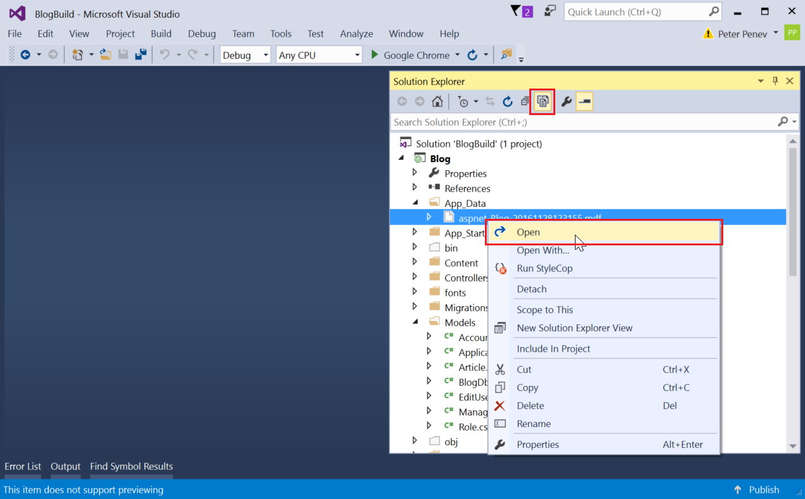

1. Right click on the table AspNetUsers and click on Show Table Data:

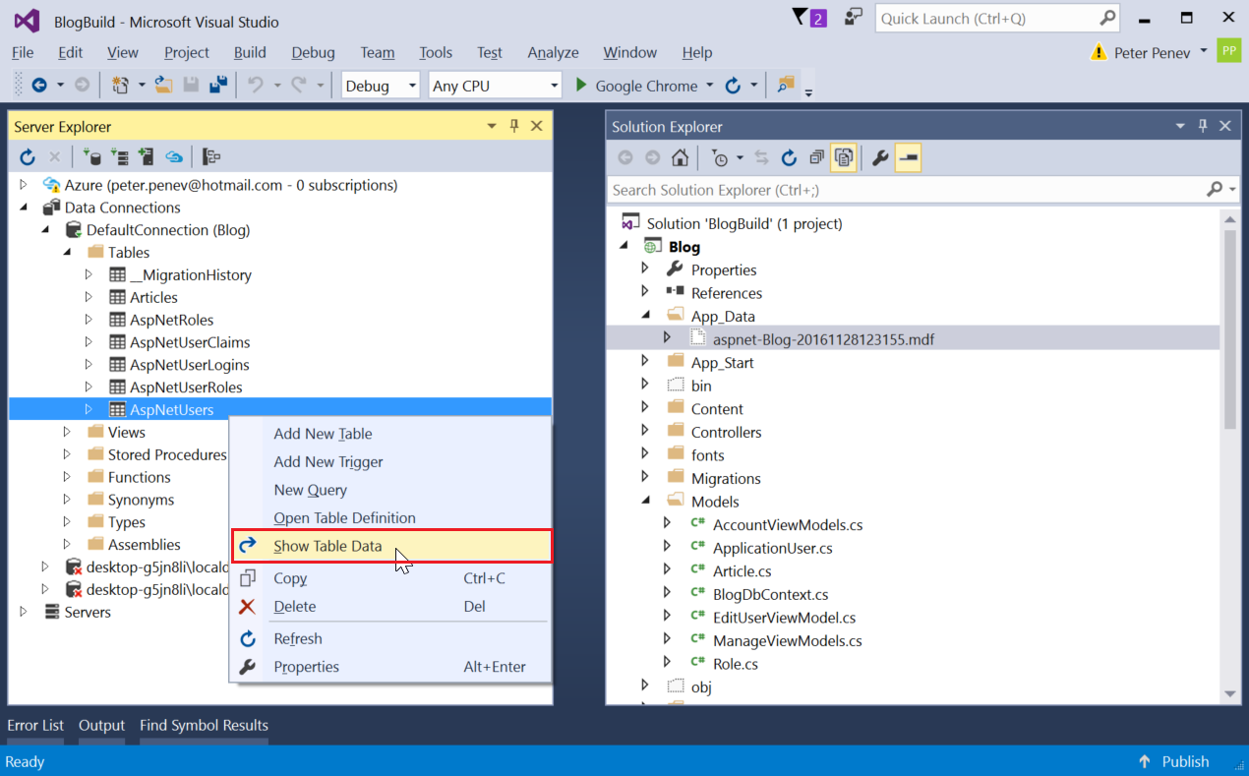

1. **Inspect the table**. There should be a user with the information you have entered earlier:

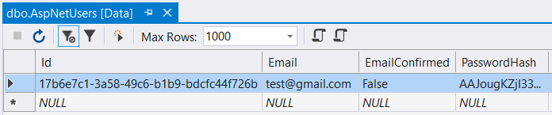

You can see that the **user Id** is a long string of letters and digits. This is a [**GUID**](https://en.wikipedia.org/wiki/Globally_unique_identifier) or **Globally Universal Id**. Globally universal IDs are guaranteed to be **almost unique in the whole world**.

# Get Familiar with Razor Views

## Inspect the Register View

**Razor** is the engine that **handles Views in ASP**. It **mixes HTML language with C#**.

Go to file "**Views/Account/Register**". This is the file that renders the view for Action "**Register**" in the "**AccountController**":

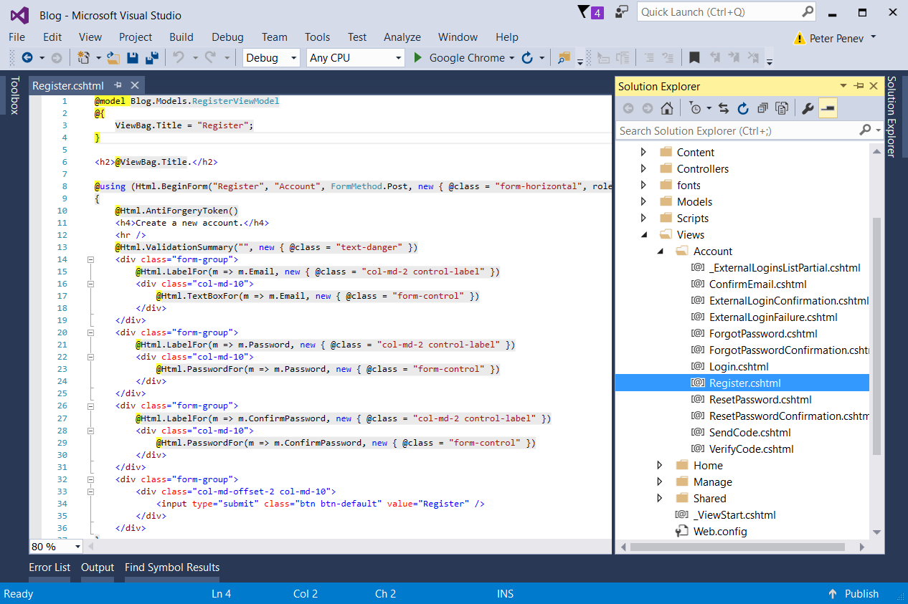

So, the above code renders this:

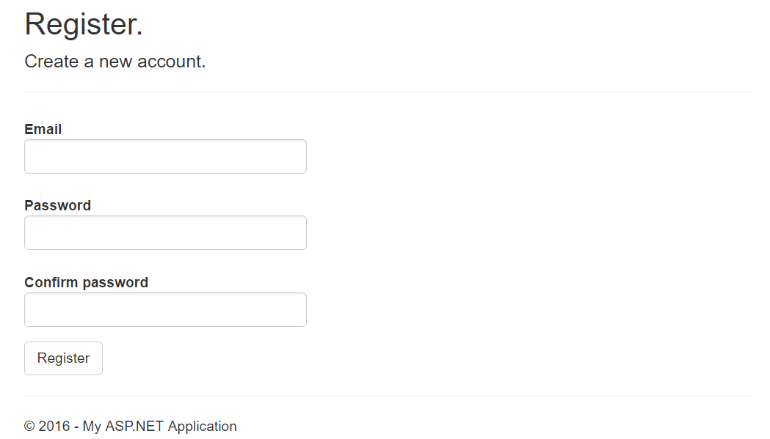

The first thing to notice is the first line:



This means that this view works with a class called **RegisterViewModel**, located in the models folder (the view's [**View Model**](http://stackoverflow.com/questions/11064316/what-is-viewmodel-in-mvc)). More on that later.

There is a single **HTML** **form** in the view (**forms** are used to **gather information** from the user):



This is a form that is related to the "**Register**" action, in the "**Account**" Controller. It is used to "**Post**" information and has some **classes** for styling.

Inside you can see three **<div>**s:

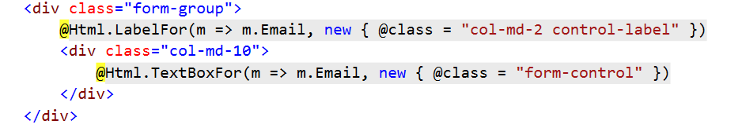

A **form group** represents some **grouped elements inside a form**. There are two elements in it -a **label** anda **text box**. The above div represents this:



The other **<div>**s are analogous.

The fourth one has a **button** in it. This button submits the form along the information gathered.

## Editing a Razor View

Let's make the register page to look and feel familiar to the blogs that we have already made.

Create a **<div class="container">** with a **<div class="well">** in it. Place the form and the title inside of them (the hole form, with all four divs):

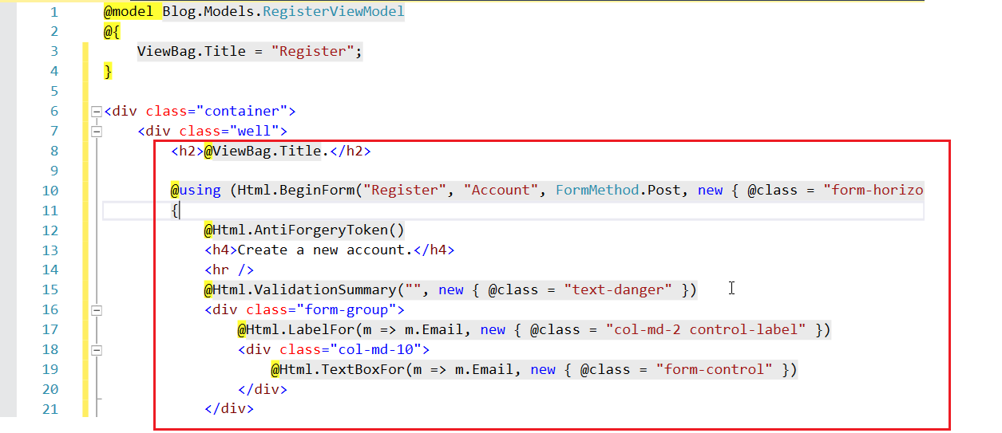

Now go through the view and make all **"col-md-2"** or whatever number they have in all of the divs, to be **"col-sm-4"**:

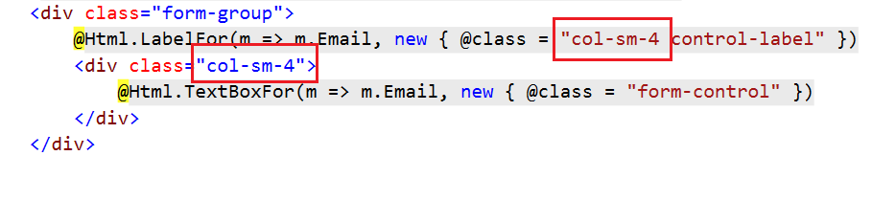

Also, make sure to correct the offset for the buttons:

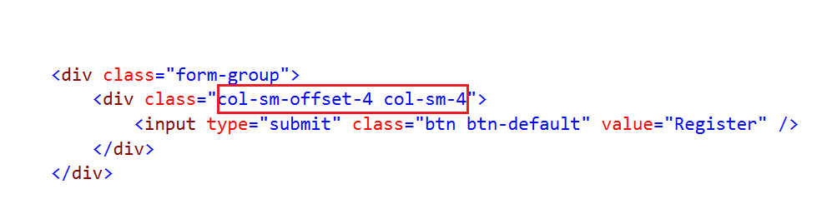

This should make **every label** and **text box** to **take 4 columns of the grid** when the window is of size small and above.

So, the result should be this:

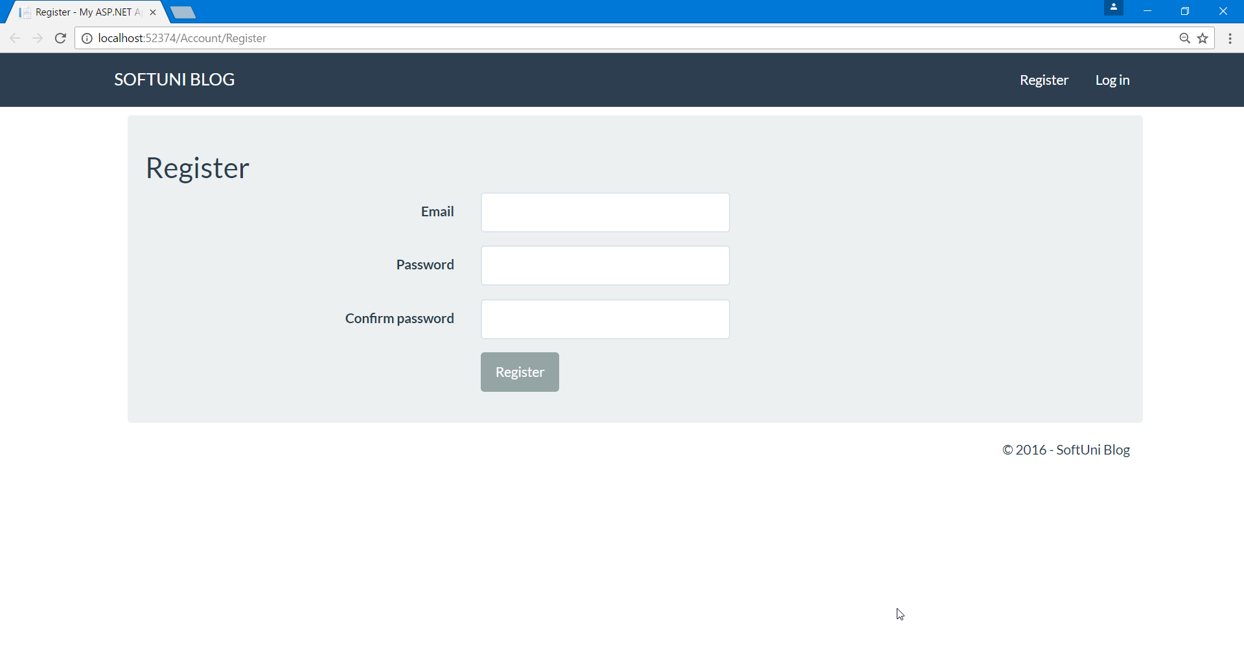

## Editing the Rest of the Views

Now we won't need all of the views that come with **ASP.NET** but we need some of them so let's edit them to have the same layout. Go through all views that you think you will need and edit them, following the same steps as above:

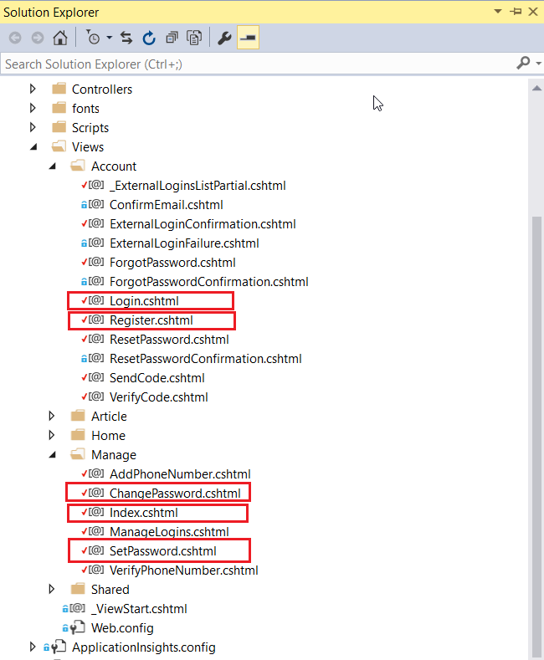

# Start Working with Project Models

There is a problem with the application user. The model has no full name. We need to add this:

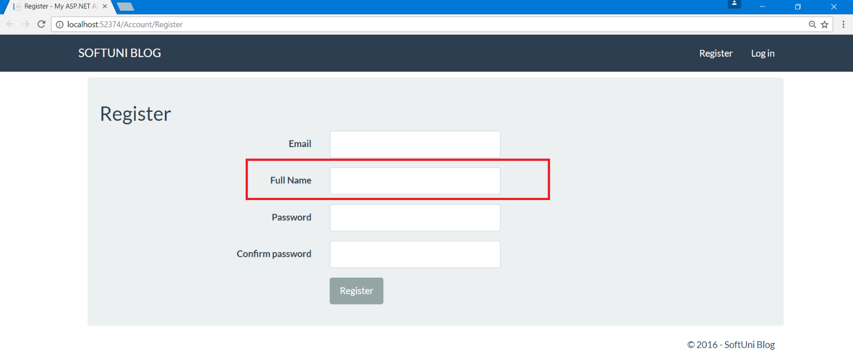

In order to have a full name saved for every user in the database we need to:

1. Edit the **view**
2. Edit the **model**
3. Edit the **controller**

As we recently worked with the views, let's start from there.

## Edit the Register View

Go back to "**Views/Account/Register.cshtml**". Remember that there were some divs **representing every element on the register page** like this one:

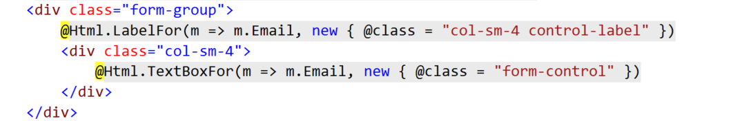

We need to **add additional one** for the full name. Insert one **between** the **email** and the **password**:

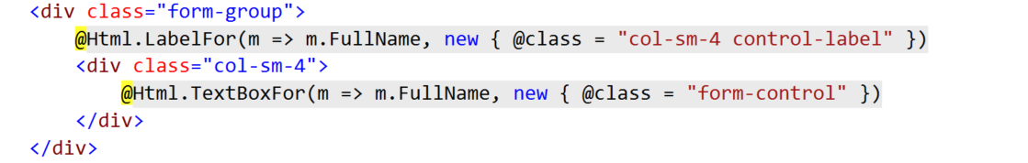

But there is a problem, our model has no **property** for "**FullName**". That's why you don't get any autocompletion and "**FullName**" has red underlining.

## Edit the Register View Model

There are **two kinds of models** in ASP.NET. **Data models** and **View models**. In short, **data models are meant to interact with the controller** and **view models with the views**.

Go to "**Models/AccountViewModels.cs**" and search for **RegisterViewModel**. This is the model that our view works with.

Add the following lines of code:

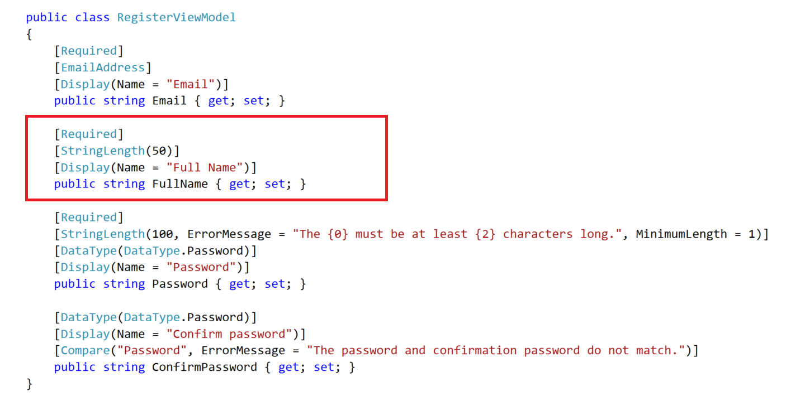

This will **add a new property** called **FullName**, that is required and its maximum length is 50.

Now you can **compile the project** and see that you have a **new textbox on the register view**:



But **it is not functional**. It doesn’t save data in the database.

## Edit the Application User

Head to the **"Models/ApplicationUser.cs"** and **add a string property called FullName**:

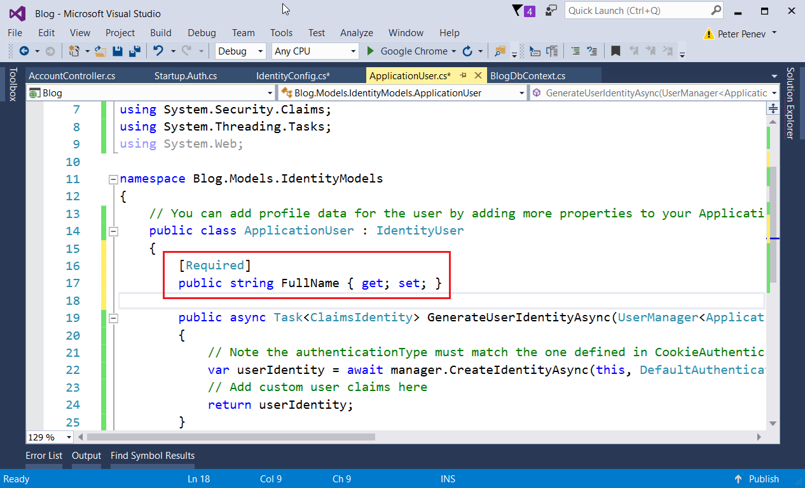

The **property should be public**. Include an [attribute](https://www.dotnetperls.com/attribute) [**Required**]. In this case the attribute is **used for validation** that makes sure that a user without full name **cannot be inserted into the database**.

**Don’t forget** to **add missing libraries** for the attribute.

## Edit Register Action

The only thing left to do is to set the full name when the user is registered.

Go to "Controllers/AccountController" and find the Register method.

Add the following code:

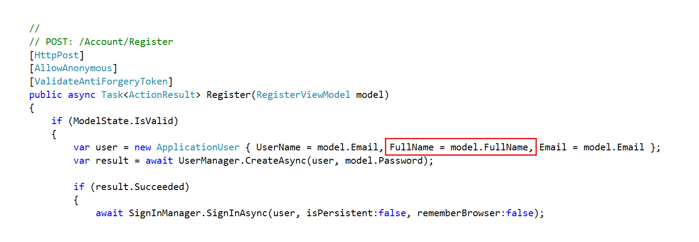

## Add Database Migrations

Now, if you try to register a new user, you should **get an error**:

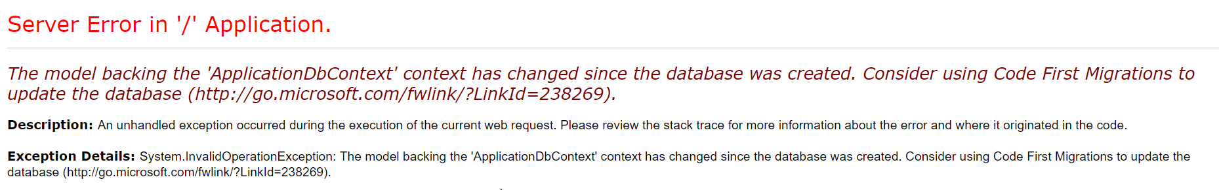

**This error tells us that the database has changed**. We need to explicitly state that we want the **database to be modified if any changes are made** to the entities.

First, open the package manager. In the top left corner of the screen click "**View -> Other Windows -> Package Manager Console**":

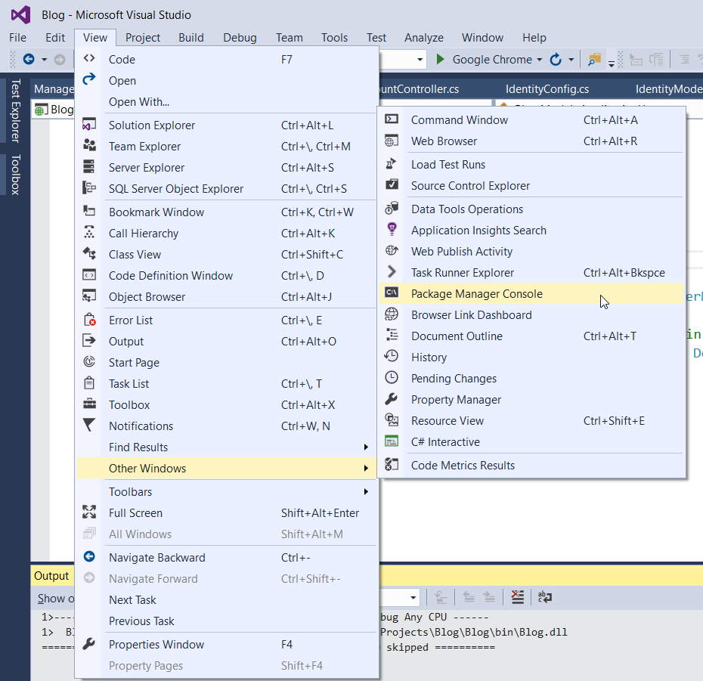

Type:

|  |
| --- |
| **Enable-Migrations -EnableAutomaticMigrations -Force** |

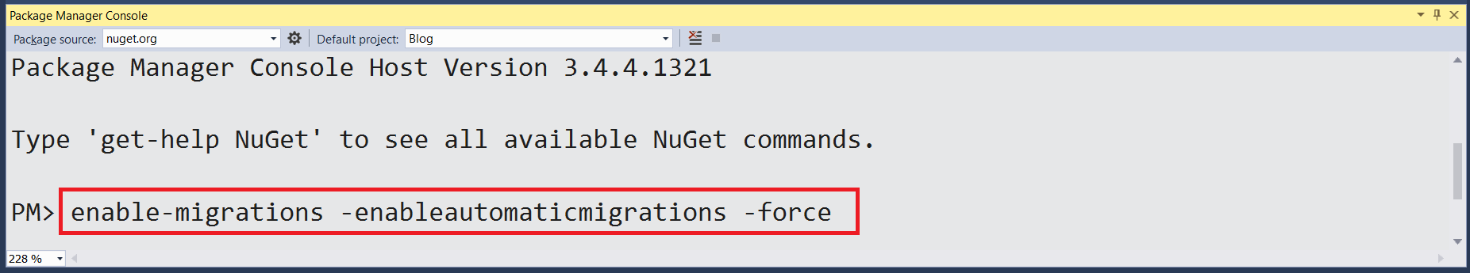

Next, go to the newly created file "**Migrations/Configurations.cs**".

1. Make the class public
2. Add:



1. Don't forget to turn off the above option, once you have sensitive information in the database ☺

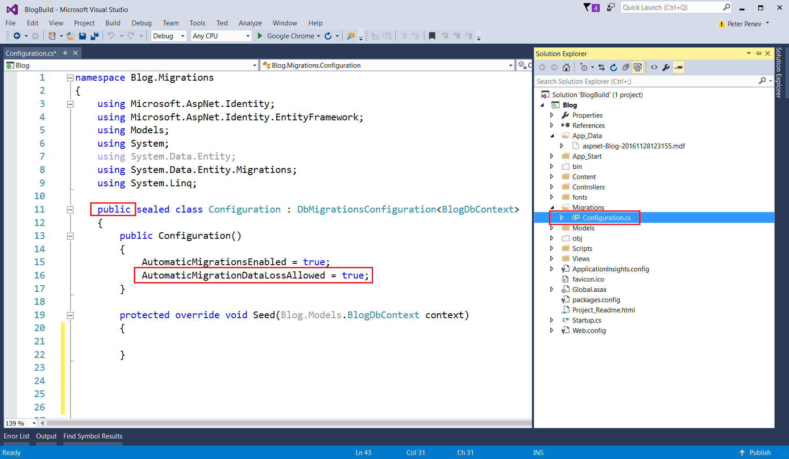

The last thing that you need to do is head to "**Startup.cs**" (it is in the root directory):

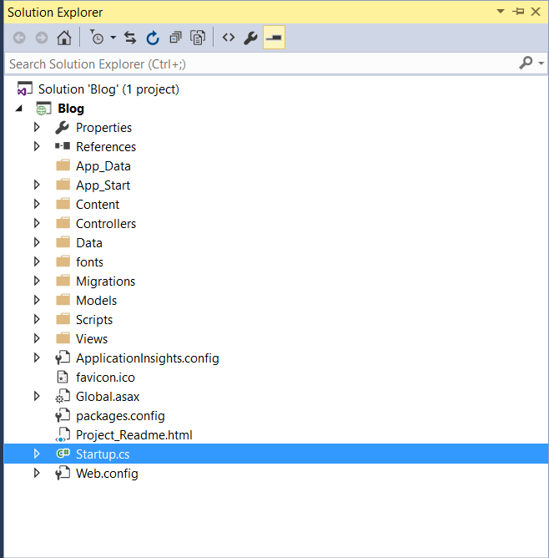

And add the following lines:

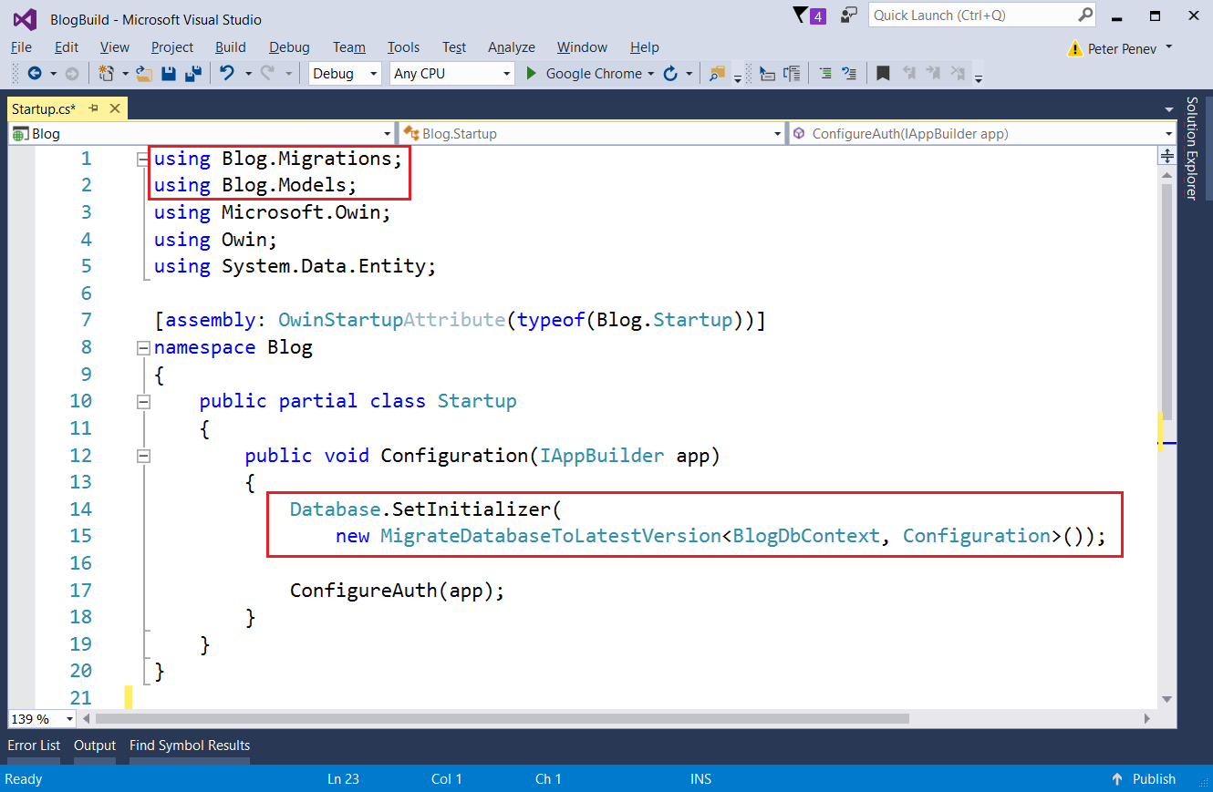

Don't forget to include the new usings with **[Ctrl + .]**

**Make sure** that you can **start the app**, **register a new user** and the User entity in the database has a full name column.

# Creating Article Entities

This is the moment we can actually **create something**. Let's start with articles.

For the articles, we will need a **controller** and a **model**. In the controller, we will have action for **listing all articles**, action for **creating an article**, action for **displaying a single article** and actions for **editing** and **deleting articles**. For each action, we need a **view**.

## Creating the Article Model

This is a class that will **hold information about a single article** and will be **saved in the database** (e.g. an **entity**). So, **create a new class** in the "**Models**" folder and name it "**Article**":

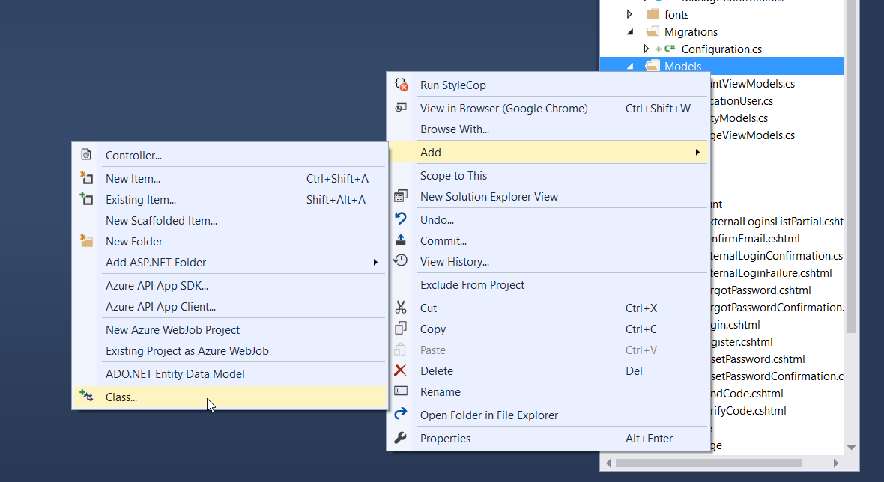

Add a public int property "**Id**" with an attribute [**Key**]:

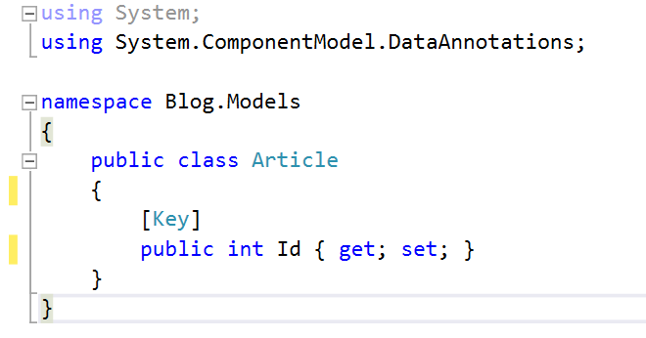

The attribute [**Key**] specifies that this is the [primary key](https://www.techopedia.com/definition/5547/primary-key) and is used to **identify** a record in the table (think of it as an **id**).

Now we need the other properties of an article: Title, Content, Date Added and Author.

The **title** will be with a maximum length of 255 characters and will be **required**, so again, we can use an attribute to specify that:

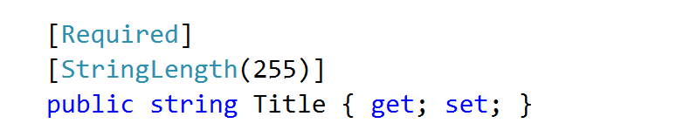

The **content** won't have any restriction to length and it can be an **empty** **string**, so:

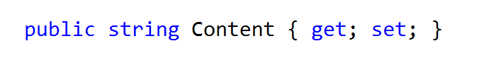

And we need an **author id**, which will be of type **string**:

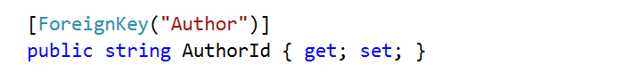

An author for the article, which will be of type ApplicationUser:



You can include the constructor and the properties in whatever order you choose as long as they are inside the class Article. However, the convention is for the constructor to be before the properties, so you can end up with something like this:

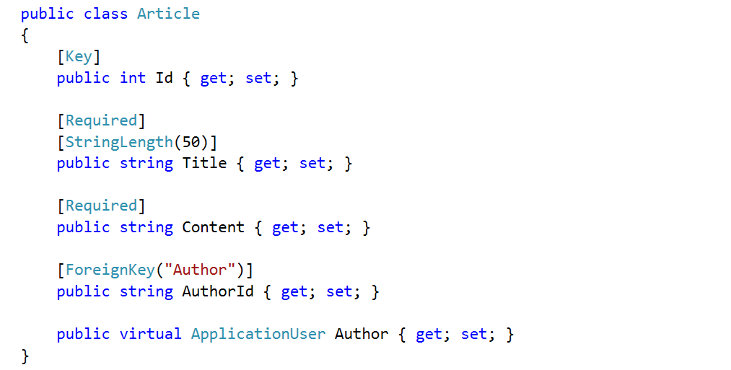

## Inserting Articles Manually

We want to test if the **entity is created properly** in the database. In order to check this, the database should know about articles. We can do this in the file "**Models/BlogDbContext.cs**".

The **database context** is the layer in our application that **communicates with the database**.

Just create a new property that is of type **public virtual IDbSet<Article>** and name it Articles:

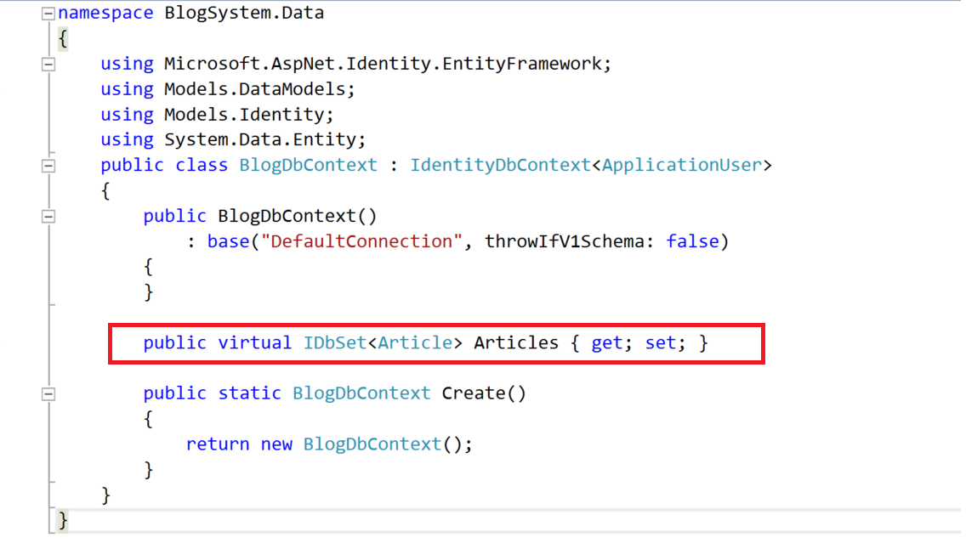

**Build the application** and then do something involving **modifying the database**, like registering a new user. After that you can see that in there is a new table called Articles:



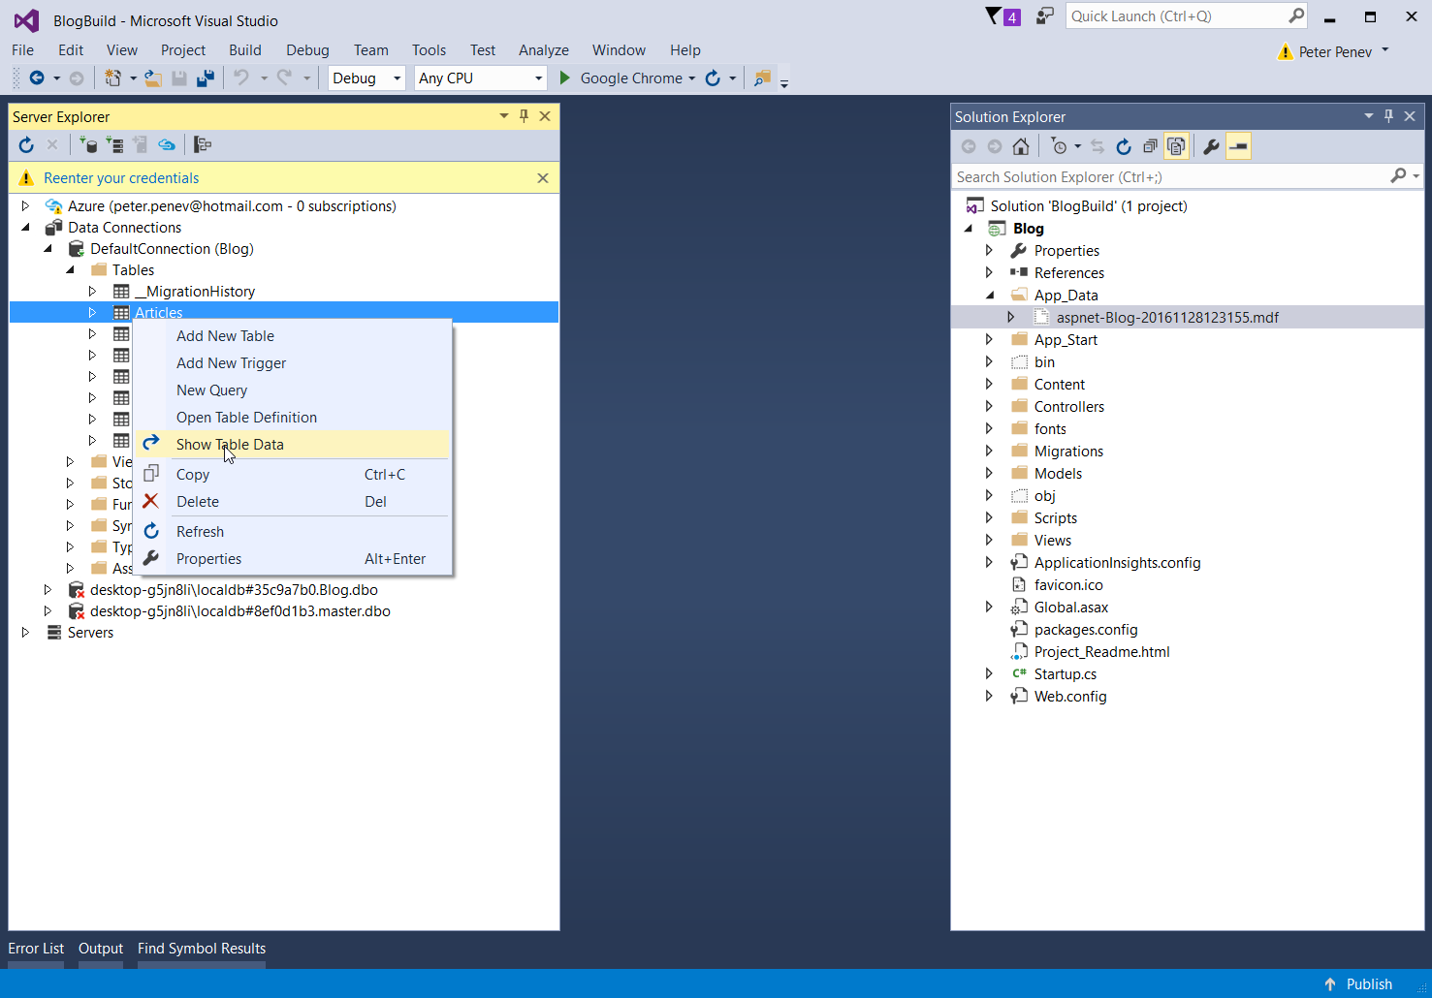



So, try to **insert some articles**. Just click on a field and **type some information in**. Make sure you copy and paste the **GUID** of some existing user, otherwise it won't let you to insert an article with an invalid or missing author.



The only problem is that we don't have a place in the blog where we see the articles. For this we will need an **Article Controller**.

## Creating the Article Controller

Head to the "**Controllers**" folder and create a new **Controller**:

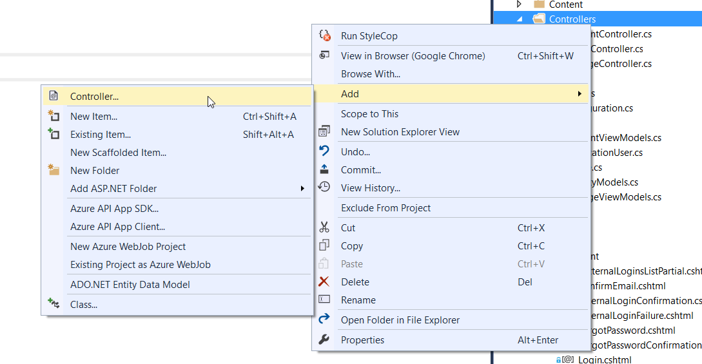

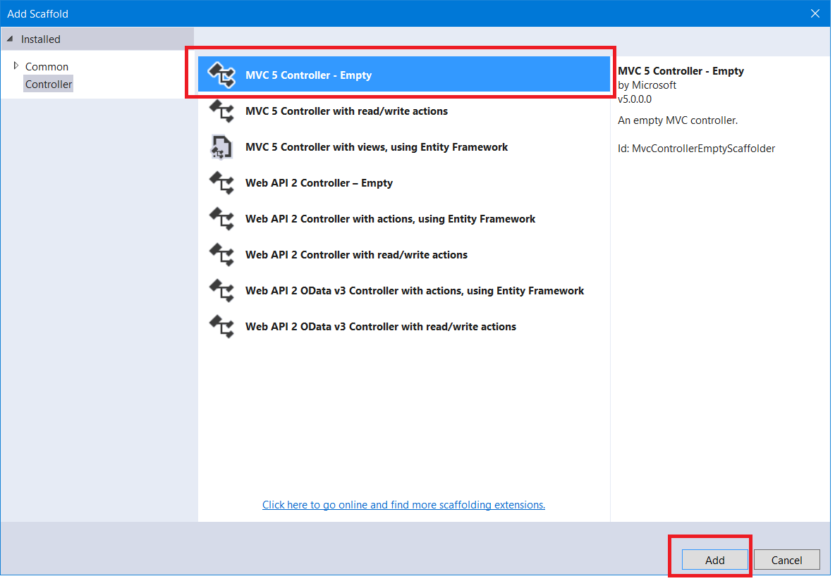

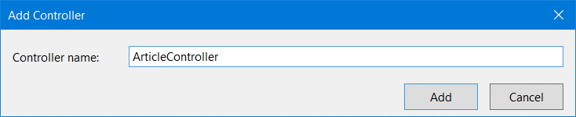

Create a new **method** (**Action**) in it called "**List**" and make the **Index()** action to redirect to it:

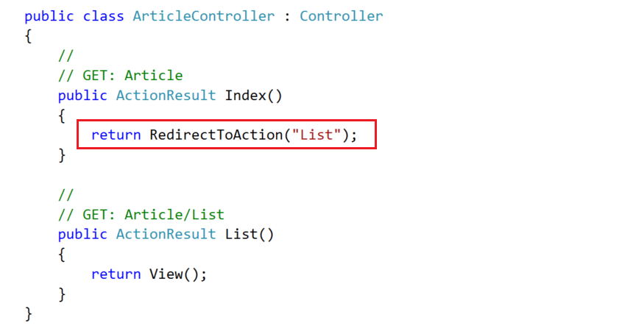

So, when the **Index()** action is called, it will automatically redirect to **List()**.

# List Articles

## Creating the Get Method

Now, head to the **List()** action:

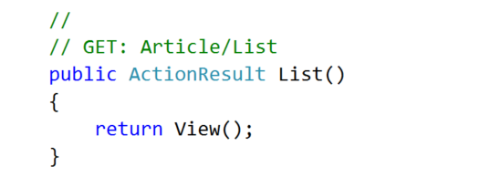

We need to **get all articles** from the database.

To do this, we need an instance of the class **BlogDbContext** and we need to **dispose** it after we are done with it, so we are going to place it inside a using block:

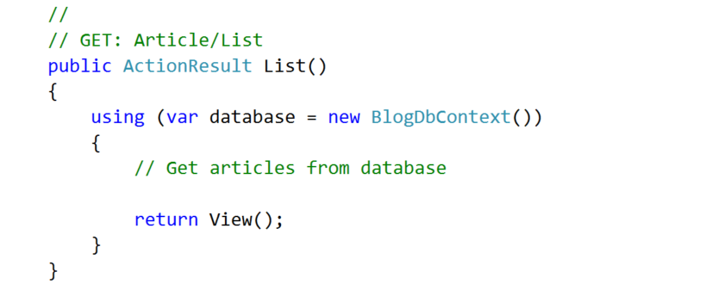

Now, using **LINQ**, we can **get all articles** and then **pass them to the view**:

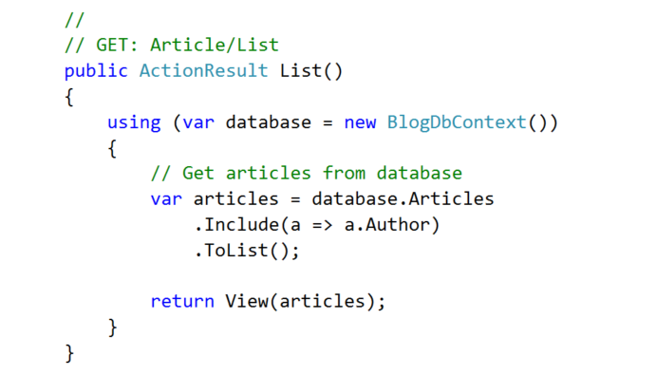

Notice the **".Include()**" statement. What it does is when we **materialize** the articles from the database, we need to **include information about their authors**. If we didn’t do that, the author would be left **null** and if we try to get information about the author inside the view, an **exception will be thrown**.

## Creating the View

Create a new view inside the "**Views/Article**":

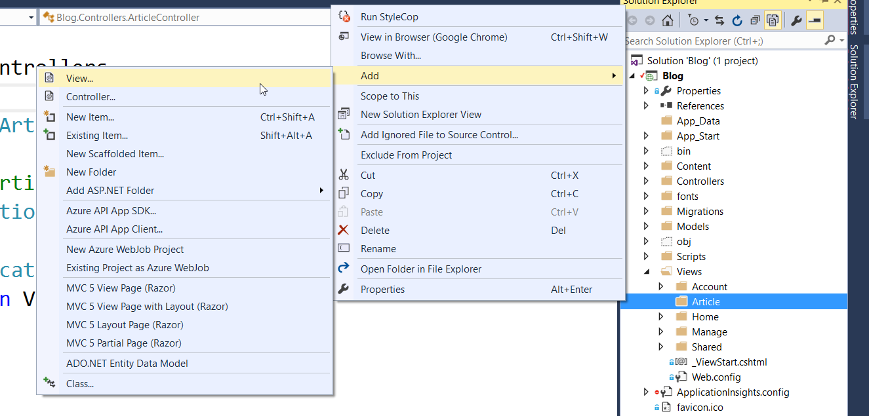

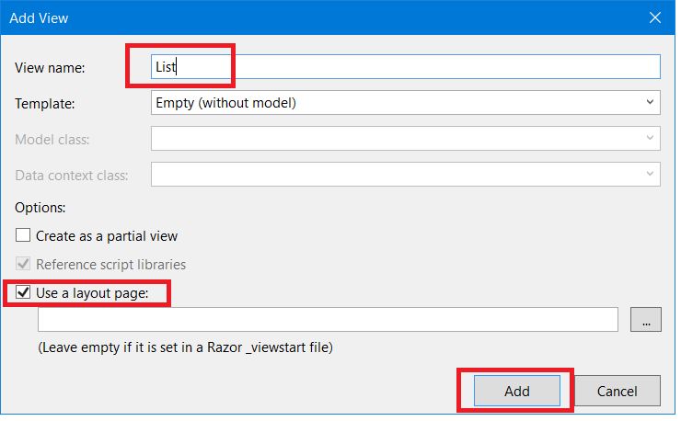

Paste this code in the view:

|  |
| --- |
| @model List<Blog.Models.Article>  @{  ViewBag.Title = "List";  }  <div class="container">  <div class="row">  @foreach (var article in Model)  {  <div class="col-sm-6">  <article>  <header>  <h2>  @Html.ActionLink(@article.Title, "Details", "Article", new { @id = article.Id }, null)  </h2>  </header>  <p>  @article.Content  </p>  <footer class="pull-right">  <small class="author">  --author @article.Author.FullName  </small>  </footer>  </article>  </div>  }  </div>  </div>  <hr /> |

Examine the code.

The view uses a **model**. On the first line is the statement that specifies the **type of the model** (which is **List<Article>**). Then, every time the **@Model** or **Model** is used, it basically is a **List<Article>**. So, we can iterate through it with a **foreach loop** and use the properties of the article to show them on screen.

**Notice also** that there is an **ActionLink** pointing to **Article/Details**. If you try to click it, it won’t work, because we haven't yet created neither the Details action, nor the view.

**While you are in the List view, start the application** and see what happens:

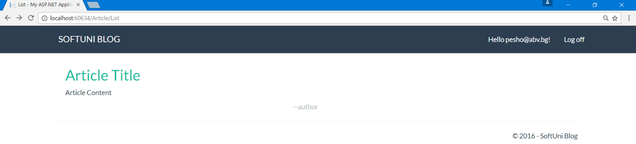

If you start the application from somewhere else, just type "**/Article/List**" or "**/Article**" after the localhost and you should see the above screen.

If you click the title you should get an error. We will fix that in a moment.

## Redirect to List Articles

The **listing of all articles** should be the **home page** of the blog. It is really easy to do that. We need to redirect to the **Article/List** action from **Home/Index** action:

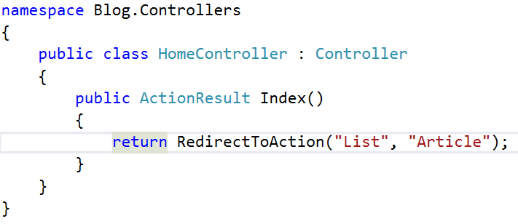

This should **redirect** you to the **List()** method of the **Article Controller** whenever you try to access the home page.

But there is a problem. When you **click on the article title** to view it, an **exception is thrown**.

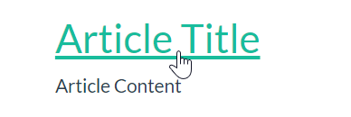

We need to implement **Article Details**.

# Article Details

## Creating the Get Method

In the Article controller, create an action called Details.

The integer parameter should be **nullable** (**int?**), e.g. it can have a null value (unlike a normal **int**), just like an object:

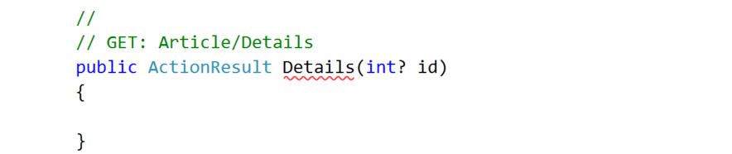

We should **check if it is null** (e.g. something went wrong in the request):

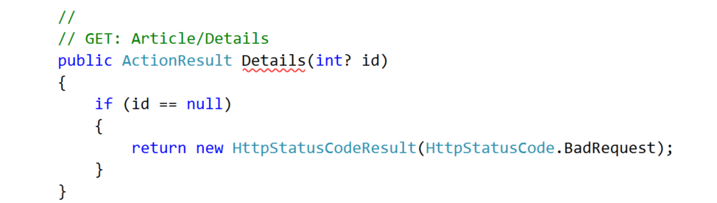

Now we need an **instance** of the **database context** and a query for the article by its id:

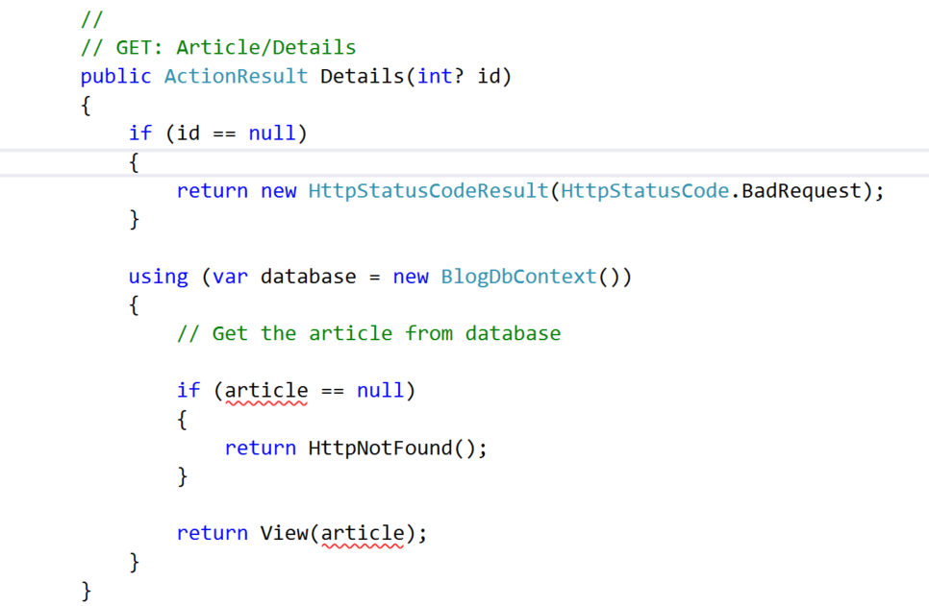

Fetch the article using this **LINQ** query:

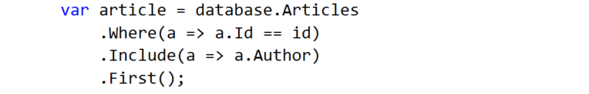

You can see how the **id is passed** to the action inside the List view:

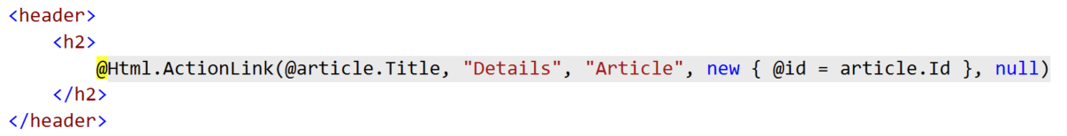

It is passed as a **parameter in the action link**.

## Creating the View

The above action gives the view an article. Now we need to show it in the browser. Create a view called **Details** and paste the following code:

|  |
| --- |
| @model Blog.Models.Article  @{  ViewBag.Title = "Details";  }  <div class="container">  <article>  <header>  <h2>  @Model.Title  </h2>  </header>  <p>  @Model.Content  </p>  <small class="author">  --author @Model.Author.FullName  </small>  <footer class="pull-right">  @Html.ActionLink("Edit", "Edit", "Article", new { @id = Model.Id }, new { @class = "btn btn-success btn-xs" })  @Html.ActionLink("Delete", "Delete", "Article", new { @id = Model.Id }, new { @class = "btn btn-danger btn-xs" })  @Html.ActionLink("Back", "Index", "Article", null, new { @class = "btn btn-default btn-xs" })  </footer>  </article>  </div>  <hr /> |

There are some new elements in the code.

Inspect the buttons in the footer. There are three **Action Links**.

They are created with the helper method **@Html.ActionLink** which creates a link. The method takes as parameters the **display value** of the button (what it will show in the browser), **the action** and **the controller** to which the link points and **two anonymous classes**.

You can now test the Details view:

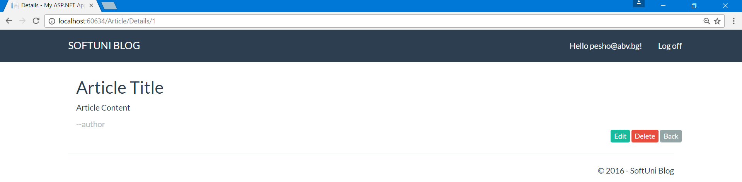

# Creating Articles

## Creating the Get Method

For article creation, we need two actions (**get** and **post**) and a view.

In **ArticleController**, create the first action called **Create**:

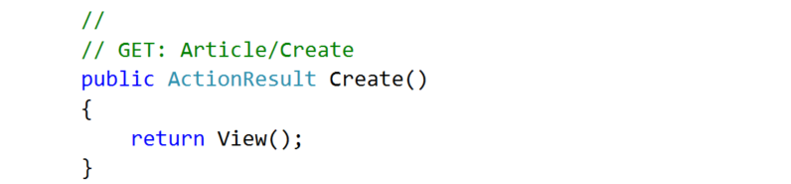

## Creating the View

Before we create the second method, lets create the view -> "**Views/Article/Create.cshtml**":

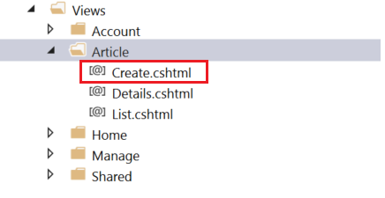

Paste the following code there:

|  |
| --- |
| @model Blog.Models.Article  @{  ViewBag.Title = "Create";  }  <div class="container">  <div class="well">  <h2>Create Article</h2>  @using (Html.BeginForm("Create", "Article", FormMethod.Post, new { @class = "form-horizontal" }))  {  @Html.AntiForgeryToken()  @Html.ValidationSummary("", new { @class = "text-danger" })  <div class="form-group">  @Html.LabelFor(m => m.Title, new { @class = "control-label col-sm-4" })  <div class="col-sm-4">  @Html.TextBoxFor(m => m.Title, new { @class = "form-control" })  </div>  </div>  <div class="form-group">  @Html.LabelFor(m => m.Content, new { @class = "control-label col-sm-4" })  <div class="col-sm-4">  @Html.TextAreaFor(m => m.Content, new { @class = "form-control", @rows = "7" })  </div>  </div>  <div class="form-group">  <div class="col-sm-4 col-sm-offset-4">  @Html.ActionLink("Cancel", "Index", "Article", null, new { @class = "btn btn-default" })  <input type="submit" value="Create" class="btn btn-success" />  </div>  </div>  }  </div>  </div> |

This should be already familiar. It's a **view** with a single form in which there are **text box** for title, **text area** for content and **two buttons**. One of the buttons **submits the form** and the other redirects to the home of the blog.

## Creating the Post Method

**Adding articles** to the database is done through the **post action method** that we mentioned earlier. Basically, once you hit the submit button you **send the information from the form to the action**.

Start with method creation:

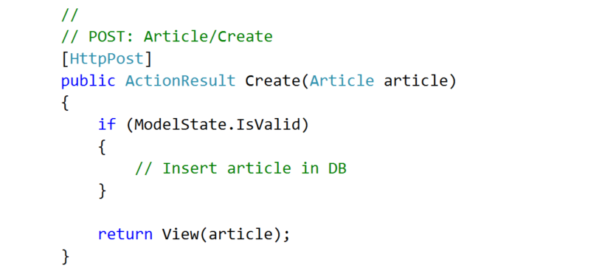

The **method receives** an **article model**. If the model is valid we can **insert it in the db**. If not, we just display the same page with the info from the model.

We can chop the article insertion into smaller problems:

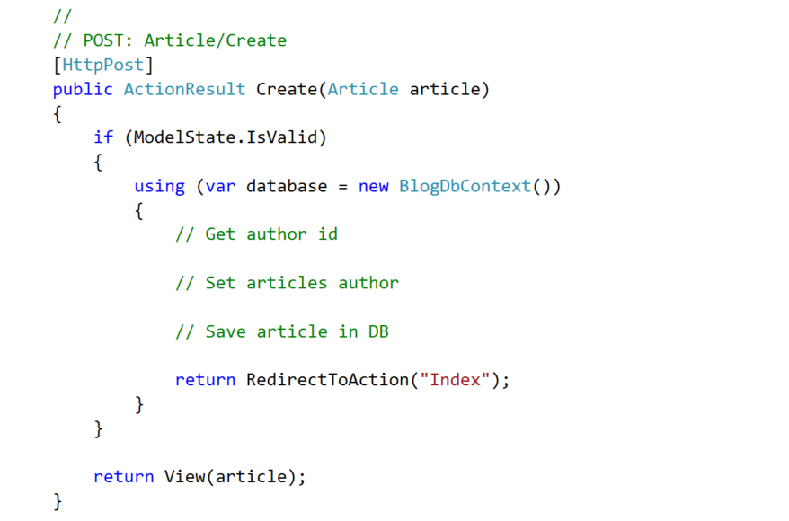

1. We can **get the author from the db** this way:

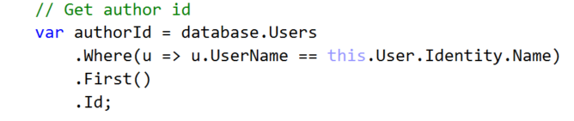

1. Now, **set the author of the article**:

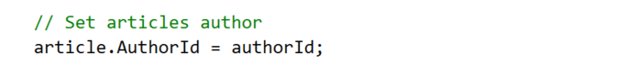

1. And **add the article** to the db:

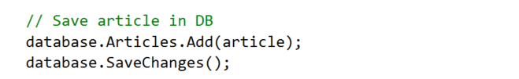

In the end, the **method should look like this**:

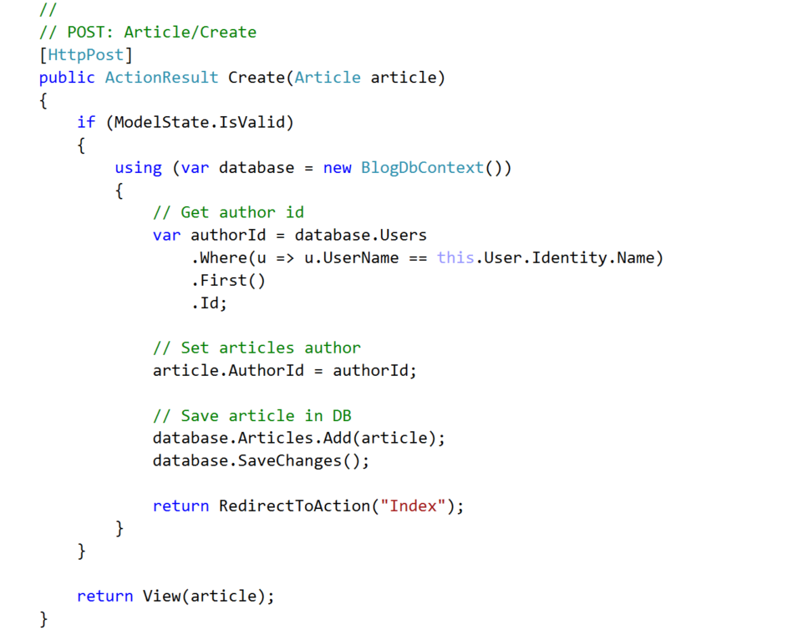

## Create Article Action Link

We need a link through which we can go to the create article page.

Just go to **"Views/Shared/_LoginPartial.cshtml"**. This is the view that handles the upper right navigation.

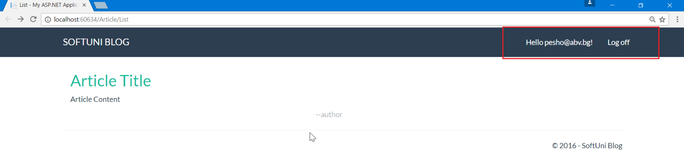

If you **inspect the view**, you will see that there is a **conditional statement** there. If the user is logged, it shows some links. If no one is logged, it shows different links.

Inside the logged user part add a new list item:

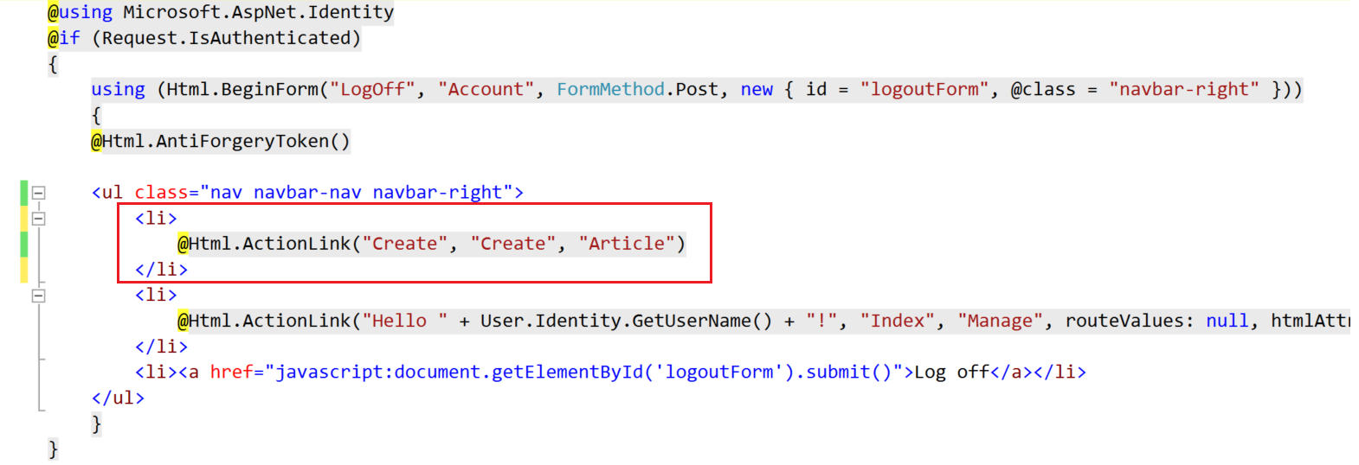

This will create a link with display in the browser "**Create**", pointing to "**Create**" action inside the "**Article**" controller.

You can now test if the article creation actually works:

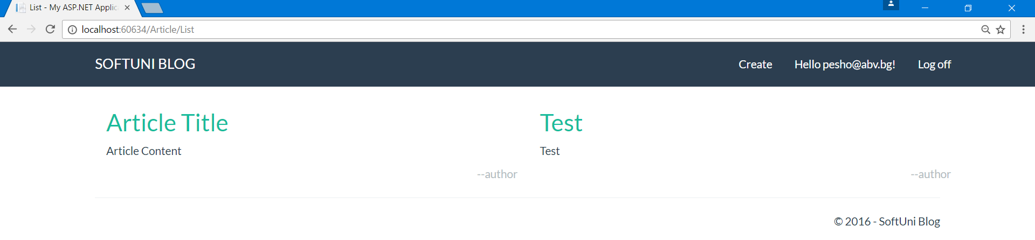

# Deleting Articles

## Create the Get Method

Deleting articles follow the same pattern as creating them. A **get** and a **post** method.

Create the **GET Method**:

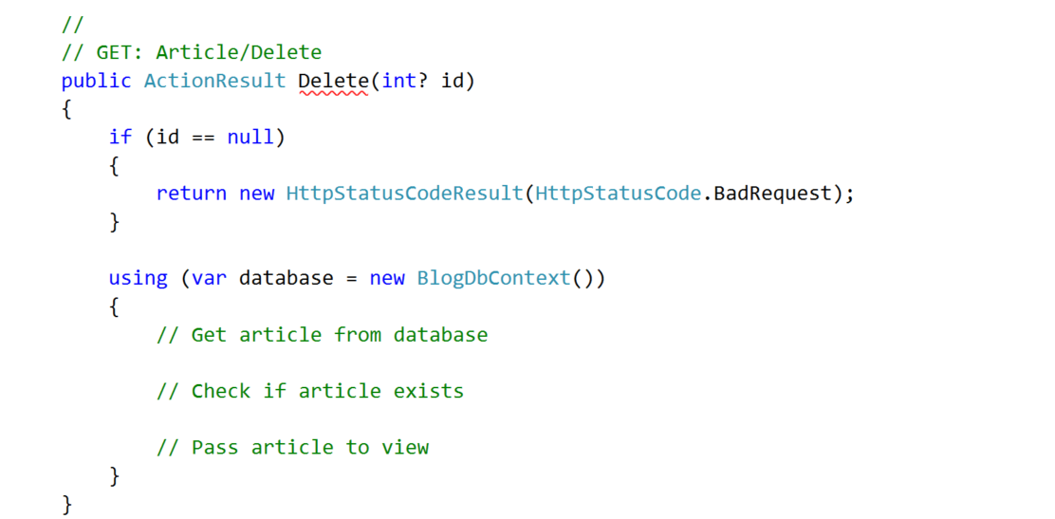

It should **receive an article id** so it would know **which article to delete**. It also checks if the id is **valid**.

Then, **get the article** from database and if it exists, pass it to the **Delete** **View**:

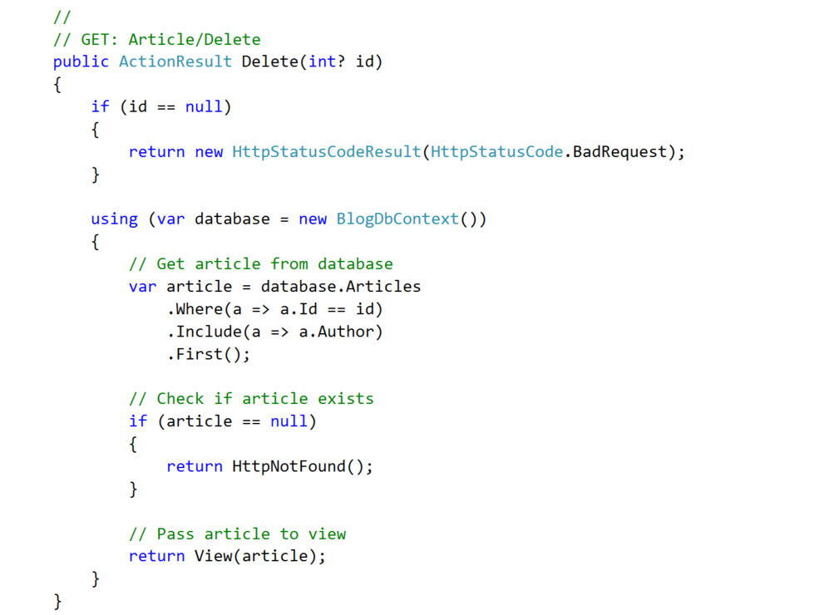

## Create the View

The above method directs to a delete view, but it doesn’t exist yet.

Create a "**Delete**" view:

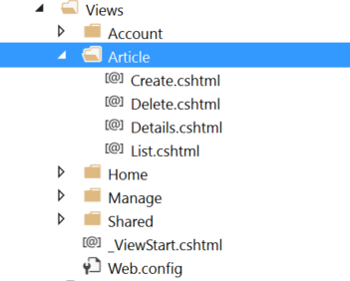

Paste the following code:

|  |
| --- |
| @model Blog.Models.Article  @{  ViewBag.Title = "Delete";  }  <div class="container">  <div class="well">  <h2>Delete Article</h2>  @using (Html.BeginForm("Delete", "Article", FormMethod.Post, new { @class = "form-horizontal" }))  {  @Html.AntiForgeryToken()  <div class="form-group">  @Html.LabelFor(m => m.Title, new { @class = "control-label col-sm-4" })  <div class="col-sm-4">  @Html.TextBoxFor(m => m.Title, new { @class = "form-control", @readonly = "readonly" })  </div>  </div>  <div class="form-group">  @Html.LabelFor(m => m.Content, new { @class = "control-label col-sm-4" })  <div class="col-sm-4">  @Html.TextAreaFor(m => m.Content, new { @class = "form-control", @readonly = "readonly", @rows = "7" })  </div>  </div>  <div class="form-group">  <div class="col-sm-4 col-sm-offset-4">  @Html.ActionLink("Cancel", "Index", "Article", null, new { @class = "btn btn-default" })  <input type="submit" value="Delete" class="btn btn-danger" />  </div>  </div>  }  </div>  </div> |

This is the same as the Details view, but the **text boxes are populated** with the **articles information** and you can't edit it.

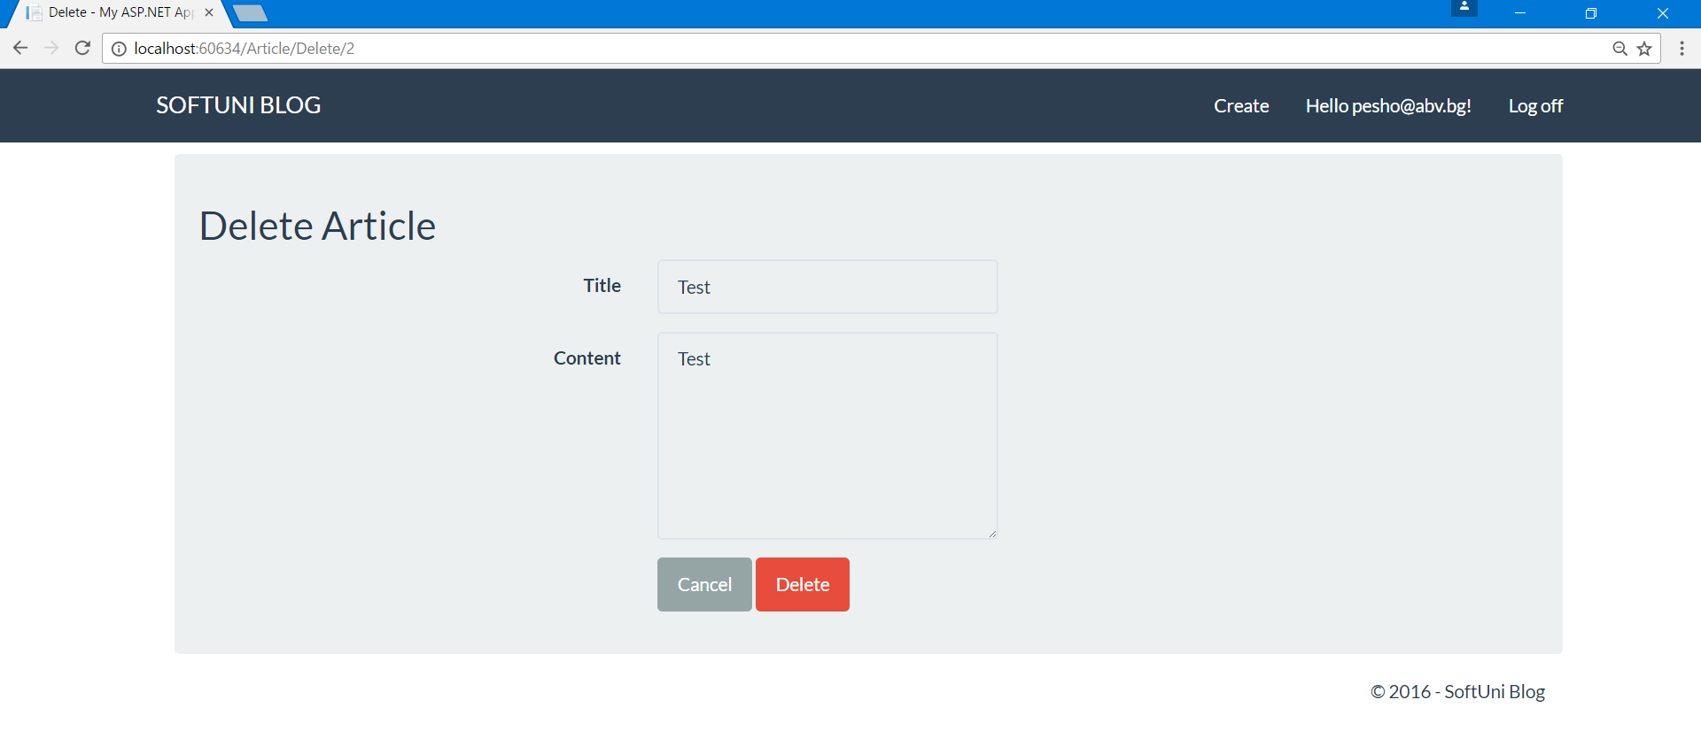

## Create the Post Method

When you click on the "**Delete**" button (this is actually the submit of the form) you are sent to the **POST Method** in the controller.

Let's create it:

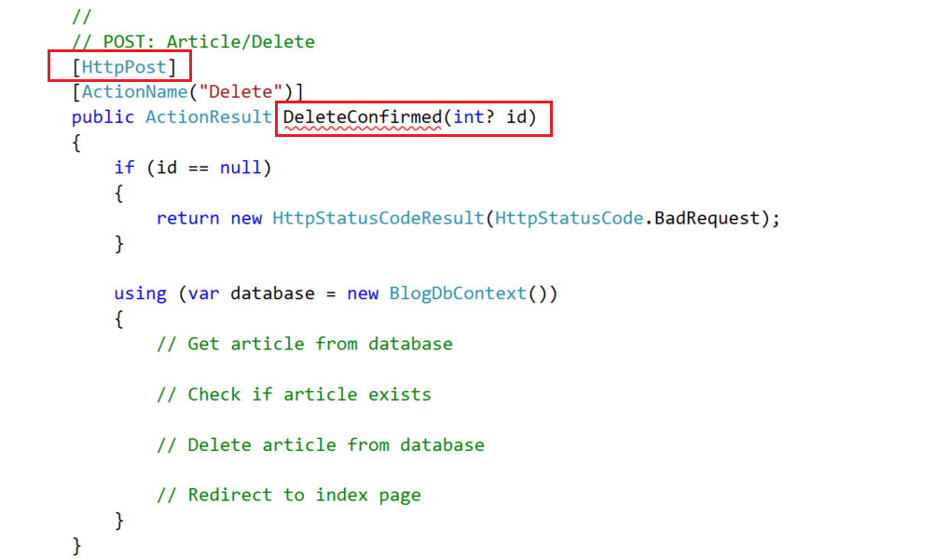

Make sure you add the attribute [**HttpPost**].

You can see that if we name the method "**Delete**" it will have the same signature as the **GET Method**. So we can name it **DeleteConfirmed**. But this way, the route to the method will not be valid (it responds to **Article/Delete/Id**). So, we fixed this by adding the attribute [**ActionName("Delete")**].

1. Now, let’s **get the article** form the database:

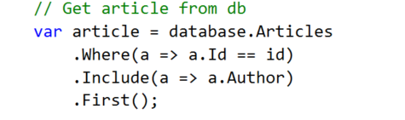

1. **Check** if the article exists:

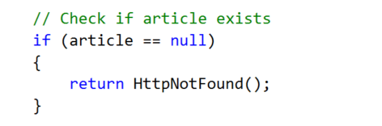

1. **Delete** the article:

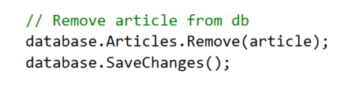

1. And, **redirect** to the index page:

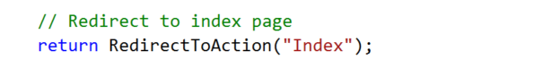

Test if you can delete an article:

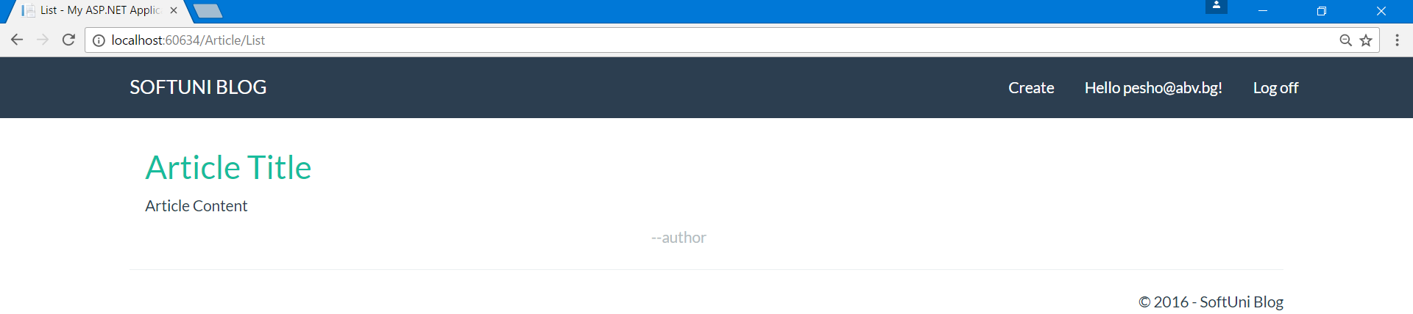

# Editing Articles

For editing articles, we are going to create a view model.

## Creating the View Model

This is the same as creating regular models. Just create a class named **ArticleViewModel** in the models folder:

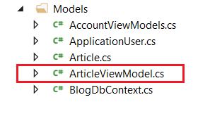

Inside the new class, we will have the properties we need to be edited in the view - **Title** and **Content**. But aside from them we will need properties for **article id** and **author id**, so we can keep track of them:

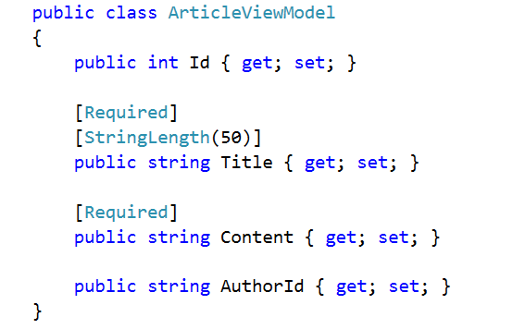

We are going to use the **ArticleViewModel** to edit an article and later on, to create one.

## Creating the Get Method

Again, editing articles follow the same pattern. A **get** and a **post** method.

Create the **GET Method**:

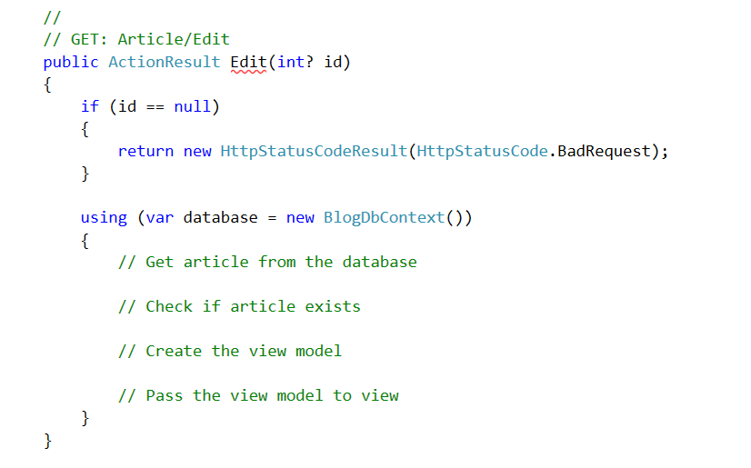

1. **Get** the article

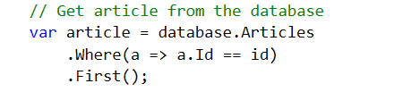

1. **Check** if it exists

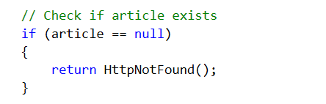

1. **Create** the view model

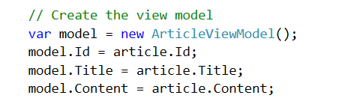

1. **Pass** it to the view

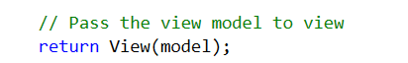

## Creating the View

You should be able to create the view by yourself.

Just kidding, paste the following code in the view:

|  |
| --- |
| @model Blog.Models.ArticleViewModel  @{  ViewBag.Title = "Edit";  }  <div class="container">  <div class="well">  <h2>Edit Article</h2>  @using (Html.BeginForm("Edit", "Article", FormMethod.Post, new { @class = "form-horizontal" }))  {  @Html.AntiForgeryToken()  @Html.ValidationSummary()  @Html.HiddenFor(m => m.Id)  @Html.HiddenFor(m => m.AuthorId)  <div class="form-group">  @Html.LabelFor(m => m.Title, new { @class = "control-label col-sm-4" })  <div class="col-sm-4">  @Html.TextBoxFor(m => m.Title, new { @class = "form-control" })  </div>  </div>  <div class="form-group">  @Html.LabelFor(m => m.Content, new { @class = "control-label col-sm-4" })  <div class="col-sm-4">  @Html.TextAreaFor(m => m.Content, new { @class = "form-control", @rows = "7" })  </div>  </div>  <div class="form-group">  <div class="col-sm-4 col-sm-offset-4">  @Html.ActionLink("Cancel", "Index", "Article", null, new { @class = "btn btn-default" })  <input type="submit" value="Edit" class="btn btn-success" />  </div>  </div>  }  </div>  </div> |

It should result in this:

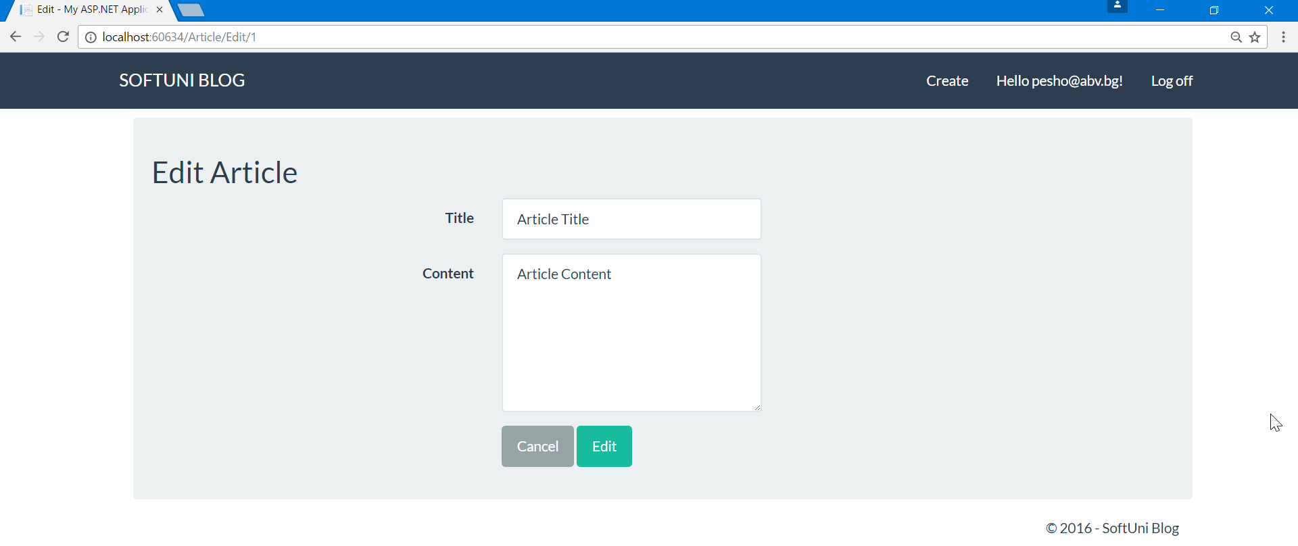

## Creating the Post Method

We can also use the view model In the **Post Method**. This is done **through method parameters**:

**Create the method**:

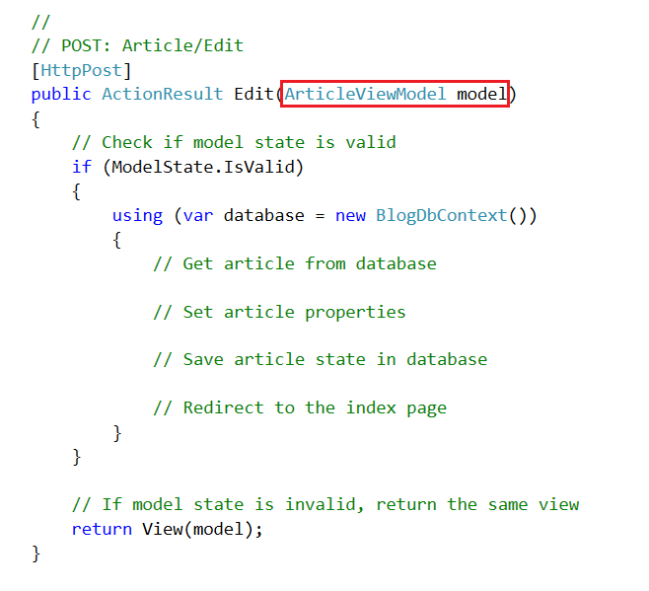

To implement the method:

1. First, **get the article** from the database

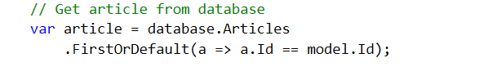

1. Next, **set article's** new **values**

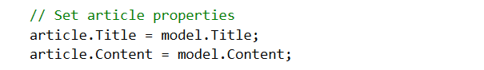

1. **Set the article state** to modified

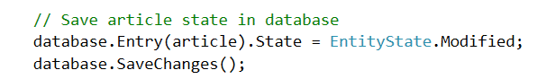

1. **Redirect** to the **index page**

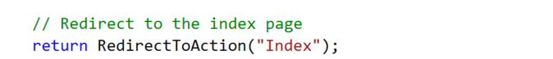

# Validations

## Validating Create Article

Right now, **everyone can use the routing** to get to article creation and **to create an article**. Only registered users should be able to do that.

The only thing we need to do is to **add an attribute** over the **Create Article Actions**:

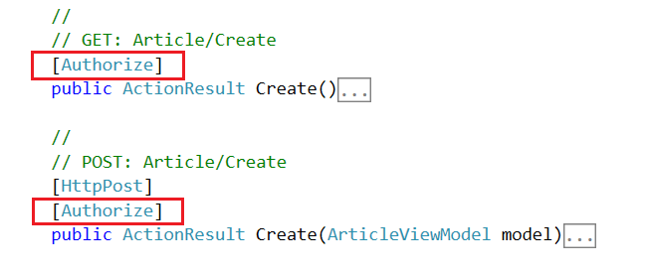

If you now try to create an article when you are not registered, you won't be able to.

## Creating a Helper Methods

Let's create a method inside the **Article Class** that checks **if a given user is its author**:

It is a really simple method:

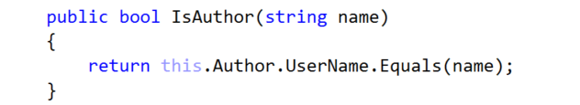

We can use the name of a user because usernames are unique.

The second method will be inside the **Article Controller**. Again, it is pretty simple:

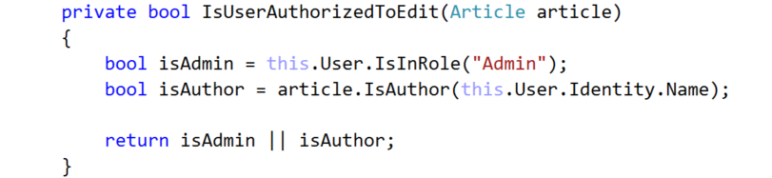

It **receives an article** and **checks weather the user is authorized** to edit it in any way. If he is the author the author of the article or the admin, he gets the permission.

## Hiding Edit and Delete

We want only article authors and admins to see the buttons for editing and deleting articles.

We can do this in the "**Views/Articles/Details** ".

Find the footer:

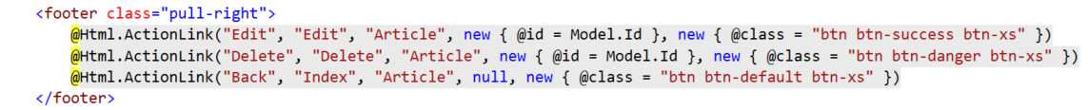

Add the following conditional and place only the edit and delete buttons:

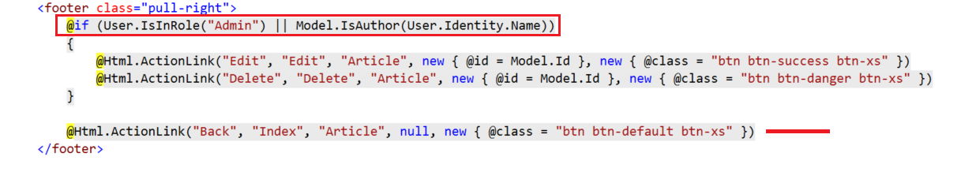

## Validating Delete Requests

The only thing left to do is to validate any requests for editing and deleting articles.

Go to the **Article/Delete** Action and **add the following validation**:

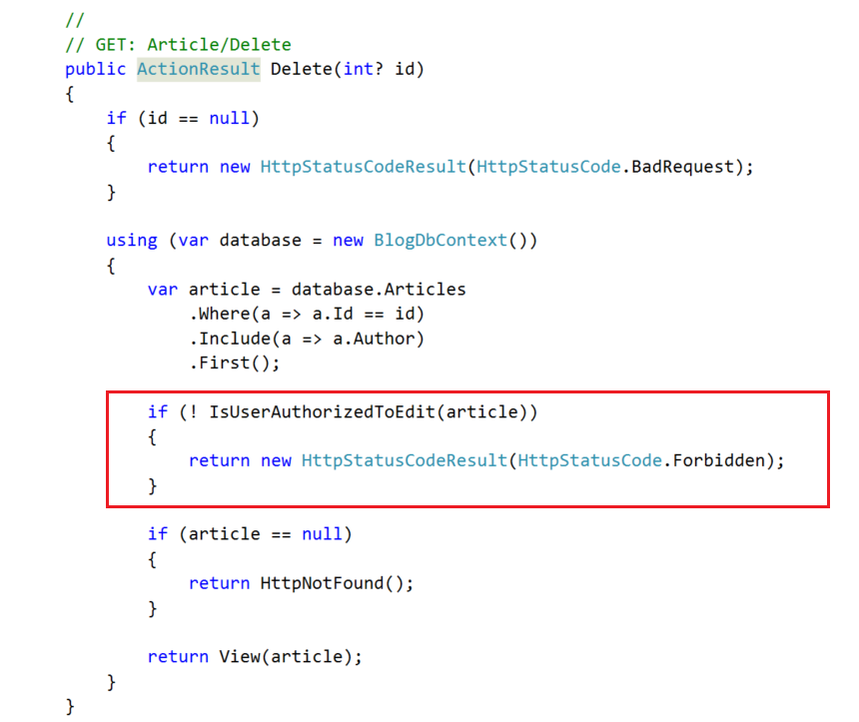

## Validating Edit Requests

Do the same as above but this time for the action **Article/Edit**.

## Test Edit and Delete Article

Test if you can **edit** or **delete** any articles, while you are not logged, logged as a user, being an author of an article.

Now we need to add the **Admin Role**.

# Roles

Roles in **ASP.NET** come readily implemented. All we need is create the actual roles and learn how to use them.

## Creating Roles

We can create the user roles in the **Seed Method**. This is a method which **runs every time the application starts** and "**seeds**" the database.

Head to "**Migrations/Configuration**":

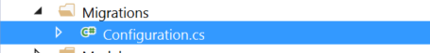

You should find the Seed method there. Delete the comments:

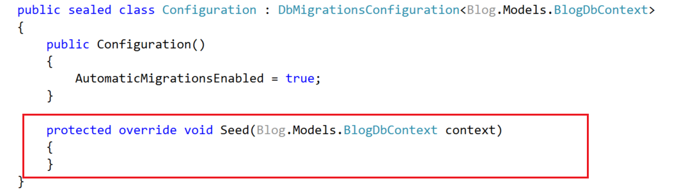

**If there are no roles** in the database, we should **create admin and user**:

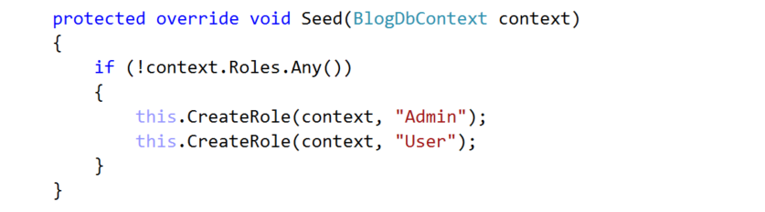

There is only **one check just for simplicity**. Maybe you should **check for admin role** and **user role separately**. If you want **do this on your own**.

Let's create the "**CreateRole**" method. It should be inside the class, but outside of other methods:

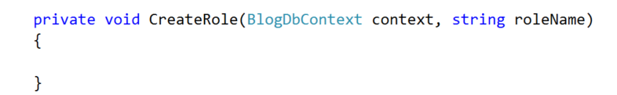

First of all, we need a **role manager**. This is a class that **manages the roles in our app**:

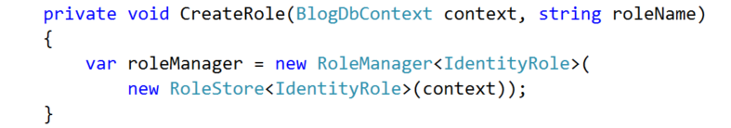

The **role manager** can create a new role by a given name:

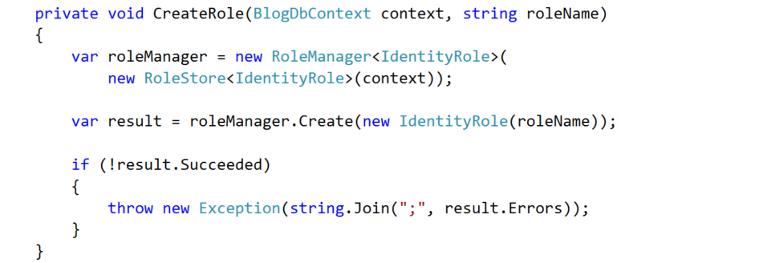

Finally, we need to **check** if the **creation** **was** **successful**. **If not**, we need to **throw an exception**.

## Creating the Admin

If there are no users in the database, we need to **create an admin**.

Head back to the **Seed Method** and check if there are users in the db:

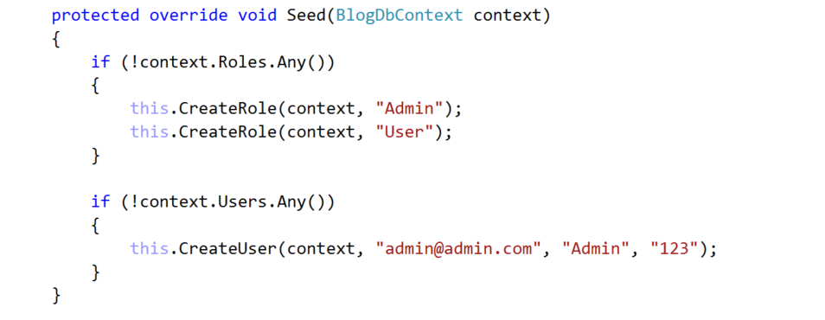

Create the "**CreateUser**" method. It receives a **database context**, **email**, **full name** and **password**.

We have several steps to complete that are listed inside the method:

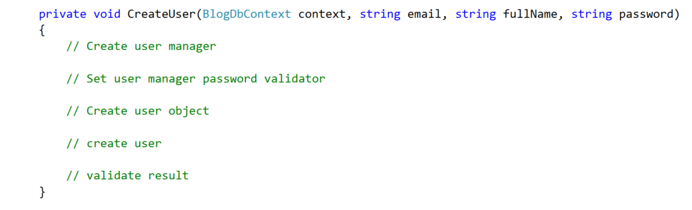

To create a user, we need a **user manager**. This is a class that is analogous to the **role manager** but handles users:  
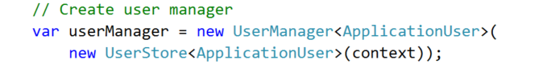

The **user manager** needs a **password validator**, to be able to create a user with a password:

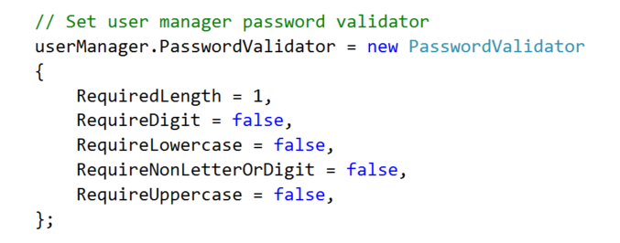

After that, we create a user object:

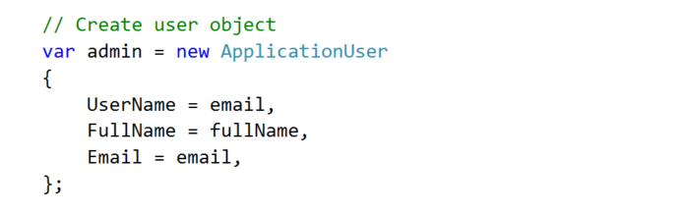

The **user manager** can now **create a user**:

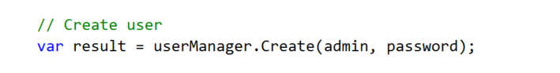

And finally, we need to **validate** the result:

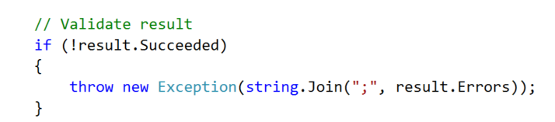

## Set Admin Role to Admin

After we have a user that will be admin, we need to **set him the actual role**.

Head back to the **Seed Method** and add the following line:

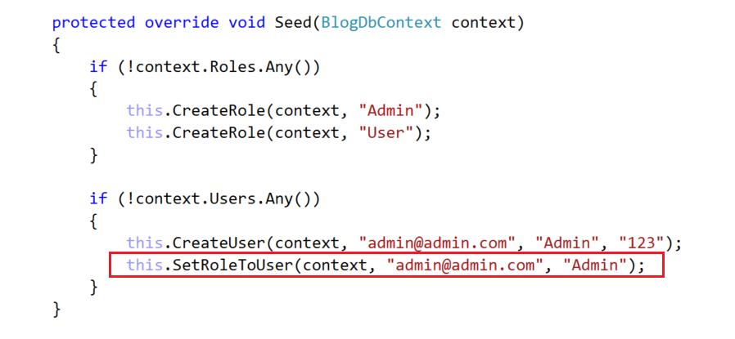

This is a new method that will set the role.

This is the whole method:

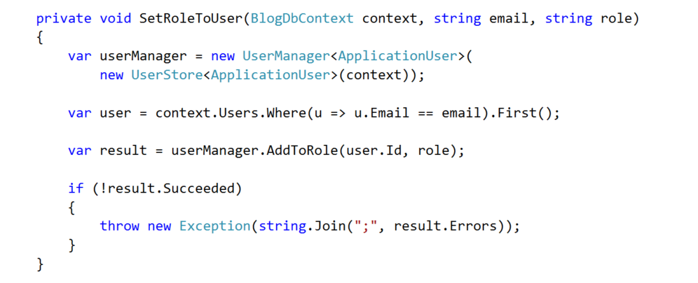

What it does:

1. It **creates a user manager**
2. **Gets the user from the db** by his email
3. The user manager **adds the role to the user**
4. **Validates** if the operation was successful

## Set a Role to All New Users

Every user that is registered should be **set to User Role automatically**.

You need to find the **Register** method in the **Account Controller**:

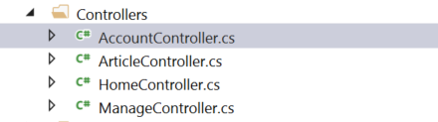

Add the following line:

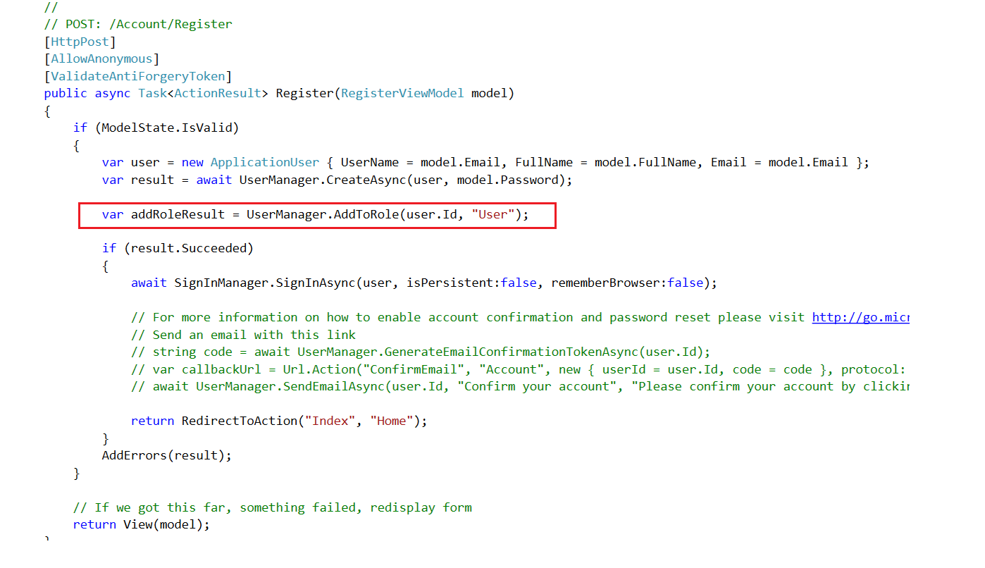

## Drop the Database

Go to **SQL Server Object Explorer**:

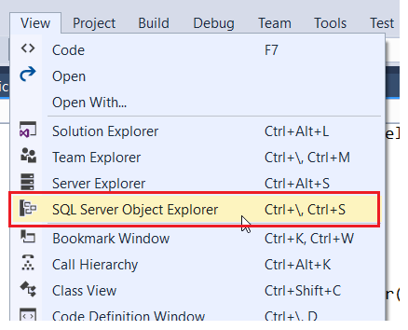

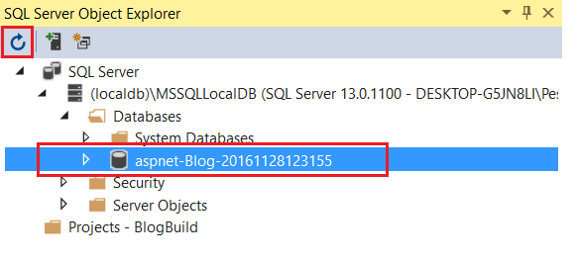

Make sure you click **Refresh**, so you are seeing the database and it should look like the db on the screenshot.

You are all set. Just delete the database and once you start the application again, the admin will be created with email "admin@admin.com" and password "123".

Test if you can login as admin:

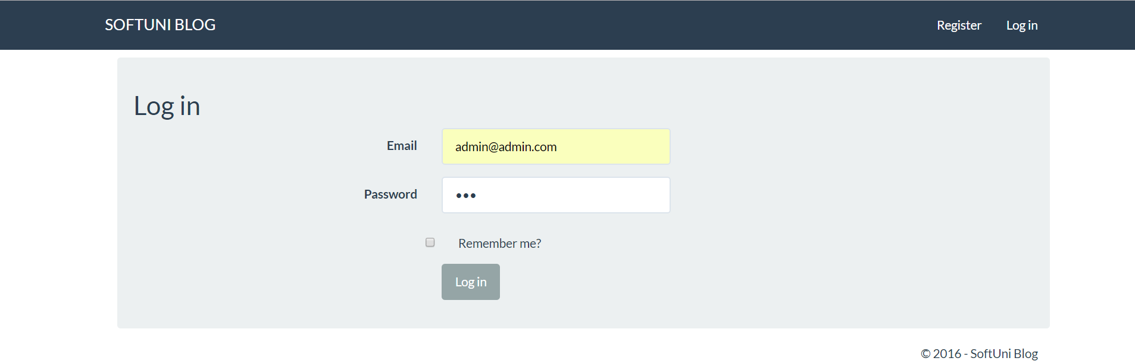

# Admin Panel

## Admin Dropdown Menu

If the user is admin, we want him to see additional button in the navbar:



We can do this by adding a conditional statement in the "**Views/Shared/_LoginPartial.cshtml**":

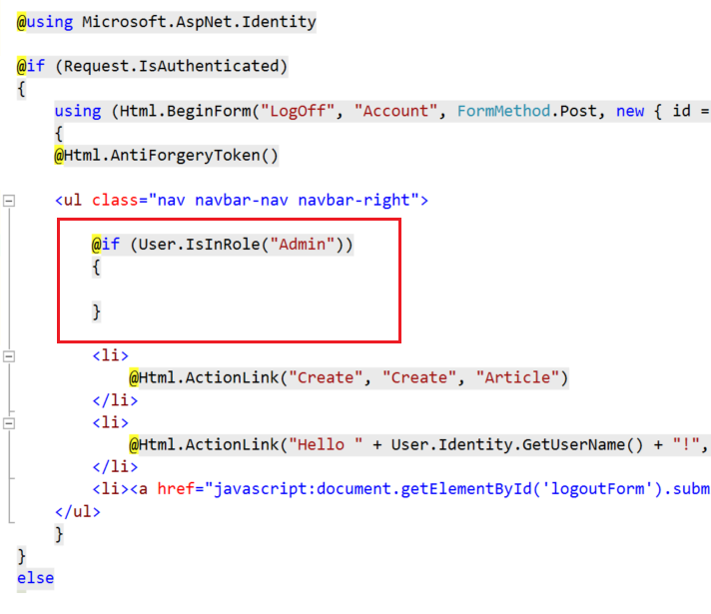

Paste this code inside the if statement:

|  |
| --- |
| <li class="dropdown">  <a href="#" class="dropdown-toggle" data-toggle="dropdown" role="button" aria-expanded="false">Admin<span class="caret"></span></a>  <ul class="dropdown-menu" role="menu">  <li>@Html.ActionLink("Users", "List", "User")</li>  </ul>  </li> |

This will create the **dropdown menu**. If you are logged as admin, you should see it.

## Creating User Controller

Go to the controllers' folder and create additional folder in it, called "**Admin**".

Inside the new folder create a new controller called **UserController**:

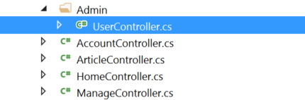

## List Users Action

Inside the new controller **create a new action name called List**, which will get all users from the database and pass them to the view.

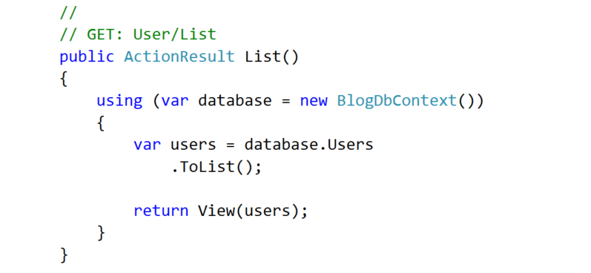

Make the **Index action to redirect to List action**:

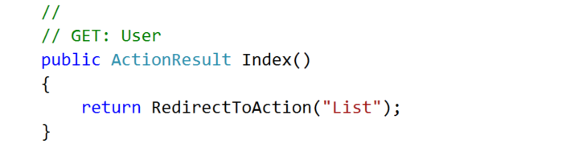

## List Users View

Create a new view inside "**Views/User**" called **List** and paste the following code:

|  |
| --- |
| @model List<Blog.Models.ApplicationUser>  @{  ViewBag.Title = "List";  }  <div class="container">  <div class="well">  <h2>Users</h2>  <table class="table table-striped table-hover">  <thead>  <tr>  <th>ID</th>  <th>Email</th>  <th>Actions</th>  </tr>  </thead>  <tbody>  @foreach (var user in Model)  {  <tr>  <td>@user.Id</td>  <td>@user.Email</td>  <td>  @Html.ActionLink("Edit", "Edit", "User", new { @id = user.Id }, null)  @Html.ActionLink("Delete", "Delete", "User", new { @id = user.Id }, null)  </td>  </tr>  }  </tbody>  </table>  </div>  </div> |

In this view, we are just listing users with some information about them and action links for editing and deleting users.

## Mark Admins

Now we want every user that is admin to be **visible in the table**. But right now, the view **does not know which user is admin** **and which user is not**. We need to pass that information to the view.

In the UserController create a new method:

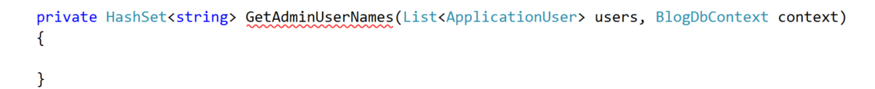

Inside the method, first, **create a user manager**:



Then, **get all user names** that are in the role "**Admin**":

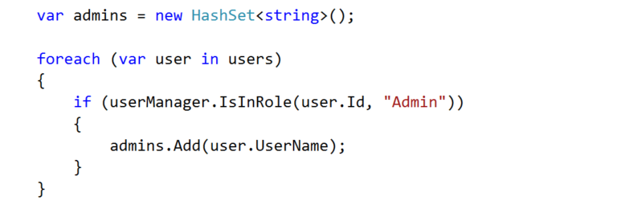

And then return the **hash set**:



Now, we can use the method where we need it, in the **List()** action:

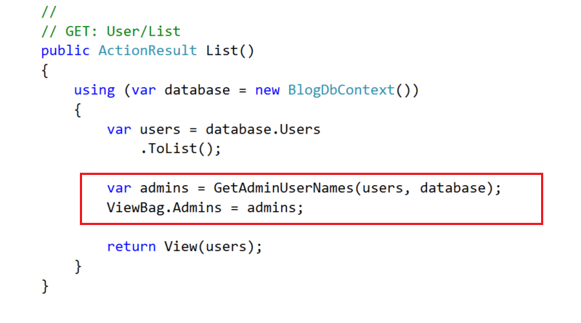

Above, you can see that we are using a **ViewBag**. This is a container in the view that can store anything that we pass.

Now we need to make the changes in the view. Go to **"Views/User/List.cshtml**" and find this code:

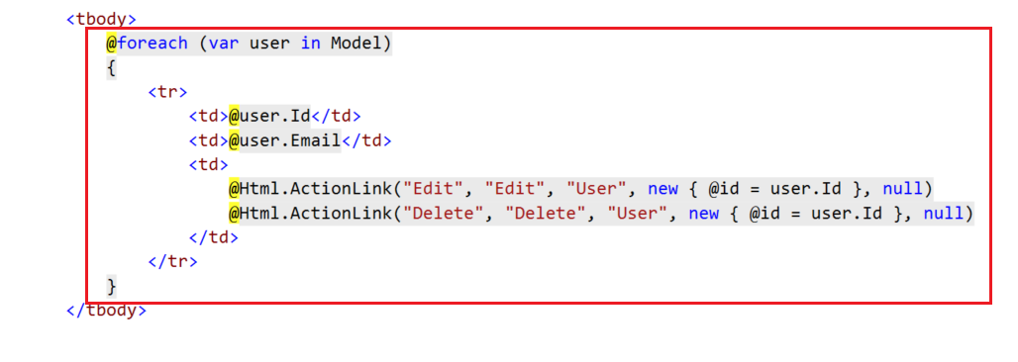

**Replace** it with this:

|  |
| --- |
| @foreach (var user in Model)  {  if (ViewBag.Admins.Contains(user.UserName))  {  @:<tr class="info">  }  else  {  @:<tr>  }  <td>@user.Id</td>  <td>@user.Email</td>  <td>  @Html.ActionLink("Edit", "Edit", "User", new { @id = user.Id }, null)  @Html.ActionLink("Delete", "Delete", "User", new { @id = user.Id }, null)  </td>  } |

In the above code, you can see how we are **using the admins** that we've added through the **ViewBag**.

You can test if the users are listed properly:

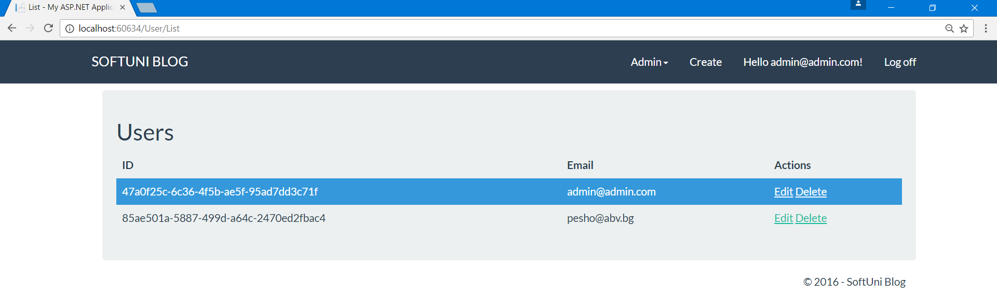

# Editing Users

Editing users will follow the same pattern as editing anything else. We need a **get method**, **view** and a **post method**.

But first we need some **classes that will help us make this easier**.

## Create Role Class

Go to the **models folder** and **create a new class called Role**. A role will have a **name** and a **Boolean value**:

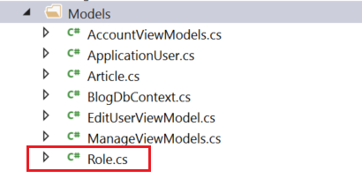

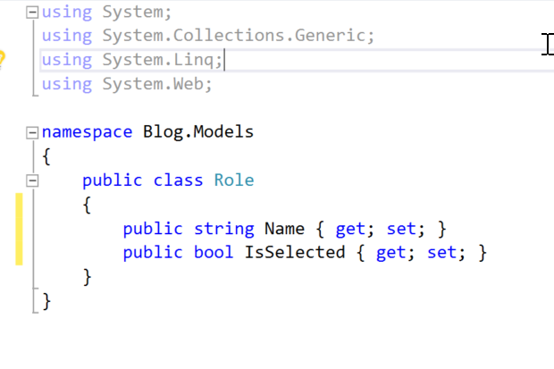

## Create a View Model

For this task, **we need a view model**. View models are classes that are **used solely for providing information to a view**.

In the models folder create a class called **EditUserViewModel**:

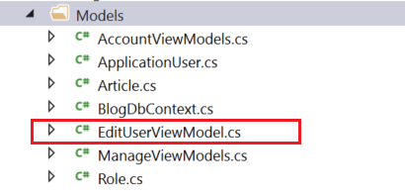

**The class will have everything we need to edit a user**: the user itself, properties for password and confirm password and a list of roles.

First, **add the user**:

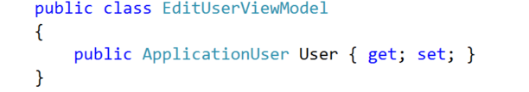

Next, **add the password** and **confirm password**:

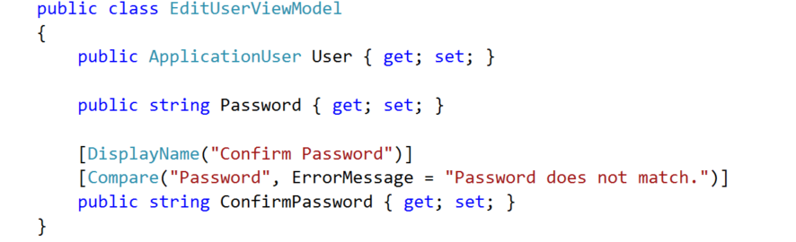

Notice that through the **attributes** we make sure that **the two will be the same**.

And lastly, add the list of roles:

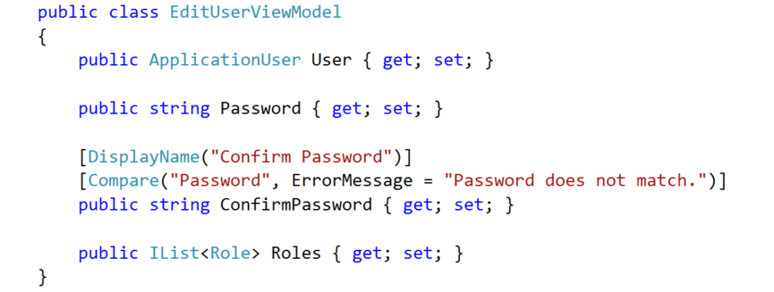

## Creating the Get Method

Inside the **Get method** we need to **instantiate the view model and fill it with information**. Let's think of that for a moment:

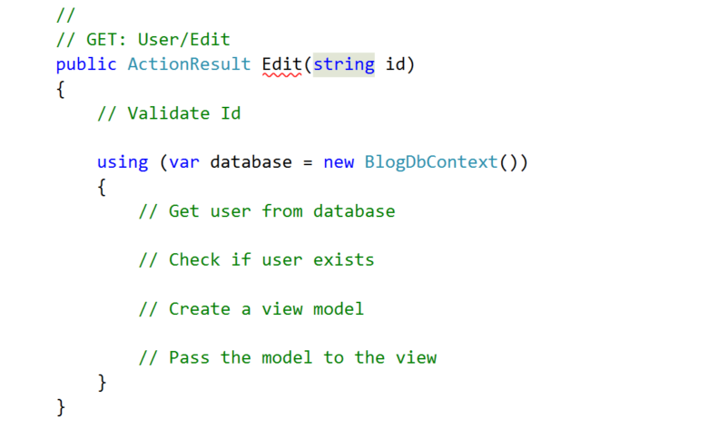

We need to check if the **id is valid** and then **create the view model** and **pass it to the view**. Let’s do that:

1. **Validate the Id**

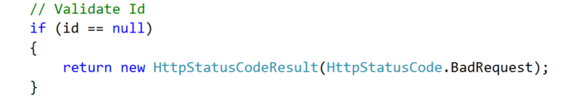

1. **Get the user** from the database

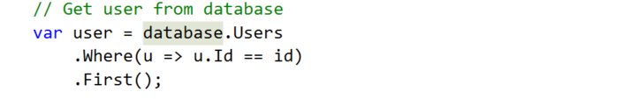

1. Check if the **user is valid**

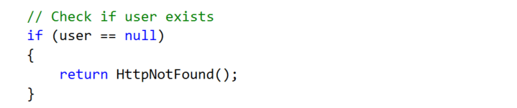

1. **Construct** the view model

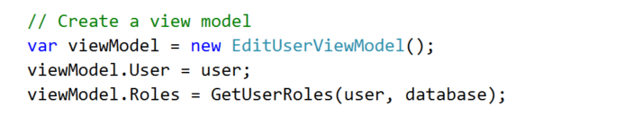

1. **Pass the constructed model** to the view



Notice that in step 4, we are using a method to get the user roles. Unfortunately, we can't do it so easily, so **we need a separate method** for it.

## Get User Roles Method

In order to get the all user roles, we are going to need both the role manager and the user manager. Also, we are going to collect all of the roles in a **List<Role>** and return it as a result.

Let’s view the pseudo code for the method:

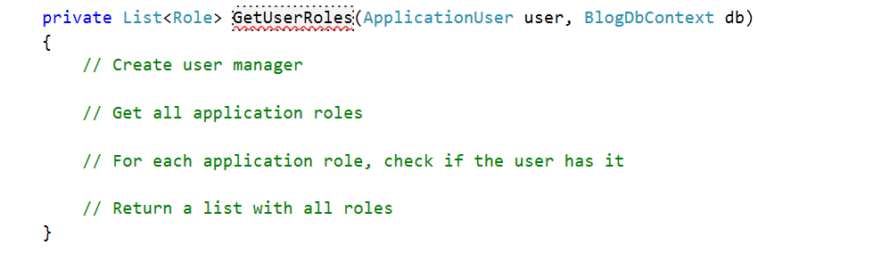

We are going to **get all roles**, no matter if the user is in it or not. For each role, we will **mark if the user is in it** (That is why we needed the property of the class **Role**, **IsSelected**). That way we can **tell the view which role will be checked** initially.

1. **Create the managers**. You are familiar with them already:

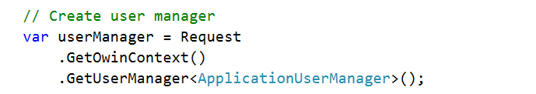

1. **Create a list** with the names of all roles

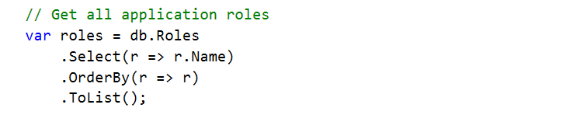

1. **Create a Role object** for each role and mark if the user is in it

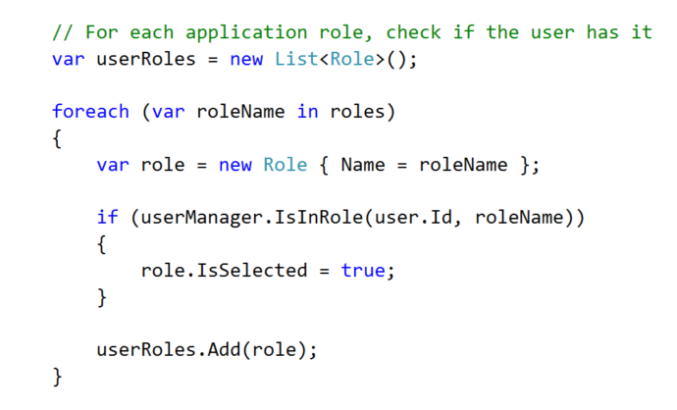

1. Return the **List<Role>**

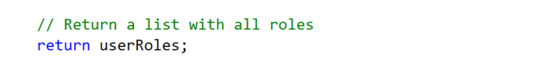

## Creating the View

Creating the view is straightforward. Create it inside "**Views/Use**r" and name it "**Edit**". **Copy and paste** the following code:

|  |
| --- |
| @model Blog.Models.EditUserViewModel  @{  ViewBag.Title = "Edit";  }  <div class="container">  <div class="well">  <h2>Edit User</h2>  @Html.ValidationSummary()  @Html.AntiForgeryToken()  @using (Html.BeginForm("Edit", "User", FormMethod.Post, new { @class = "form-horizontal" }))  {  <div class="form-group">  @Html.LabelFor(m => m.User.Email, new { @class = "control-label col-sm-4" })  <div class="col-sm-4">  @Html.TextBoxFor(m => m.User.Email, new { @class = "form-control" })  </div>  </div>  <div class="form-group">  @Html.LabelFor(m => m.User.FullName, new { @class = "control-label col-sm-4" })  <div class="col-sm-4">  @Html.TextBoxFor(m => m.User.FullName, new { @class = "form-control" })  </div>  </div>  <div class="form-group">  @Html.LabelFor(m => m.Password, new { @class = "control-label col-sm-4" })  <div class="col-sm-4">  @Html.TextBoxFor(m => m.Password, new { @class = "form-control" })  </div>  </div>  <div class="form-group">  @Html.LabelFor(m => m.ConfirmPassword, new { @class = "control-label col-sm-4" })  <div class="col-sm-4">  @Html.TextBoxFor(m => m.ConfirmPassword, new { @class = "form-control" })  </div>  </div>  <div class="form-group">  @for (int i = 0; i < Model.Roles.Count; i++)  {  <div class="col-sm-offset-4 col-sm-4">  @Html.HiddenFor(m => m.Roles[i].Name)  @Html.CheckBoxFor(m => m.Roles[i].IsSelected)  @Model.Roles[i].Name  </div>  }  </div>  <div class="form-group">  <div class="col-sm-4 col-sm-offset-4">  <input type="submit" value="Edit" class="btn btn-success" />  </div>  </div>  }  </div>  </div> |

The only thing that needs attention is how we are visualizing the **checkboxes for each role**. This is happening in a loop in which we use a helper method **@Html.CheckBoxFor()**. Also, we have a **hidden field**, that **helps to bind** the information **to the view model**, because **we need it in the post method**.

You can now test if the edit button and the view are working properly:

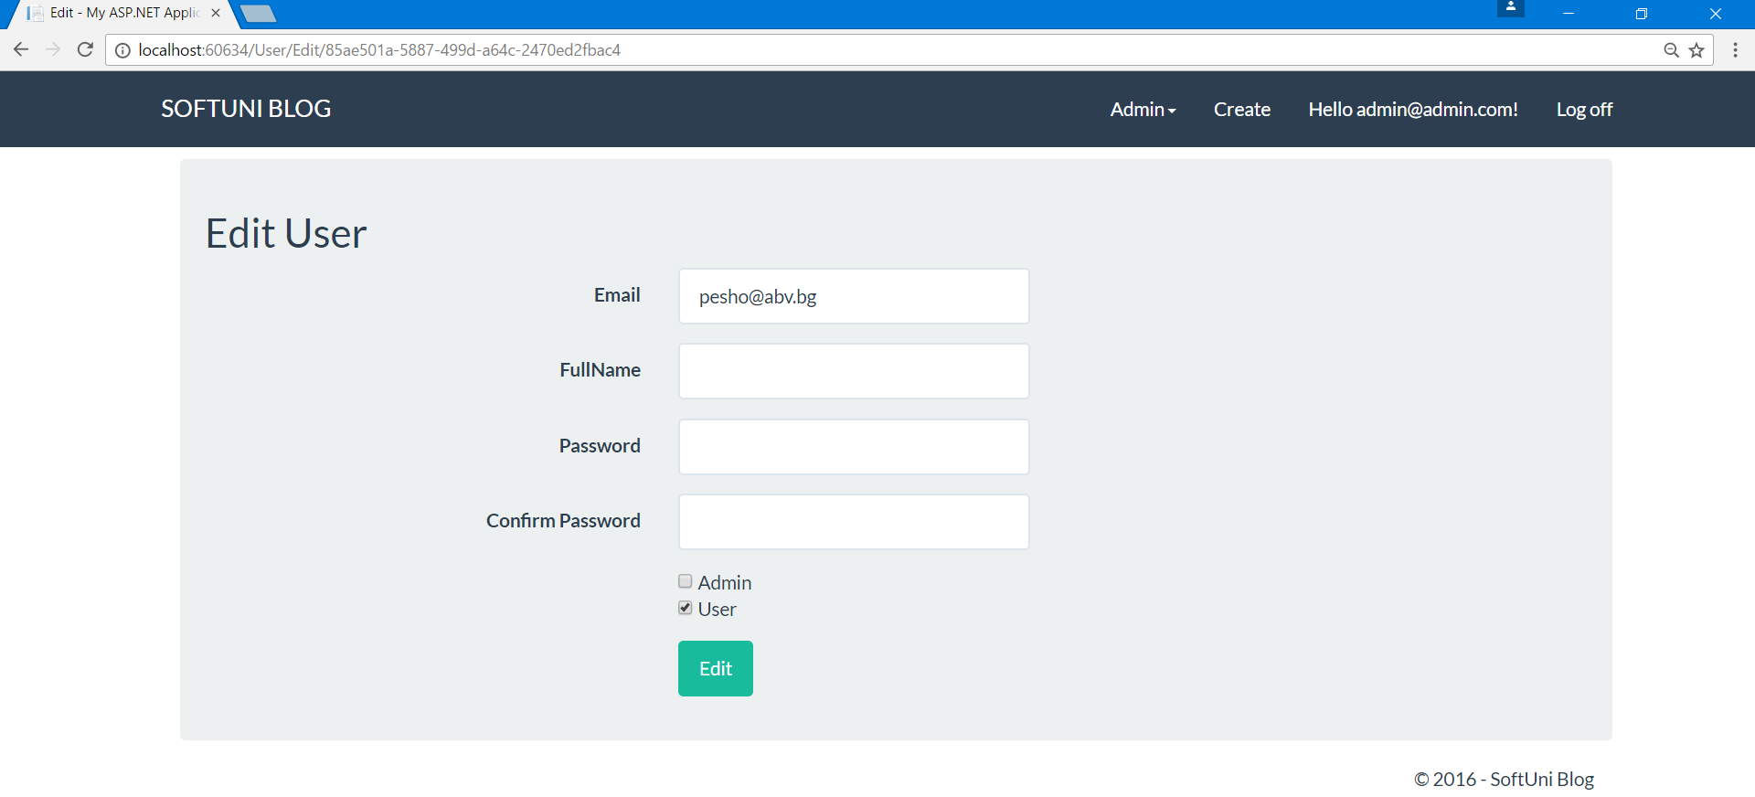

## Creating the Post Method

Let's examine the flow of this action:

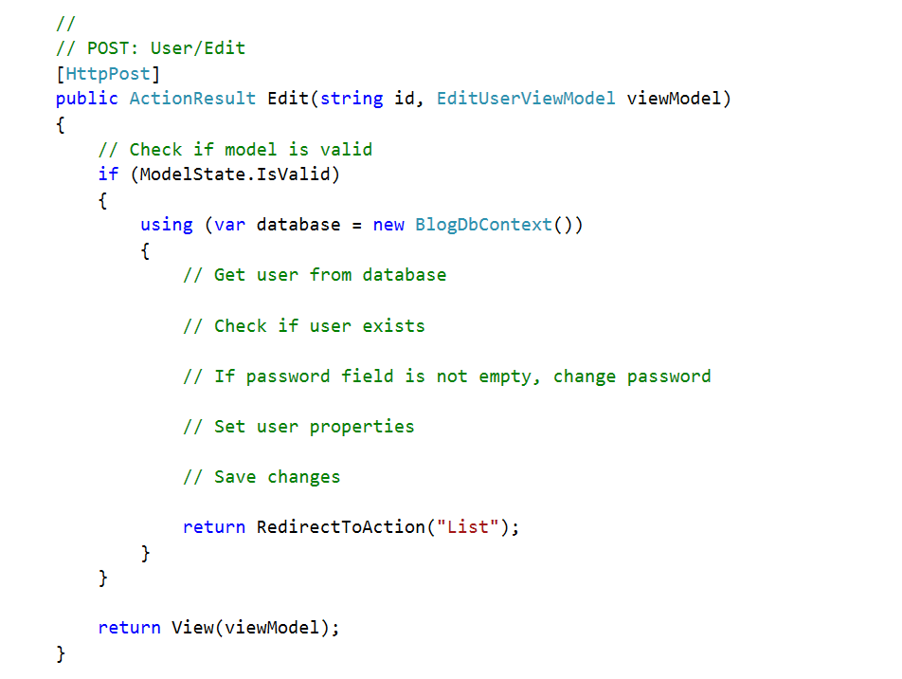

We receive an id and a view model as parameters. Next, we need to **check if the model state is valid** and after that we can perform everything else:

1. **Get the user** from database

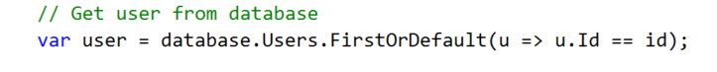

1. Check **if user is not null**

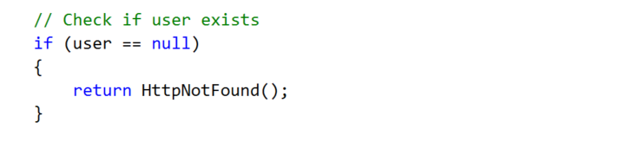

1. Check **if the admin** wants to change password

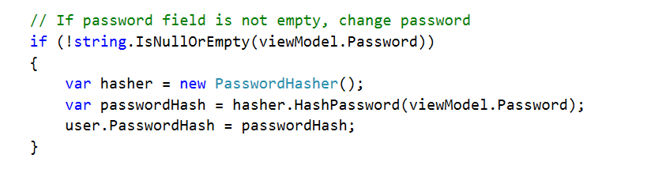

1. Set **user properties**

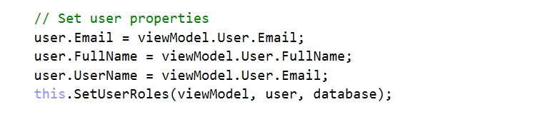

1. **Save changes** to the database

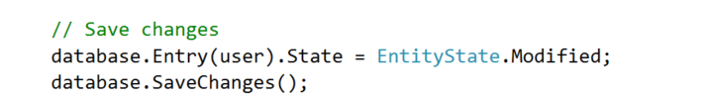

There is one more helper method, that we need to take care of - the one for setting the user roles.

## Set User Roles Method

For setting user roles, use this method:

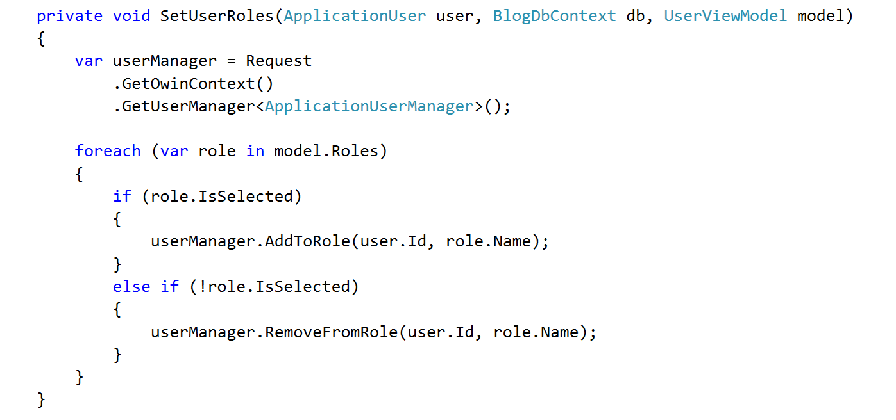

It's a helper method that **loops through all roles** that we received from the form in the view. For each role, it checks weather it **is selected**. Based on that, the **user either receives a new role or is removed from it**.

## Test Edit User

Test if the action works properly. **Test changing the password** and **if the roles are set properly**.

# Deleting Users

Deleting users should be far easier than editing them. The only thing that we need to consider is **deleting all user articles before deleting their author**.

## Creating the Get Method

The **GET Method** is really simple and we've done this a couple of times already.

We must check **if the id is not null**. After that, we use an instance of the **database context** and so on:

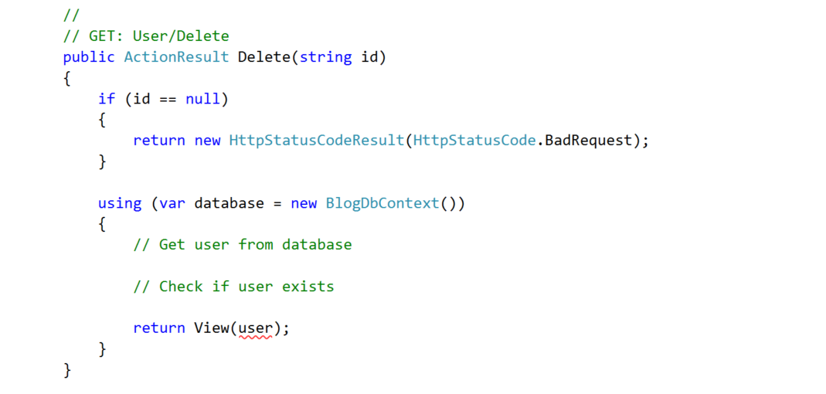

To **get the user** from the **database**:

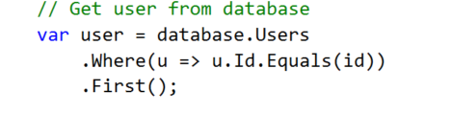

To check if the **user exists**:

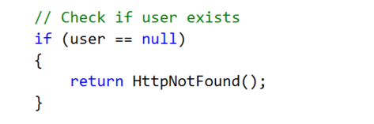

## Creating the View

Create the view inside "**Views/User**" and call it "**Delete**":

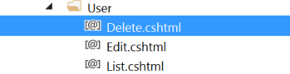

Paste the following code:

|  |
| --- |
| @model Blog.Models.ApplicationUser  @{  ViewBag.Title = "Delete User";  }  <div class="container body-content span-8 offset-2">  <div class="well">  <h2>@ViewBag.Title</h2>  @using (Html.BeginForm("Delete", "User", FormMethod.Post, new { @class = "form-horizontal" }))  {  <div class="form-group">  @Html.LabelFor(m => m.UserName, new { @class = "control-label col-sm-4" })  <div class="col-sm-4">  @Html.TextBoxFor(m => m.UserName, new { @class = "form-control col-sm-4", @readonly = "readonly" })  </div>  </div>  <div class="form-group">  @Html.LabelFor(m => m.FullName, new { @class = "control-label col-sm-4" })  <div class="col-sm-4">  @Html.TextBoxFor(m => m.FullName, new { @class = "form-control col-sm-4", @readonly = "readonly" })  </div>  </div>  <div class="form-group">  <div class="col-sm-offset-4 col-sm-4">  @Html.ActionLink("Cancel", "List", "User", null, new { @class = "btn btn-default" })  <input type="submit" value="Delete" class="btn btn-danger" />  </div>  </div>  }  </div>  </div> |

The resulting view should be this:

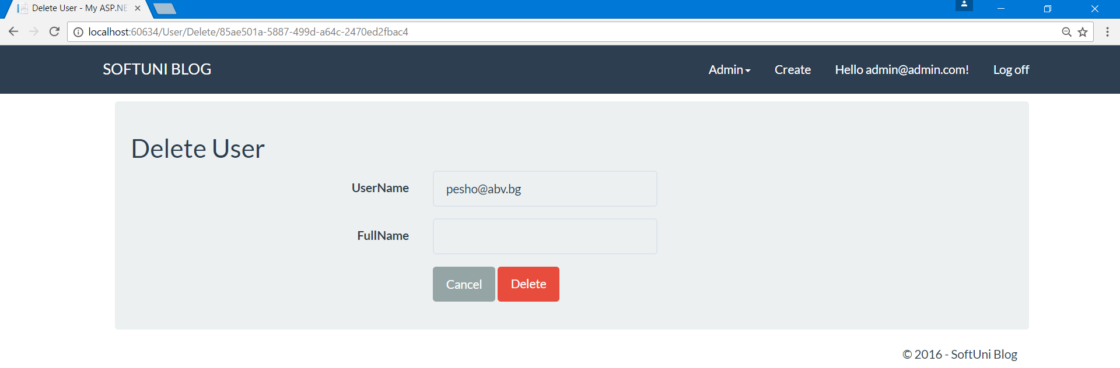

## Creating the Post Method

Once again, in the **Post Method**, we need to take care of several things.

1. Don't forget to use [**HttpPost**] attribute.
2. The **method signature** cannot be the same as the post method, se we need a different name (e.g. **DeleteConfirmed**).
3. We need to **add an attribute** that tells our app that **this method will correspond to the "Delete" Аction**.

Let's review the outline of the method:

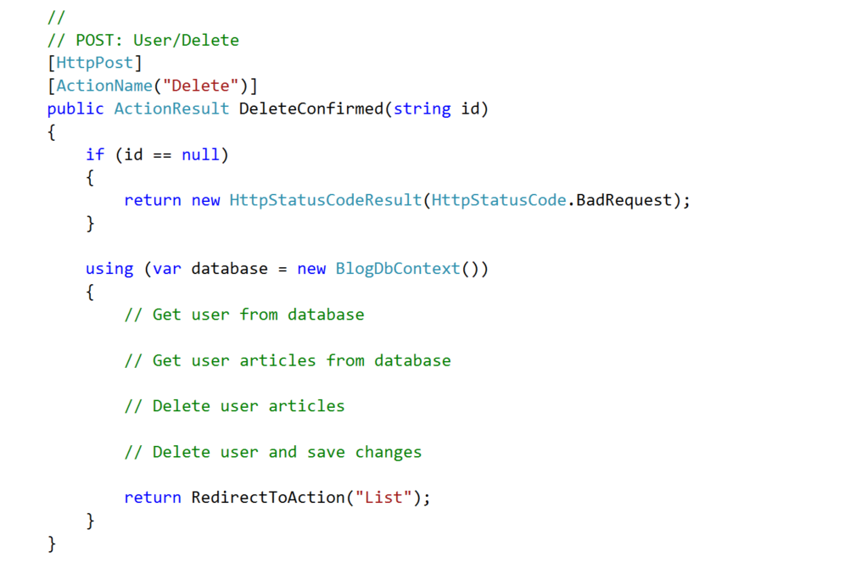

Now, to fill the gaps:

1. **Connect to the database** and get the user

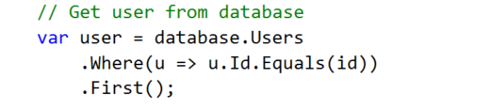

1. **Get all user articles**, so we can delete them

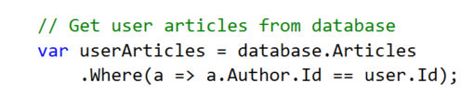

1. **Delete articles**

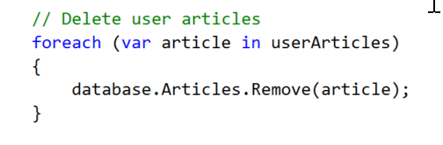

1. **Delete the user** and save changes

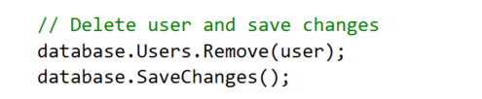

You can test if the user delete action works. You may notice that we have a problem. All **users can reach edit and delete** pages **using the url** (e.g the **routing**). We need access cotrol.

## Adding Access Control

Fortunately, in **ASP.NET** this is really easy. The only thing we need to do is to **add an attribute** stating which roles can access a controller or an action.

In our case, we want **only admins to access** all of the functionality of the user controller. Just **add the attribute above the controller**:

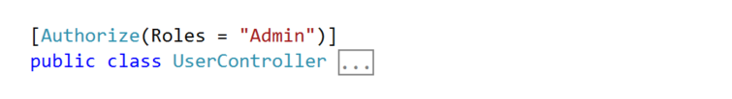

# Categories

## Create Category Model

A category has an **Id** and a **Name**. Let's **create a class** that has these two:

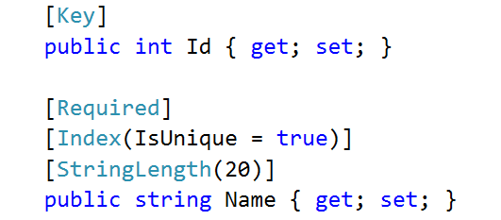

If we want the name to be unique (there won't be categories with the same name) we can state that with an attribute [**Index(IsUnique = true)**].

Aside from that, we want the category to keep track of all articles that fall into it. We can do this by adding one more property that will be navigational:



Also, it is **good practice** to **initialize virtual collections through the constructor**, so we need to **add a private field** and to **set it inside the constructor**. Add this in the beginning of the class:

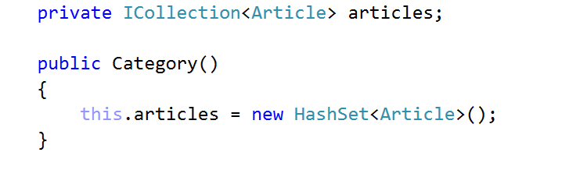

The class should look like this:

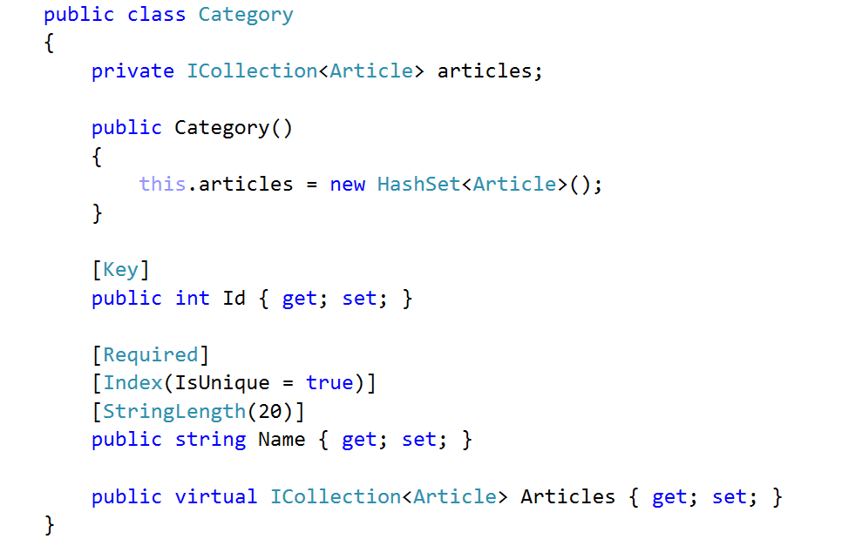

## Add Categories to Database

We need to tell to the database context that we have a new entity. Head to the **BlogDbContext** and add a new **DbSet**:

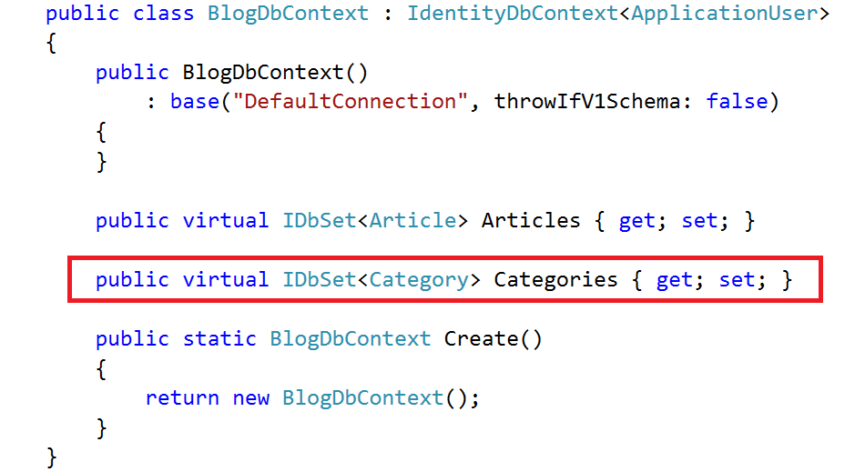

## Create Categories Action Link

To create a link in the site, from where we can reach the categories section, go to the partial view **"_LoginPartial.cshtml**" and add the following line of code:

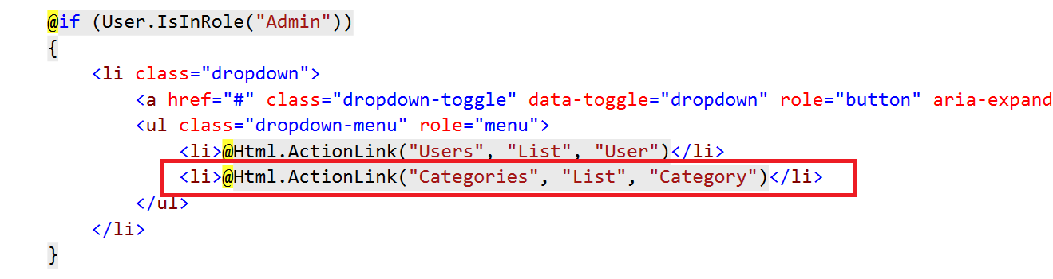

This is a new button in the drop down menu that is visible only for the admin.

## Create Categories Controller

Go to "**Controllers**" folder and add a new controller, called "**Category**":

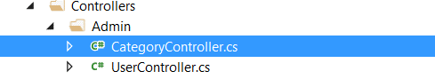

## Listing All Categories

Create an **action** called "**List**":

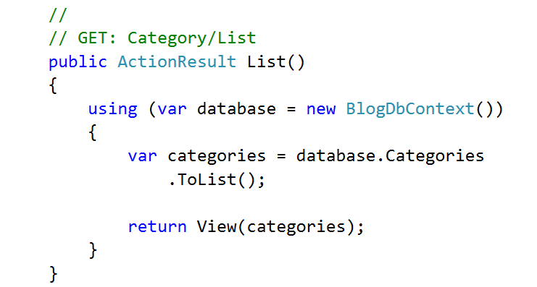

Make the **Index**() action to redirect to **List**():

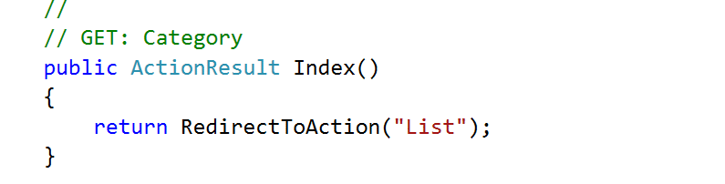

## Create List Categories View

Create a **new view** inside the "**Views/Category**" folder called "**List**" and paste the following code:

|  |
| --- |
| @model List<Blog.Models.Category>  @{  ViewBag.Title = "List";  }  <div class="container">  <div class="well">  <h2>All Categories - @Html.ActionLink("Create", "Create", "Category", null, new { @class = "btn btn-warning" })</h2>  <div class="row">  <table class="table table-striped table-hover col-sm-12">  <thead>  <tr>  <th>#</th>  <th>Name</th>  <th>Actions</th>  </tr>  </thead>  <tbody>  @foreach (var category in Model)  {  <tr>  <td>@category.Id</td>  <td>@category.Name</td>  <td>  @Html.ActionLink("Edit", "Edit", "Category", new { @id = category.Id }, null)  @Html.ActionLink("Delete", "Delete", "Category", new { @id = category.Id }, null)  </td>  </tr>  }  </tbody>  </table>  </div>  </div>  </div> |

This will create the following view:

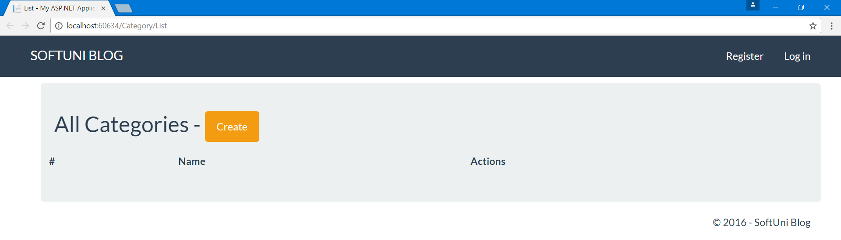

We don’t have any categories yet, but at least we have a button for creating them.

However, it doesn’t work.

# Creating Categories

## Get, Post and View

Creating categories is a cake. If you can't do it yourself, this is the code for the **GET Method**:

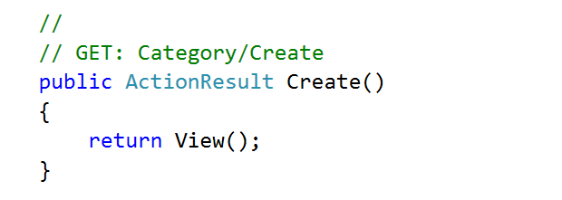

The POST method (don’t forget [**HttpPost**] attribute):

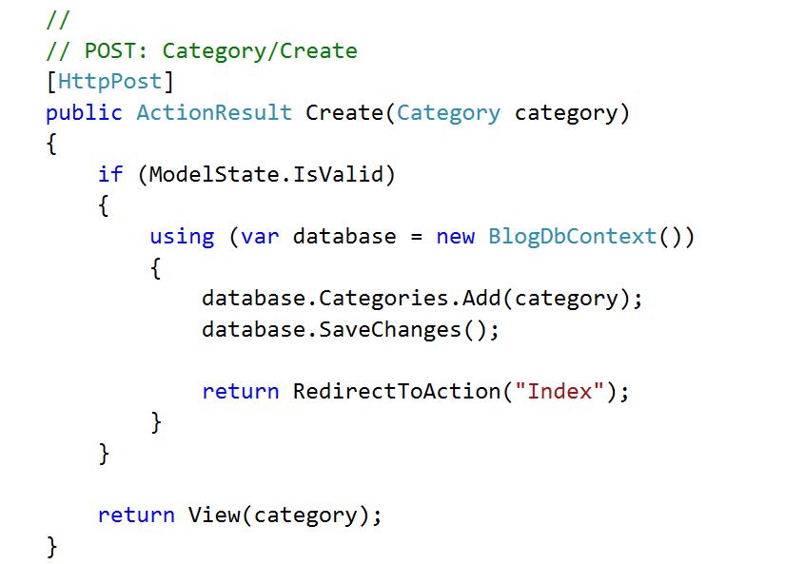

And the view:

|  |
| --- |
| @model Blog.Models.Category  @{  ViewBag.Title = "Create";  }  <div class="container">  <div class="well">  <h2>Create Category</h2>  @using (@Html.BeginForm("Create", "Category", FormMethod.Post, new { @class = "form-horizontal" }))  {  <div class="form-group span=8 offset=2">  @Html.LabelFor(m => m.Name, new { @class = "control-label col-sm-4" })  <div class="col-sm-4">  @Html.TextBoxFor(m => m.Name, new { @class = "form-control" })  </div>  </div>  <div class="form-group">  <div class="col-sm-offset-4 col-sm-4">  @Html.ActionLink("Cancel", "Index", "Category", new { @class = "btn btn-default" })  <input type="submit" value="Create" class="btn btn-success" />  </div>  </div>  }  </div>  </div> |

# Editing Categories

## Get, Post and View

Editing categories is also a cake. Here's the code for the **GET method** (but really, do it yourself):

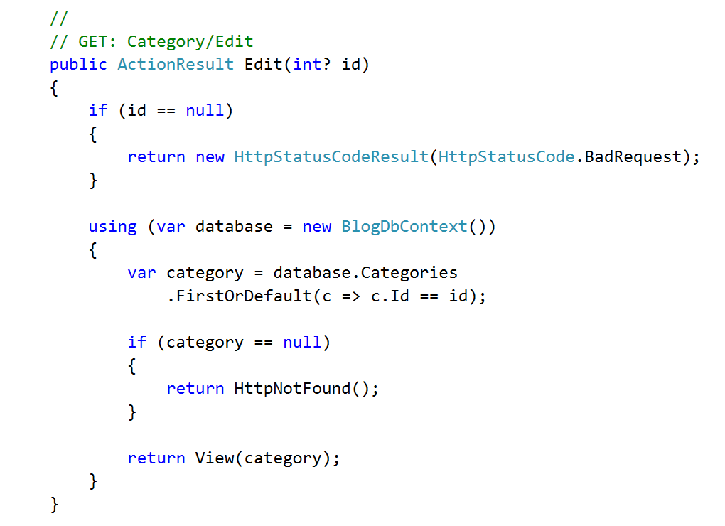

The **POST Method**:

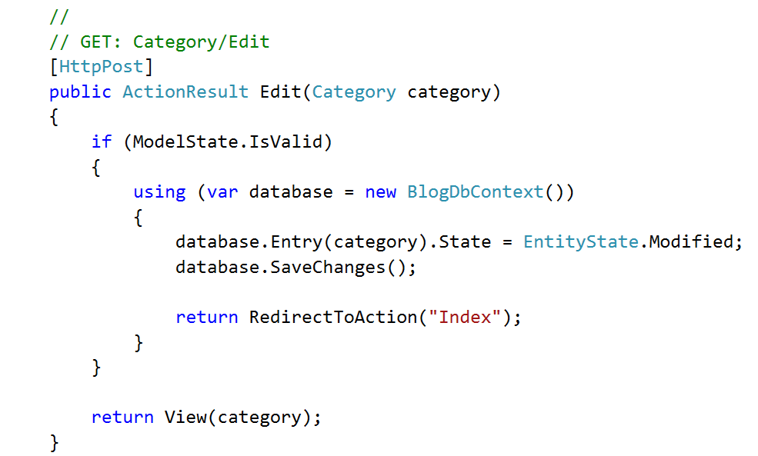

And the **View**:

|  |
| --- |
| @model Blog.Models.Category  @{  ViewBag.Title = "Edit";  }  <div class="container">  <div class="well">  <h2>Edit Category</h2>  @using (Html.BeginForm("Edit", "Category", FormMethod.Post, new { @class = "form-horizontal" }))  {  <div class="form-group">  @Html.LabelFor(m => m.Name, new { @class = "control-label col-sm-4" })  <div class="col-sm-4">  @Html.TextBoxFor(m => m.Name, new { @class = "form-control" })  </div>  </div>  <div class="form-group">  <div class="col-sm-4 col-sm-offset-4">  @Html.ActionLink("Cancel", "List", "Category", new { @class = "btn btn-default" })  <input type="submit" value="Edit" class="btn btn-success" />  </div>  </div>  }  </div>  </div> |

# Deleting Categories

## Get, Post and View

I'm sure you don't need this, but in case you are feeling lazy…

The **GET**:

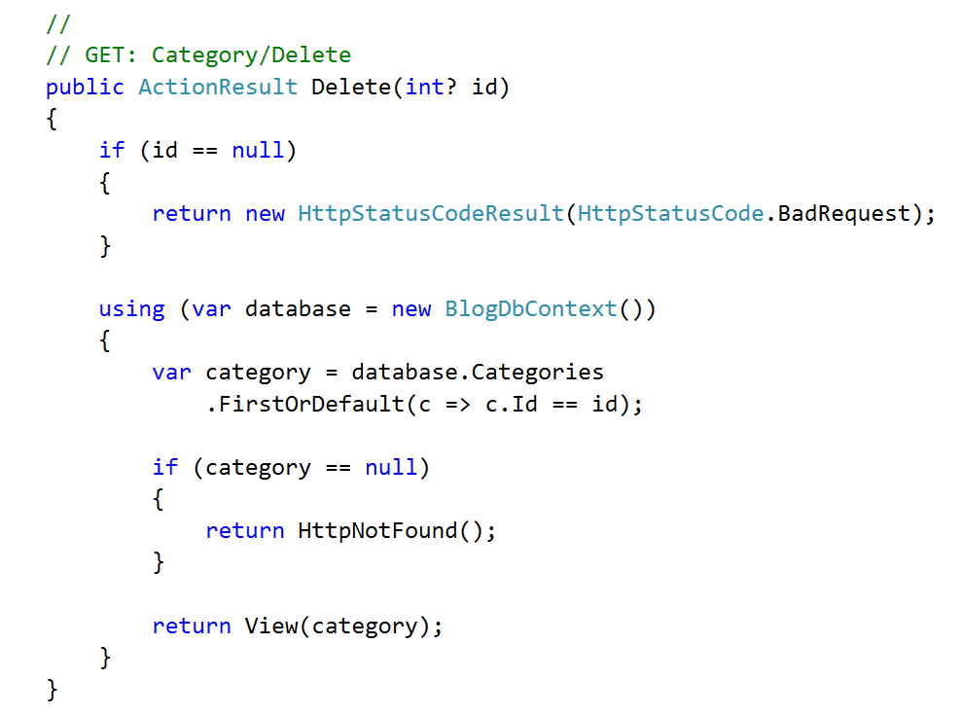

The **POST**:

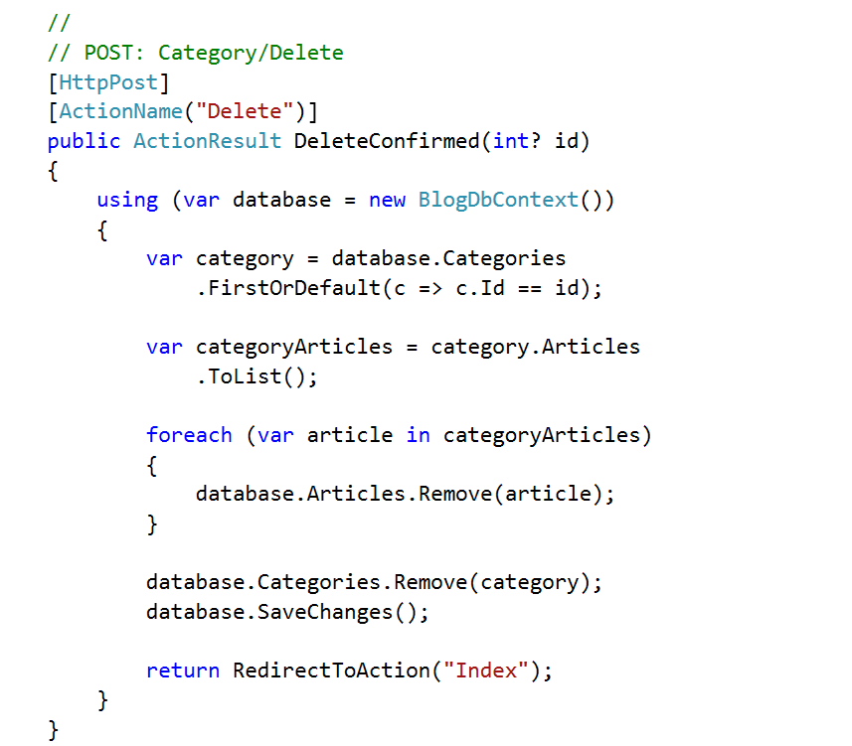

The **View**:

|  |
| --- |
| @model Blog.Models.Category  @{  ViewBag.Title = "Delete";  }  <div class="container">  <div class="well">  <h2>Delete Category</h2>  @using (Html.BeginForm("Delete", "Category", FormMethod.Post, new { @class = "form-horizontal"}))  {  <div class="form-group">  @Html.LabelFor(m => m.Name, new { @class = "control-label col-sm-4"})  <div class="col-sm-4 ">  @Html.TextBoxFor(m => m.Name, new { @class = "form-control", @readonly = "readonly"})  </div>  </div>    <div class="form-group">  <div class="col-sm-4 col-sm-offset-4">  @Html.ActionLink("Cancel", "List", "Category", new { @class = "btn btn-default" })  <input type="submit" value="Delete" class="btn btn-danger" />  </div>  </div>  }  </div>  </div> |

## Test Creating, Editing and Deleting Categories

Before we integrate categories into articles, you should **test if everything works as intended**.

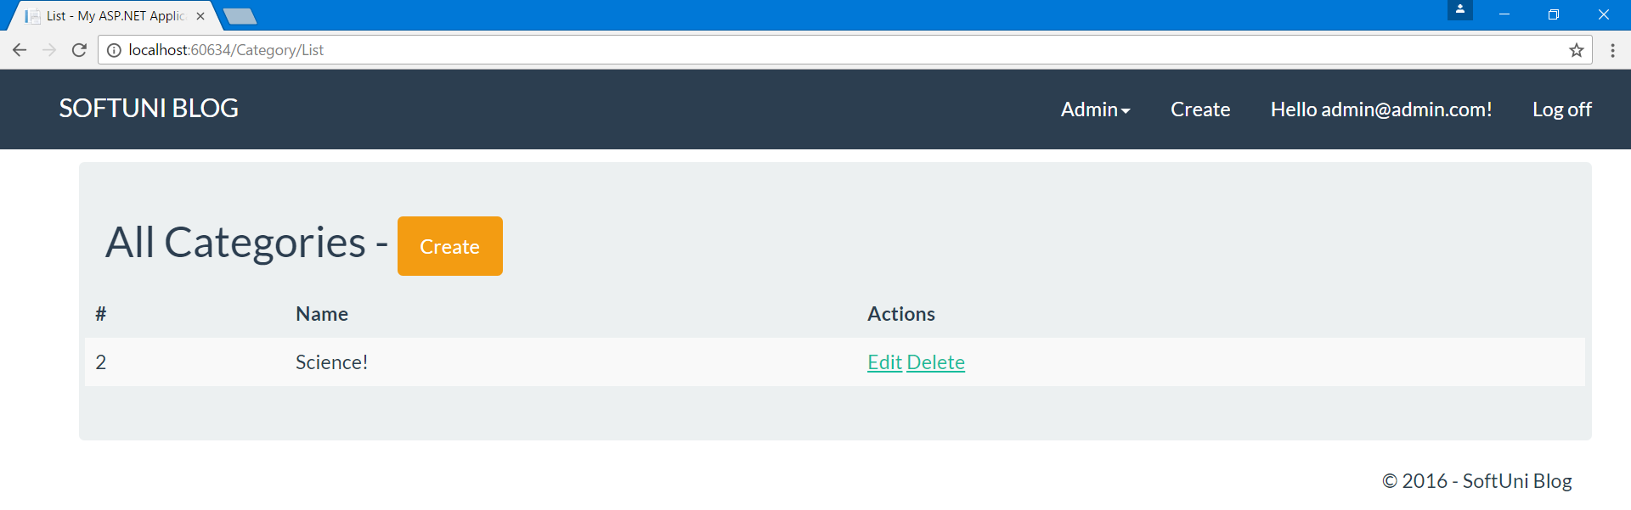

# Integrating Categories

## Adding Categories to Articles

Go to the **Article class** and add **two new properties**:

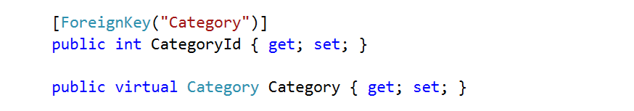

Don't forget to **make the Category virtual** as it is a **navigational property**.

While we modify the **Article Data Model** we can **add two new constructors** that we will need in a moment:

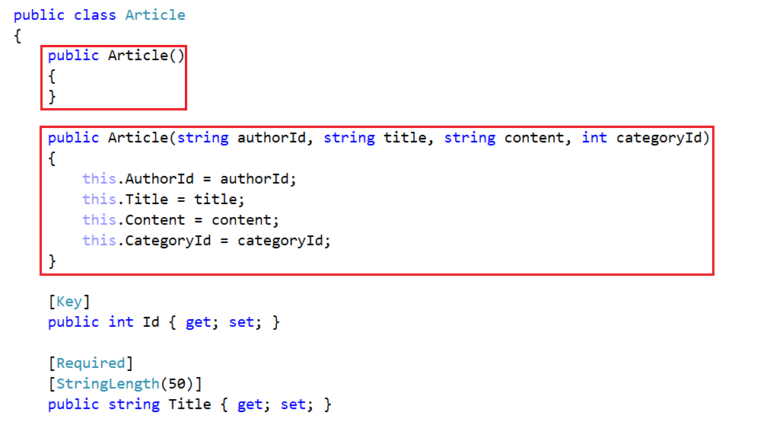

If you try to access the database right now and you have any articles in the database, you **should get this exception**:



This is because we are trying to insert the category column in the table with a default **null value**, but we already said that it **cannot be null** (it is [**Required**]).

If that is the case, just drop the database (from **Views -> SQL Server Object Explorer**).

## Adding Categories to Article View Model

To the **View Model**, add a **category id** and a **list of categories:**

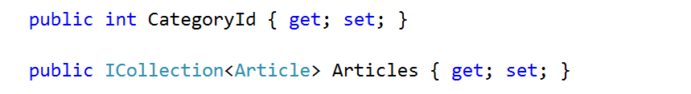

## Choosing Category on Article Creation

In order for the view to have information about available categories, we need to **pass it the information ourselves**.

But in order to do that, we will **refactor our GET and POST methods** for the create action.

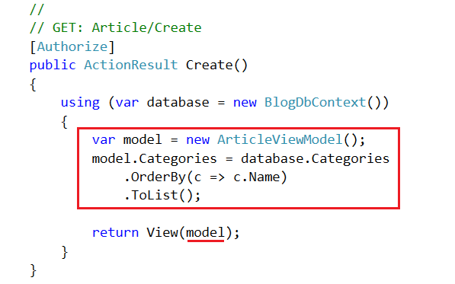

Of course, make sure everything is inside a using block, so we dispose of used resources.

Now, to modify the **POST Method**. There are a couple of things to do:

1. Make the method take as parameter an **ArticleViewModel** instead of an Article.
2. Use the constructor that we created a moment ago to create a new article
3. Pass the model back to the view if the model state is not valid

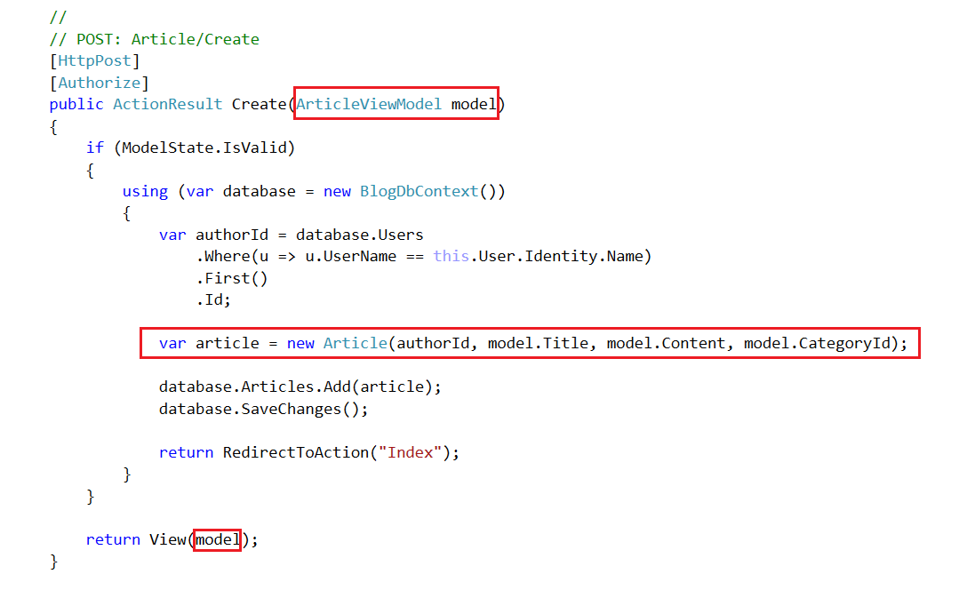

Next, we need to make changes to the view (**Views/Article/Create**).

First, modify the model of the view:

|  |
| --- |
| @model Blog.Models.ArticleViewModel |

Also, we need to show all available categories. Add the following code between content and submit button:

|  |
| --- |
| <div class="form-group">  @Html.LabelFor(m => m.CategoryId, new { @class = "col-sm-4 control-label" })  <div class="dropdown col-sm-4">  @Html.DropDownListFor(m => m.CategoryId,  new SelectList(Model.Categories, "Id", "Name"),  new { @class = "btn btn-info col-sm-12" })  </div>  </div> |

Below, you can see where exactly:

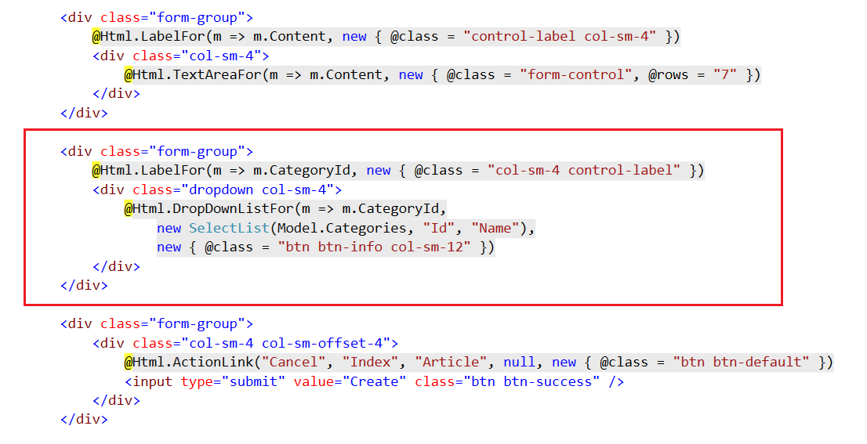

This div **creates a dropdown list** and whatever gets selected, it binds it to the **CategoryId** of the article model.

## Editing Article Category

To implement **article category editing**, we need to make **changes to get and post methods, and to the view**.

Start with the **GET Method**. Add the following code:

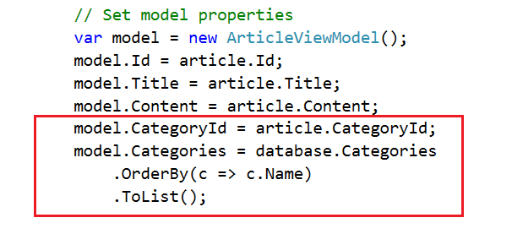

This will send the categories to the editing view.

Now **modify the view** (**Views/Article/Edit**) by adding the following code just **between content textbox and submit button**:

|  |
| --- |
| <div class="form-group">  @Html.LabelFor(m => m.CategoryId, new { @class = "control-label col-sm-4" })  <div class="dropdown col-sm-4">  @Html.DropDownListFor(m => m.CategoryId,  new SelectList(Model.Categories, "Id", "Name", Model.CategoryId),  new { @class = "btn btn-info col-sm-12"})  </div>  </div> |

You can see exactly where on the next screenshot:

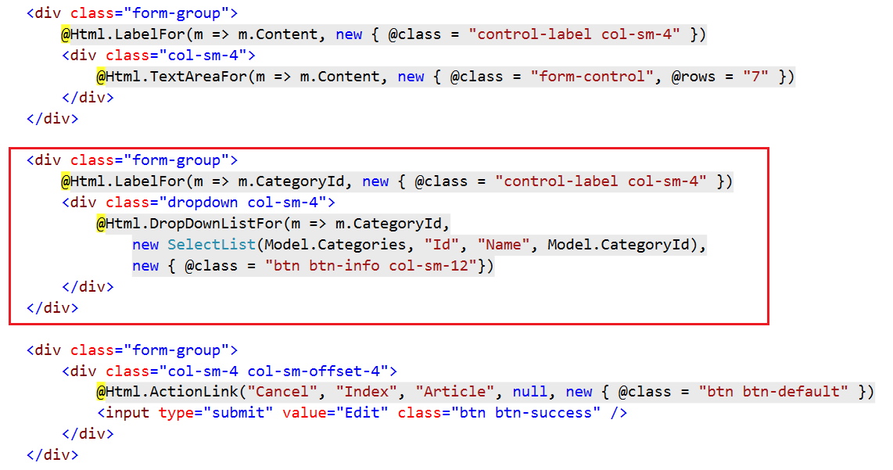

**This will add a dropdown** just like the dropdown we added on article creation.

Now, to **modify the POST method**, just add a single line:

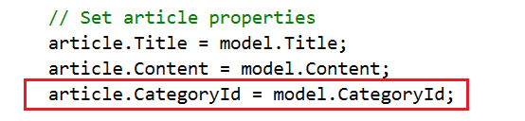

## Show Category on Article Deletion*

You can **add the article category on article deletion**, but this time **try it on your own**.

## Listing Categories and Articles on the Home Page

To have a list with all categories on the home page we can **modify the Home Controller**. We need two new actions there: **ListCategories()** and **ListArticles()**.

**ListCategories()** will **list all categories** on the **home page**:

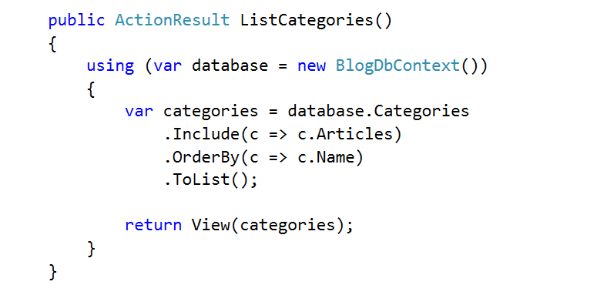

**ListArticles()** will **list all articles** of a given category **once a category is clicked**:

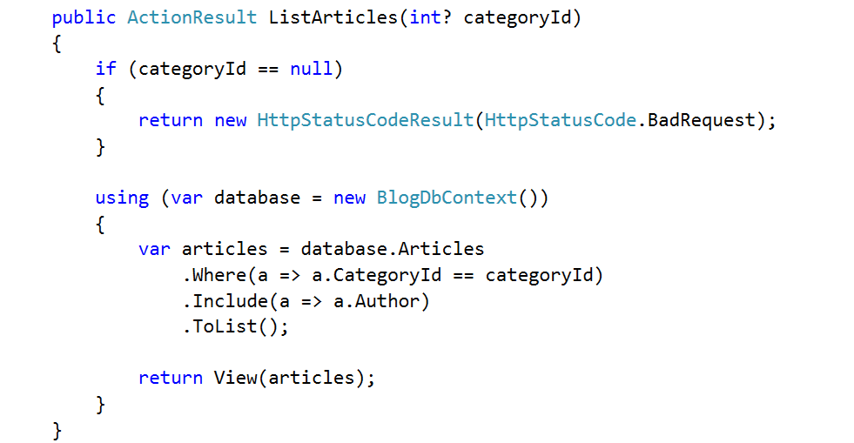

Once again, **get articles from database**, depending on the category and **pass them to the view**. We get the category id as a parameter in the method signature.

Make the **Index** action to redirect to **ListCategories**:

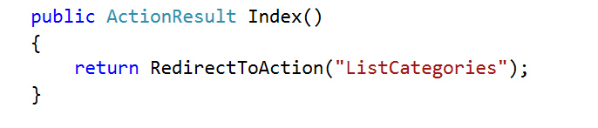

Now **create two new views**:

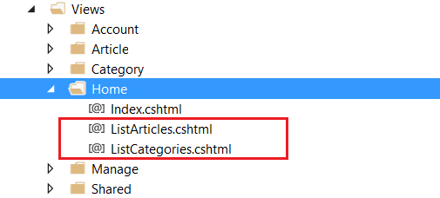

For the **ListArticles** **View** use this code:

|  |
| --- |
| @model List<Blog.Models.Article>  @{  ViewBag.Title = "List";  }  <div class="container">  <div class="row">  @foreach (var article in Model)  {  <div class="col-sm-6">  <article>  <header>  <h2>  @Html.ActionLink(@article.Title, "Details", "Article", new { @id = article.Id }, null)  </h2>  </header>  <p>  @article.Content  </p>  <footer class="pull-right">  <small class="author">  --author @article.Author.FullName  </small>  </footer>  </article>  </div>  }  </div>  </div>  <hr /> |

The above is the same as list articles in the article controller.

And for **ListCategories** use the following code:

|  |
| --- |
| @model List<Blog.Models.Category>  @{  ViewBag.Title = "List";  }  <div class="container">  <div class="row">  @foreach (var category in Model)  {  <div class="col-sm-6 text-center text-uppercase">  <p>  <h2>@Html.ActionLink(string.Format($"{category.Name} ({category.Articles.Count})"),  "ListArticles", "Home", new { @categoryId = category.Id }, null)</h2>  </p>  </div>  }  </div>  </div>  <hr /> |

The only interesting thing in the code above is that we use **string.Format()** as a name of the link. Then we give the category name and the count of all articles in a given category. That is why we included articles in the **GET** method.

If you want, you can **fix all other links in the blog**. Right now, if you create, edit or delete an article, you are redirected to listing all articles. You can **redirect to listing all categories**, or to the **articles in the current article category**. The choice is yours.

# Creating Tags

The connection between articles and tags is a typical example of **many to many relationship**. One article can have many tags and a single tag can be set to many articles. In **entity framework**, this is done like this:

## Create Tag Model

First, we need two properties - id and name:

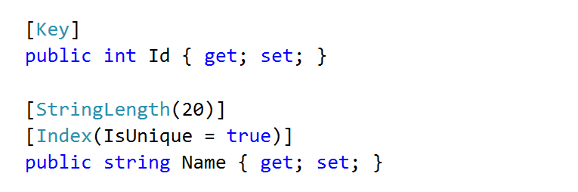

Next, a collection of articles that the tag will be attached to:

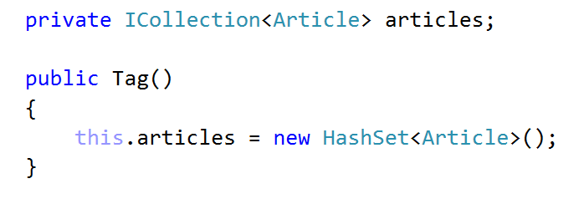

Finally, a property through which to access the collection:

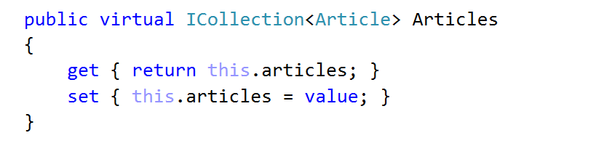

The whole class should look like this in the end:

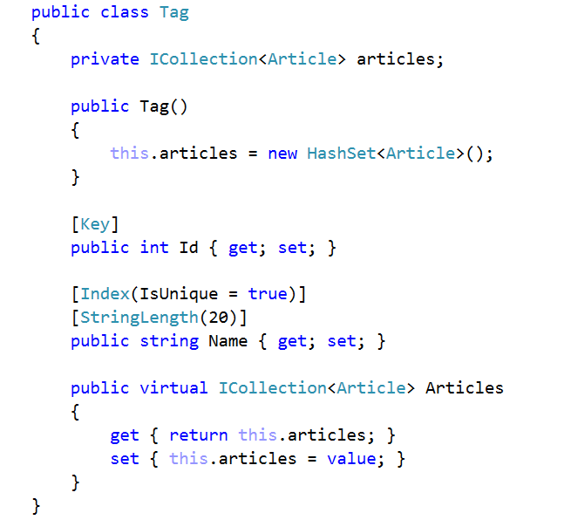

## Modify Article Models

Add a new property to **Article Data Model**:

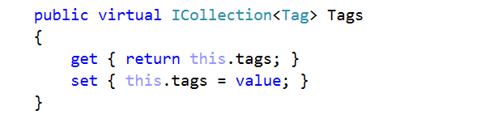

For this new property, we need a few changes in the code.

1. Make a **private field** for it.
2. In the **default constructor**, initialize the private field
3. Do the same in the **non-empty constructor**

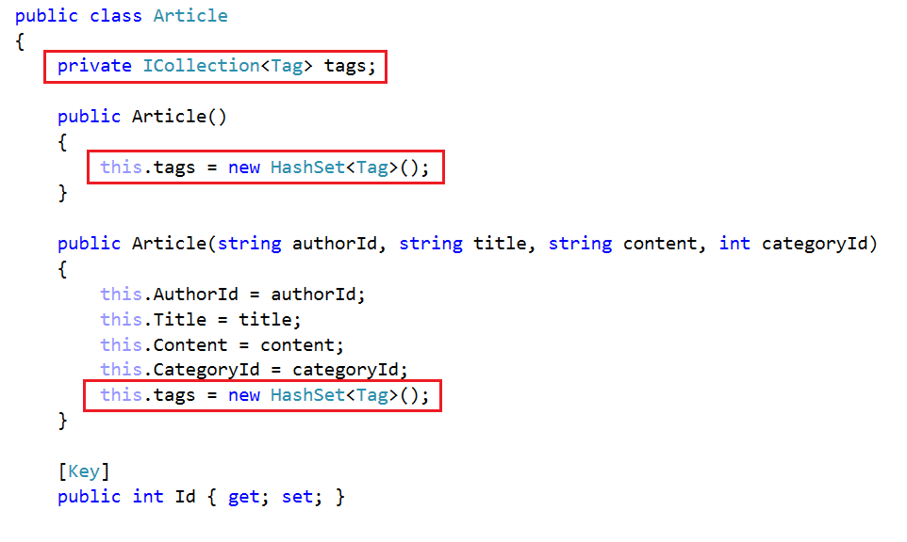

Add a new property to **Article View Model**:



## Add Tags to Database

In **BlogDbContext**:

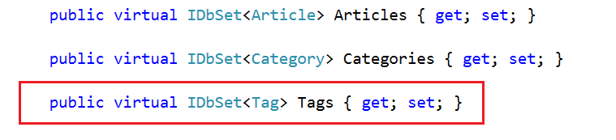

## Add Tags to Article Creation

Modify **Create Post Action** inArticle Controller:

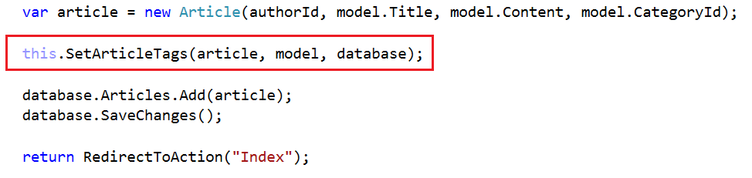

Modify Views/Article/Create:

|  |
| --- |
| <div class="form-group">  @Html.LabelFor(m => m.Tags, new { @class = "control-label col-sm-4" })  <div class="col-sm-4">  @Html.TextBoxFor(m => m.Tags, new { @class = "form-control col-sm-4" })  </div>  </div> |

## Add Tags to Article Editing

Modify the GET method:

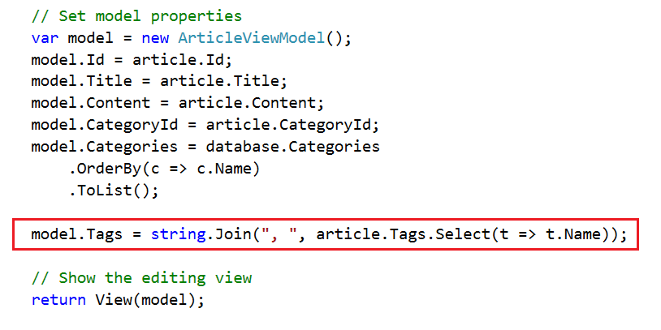

View:

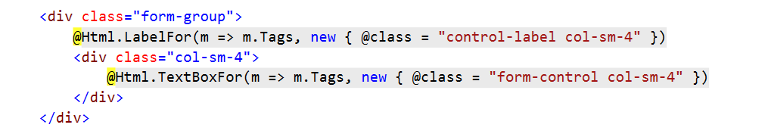

Modifying the **POST** Method will be a little bit trickier because **if a tag already exists**, we need to **set it through the database**. **If not**, we need to **create it and set it to the article**. For this we will need a couple of helper methods. The first one is called from within the **POST** Method:

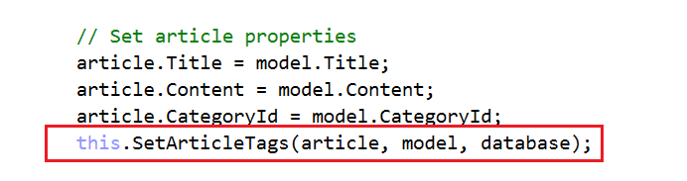

Now, to create the **SetArticleTags** Method:

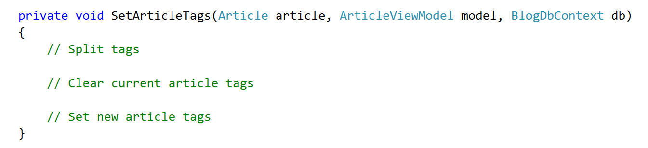

1. First, split the tags that we received from the view. Note that we are selecting only the unique ones (with distinct). Also, we are transforming them into a lowercase, because comparison in the database is case insensitive:

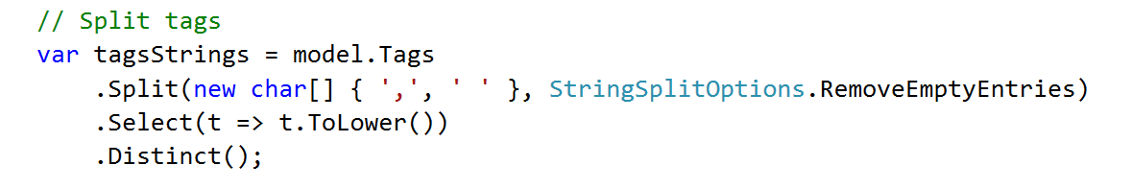

1. Remove all current article tags

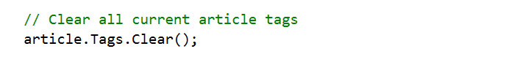

1. Setting the new tags is done in a loop:

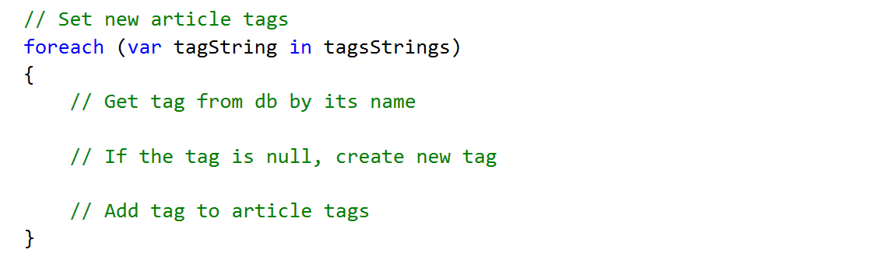

* 1. First, get a tag from the database

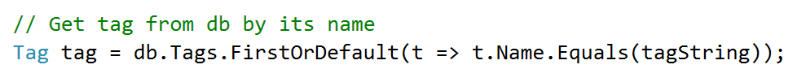

* 1. Check if the tag actually exists and create it if it doesn't

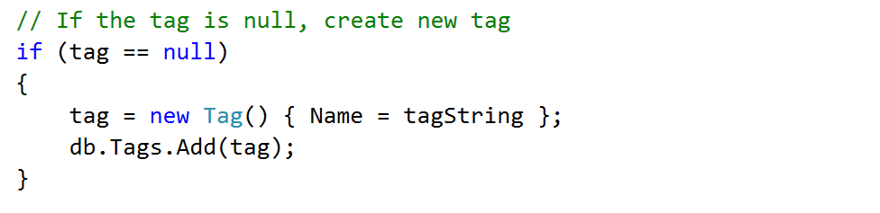

* 1. Add it to the article tags



## Add Category and Tags to Article Deletion

**Article/Delete** GET Method:

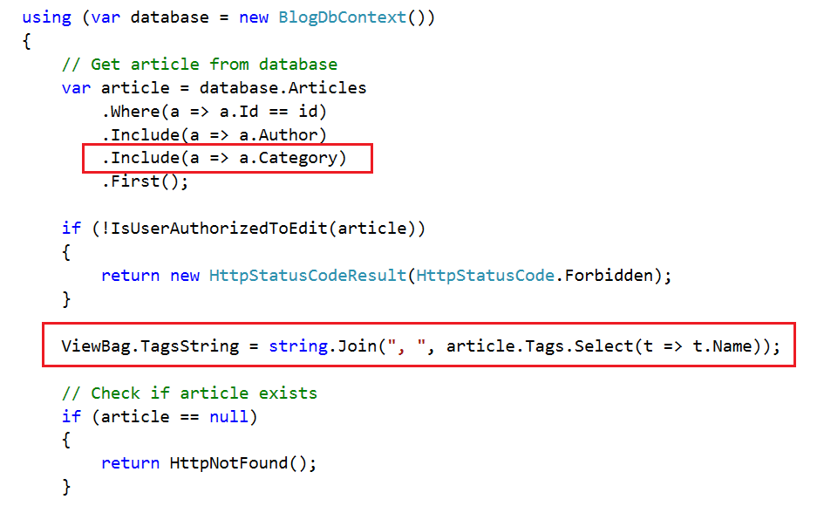

Add this to **Views/Article/Delete**:

|  |
| --- |
| <div class="form-group">  @Html.LabelFor(m => m.Category, new { @class = "control-label col-sm-4" })  <div class="col-sm-4">  @Html.TextBoxFor(m => m.Category.Name, new { @class = "form-control", @readonly = "readonly" })  </div>  </div>  <div class="form-group">  @Html.LabelFor(m => m.Tags, new { @class = "control-label col-sm-4" })  <div class="col-sm-4">  @Html.TextBox("tagsString", (object)ViewBag.TagsString, new { @class = "form-control", @readonly = "readonly" })  </div>  </div> |

## Add Tags to Article Listing and Details

Modify some of the existing code.

First, within **Article/List**:

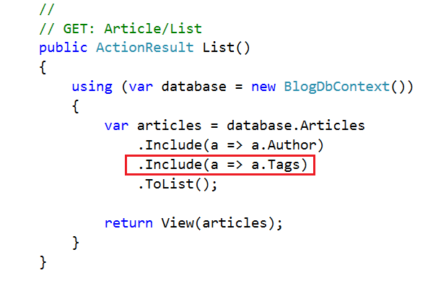

**Substitute** the footer of **Views/Article/List** with this one:

|  |
| --- |
| <footer >  <div class="pull-left">  @foreach (var tag in article.Tags)  {  @Html.ActionLink(tag.Name, "List", "Tag", new { @id = tag.Id }, new { @class = "btn btn-default btn-xs" })  }  </div>  <small class="author pull-right">  --author @article.Author.FullName  </small>  </footer> |

**Modify** the code inside **Article/Details** to contain the following query:

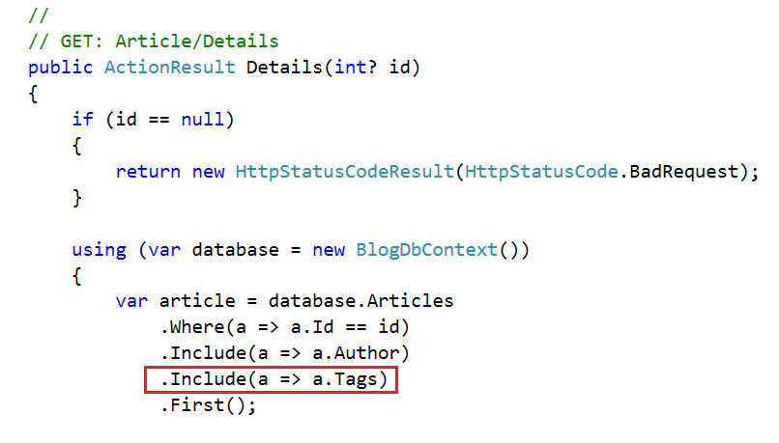

Do the same inside **Home/ListArticles:**

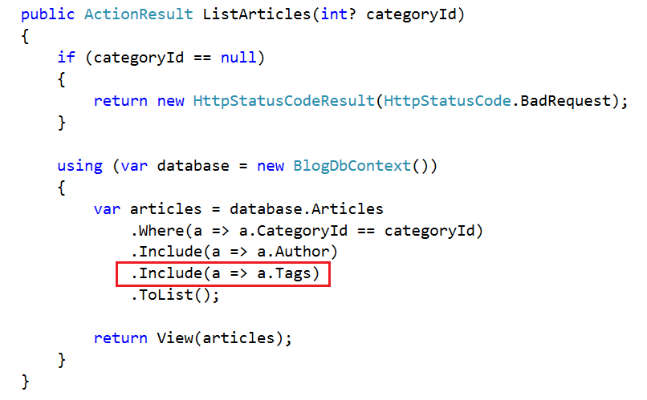

## Filter Articles by Tag

In order to have a **new action** that is used to **filter** **articles by tag** we need to create the **tag controller**:

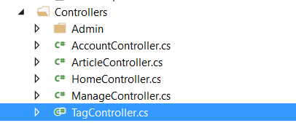

Create a **single method** within:

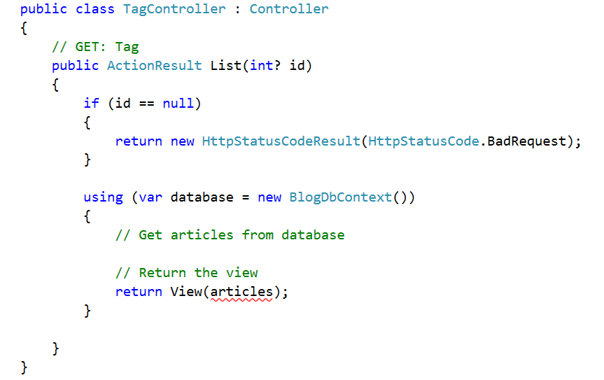

Again, getting articles from the database is a little bit trickier because **we need** both **information about articles author and articles tags** to be passed to the view.

This is because when listing an article both the tag's name and the author's name are displayed. If you pass the articles **without including them you will get a null reference exception**.

When we are trying to **include multiple levels of information** from an entity we use the **Select extension method**:

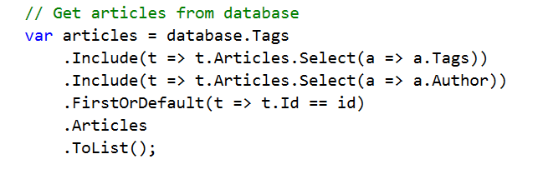

This includes the information we need, finds the tag and then gets all its articles, transforming them to a list collection.

## List by Tag View

Now the only thing left is to create the view for that given action. You have that ready for you somewhere in the project. Think where exactly you can get it from.

You can **test all** the functionality that we have built.

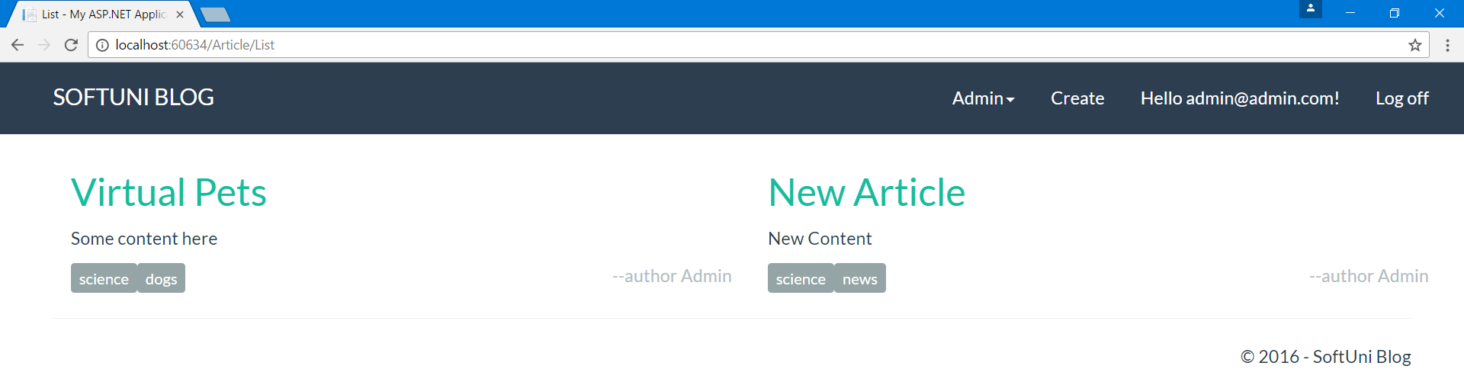

This is everything. We want to **congratulate** **you** if you got to this point and **thank you** for your patience.

We hope that **you've** **enjoyed working** with **C#, Entity Framework, ASP.NET MVS** and **MSSQL**. Farewell, friends!